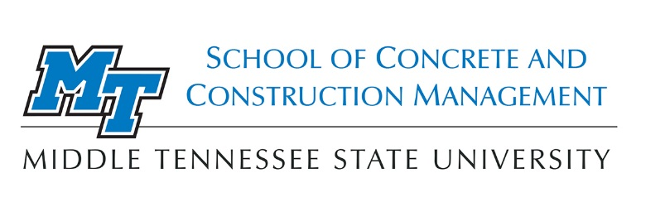
Internship Program:
Employer Evaluation of
Student Performance

Please type the requested information into this form at the end of the internship.
Save the file, and either email to the Faculty Internship Coordinator, contact information can be found at mtsu.edu/ccm/internships.php or print and mail to: MTSU School of CCM, MTSU Box 24, 1301 E. Main Street, Murfreesboro, TN 37132

Date:
Student Name:
Company Name:
Dates of Work: from: to:

Supervisor Name:
Title:
Supervisor Email: Supervisor Phone:

Briefly describe the student’s responsibilities and duties (box will expand as you type):

Total Hours Worked:

Please evaluate the student’s current skill level by checking the appropriate box (leave blank if not observed):
1 2 3 4 5
Low Below Average Average Above Average Exceptional

Oral Communication: The student demonstrated or developed oral communication skills with respect to:
1 2 3 4 5
- Logical organization of thoughts and ideas
- Making contributions that were relevant and to the point
- Clarity of language and understandable explanations
- Use of appropriate and professional language
Written Communication: The student demonstrated or developed written communication skills with respect to:
1 2 3 4 5
- Logical organization of thoughts and ideas
- Making contributions that were relevant and to the point
- Clarity of language and understandable explanations
- Correct grammar and syntax

1 2 3 4 5
Low Below Average Average Above Average Exceptional

Employability: The student demonstrated or developed:
1 2 3 4 5
- Skills and knowledge related to the internship duties
- Confidence in skills and knowledge
- Integrity and work ethic
Ability to work within a team: The student demonstrated or developed the ability to:
1 2 3 4 5
- Build positive working relationships
- Work effectively within a team
- Adapt to working styles of others
- Contribute positively to the group’s effort
Overall Evaluation:
1 2 3 4 5
- Student responded well to constructive feedback
- Student arrived with adequate skills to begin work
- Student left with adequate skills to complete the work
- Overall performance met supervisor’s expectation
Please provide written responses to questions below (boxes will expand as you type):

What strengths did the student possess that allowed him/her to perform in the workplace?

What skills and abilities did the student learn and apply in the workplace?

In what areas should the student concentrate to improve his/her work effectiveness, both technical and personal?

Do you have any comments or suggestions on how to improve the Internship Program?

