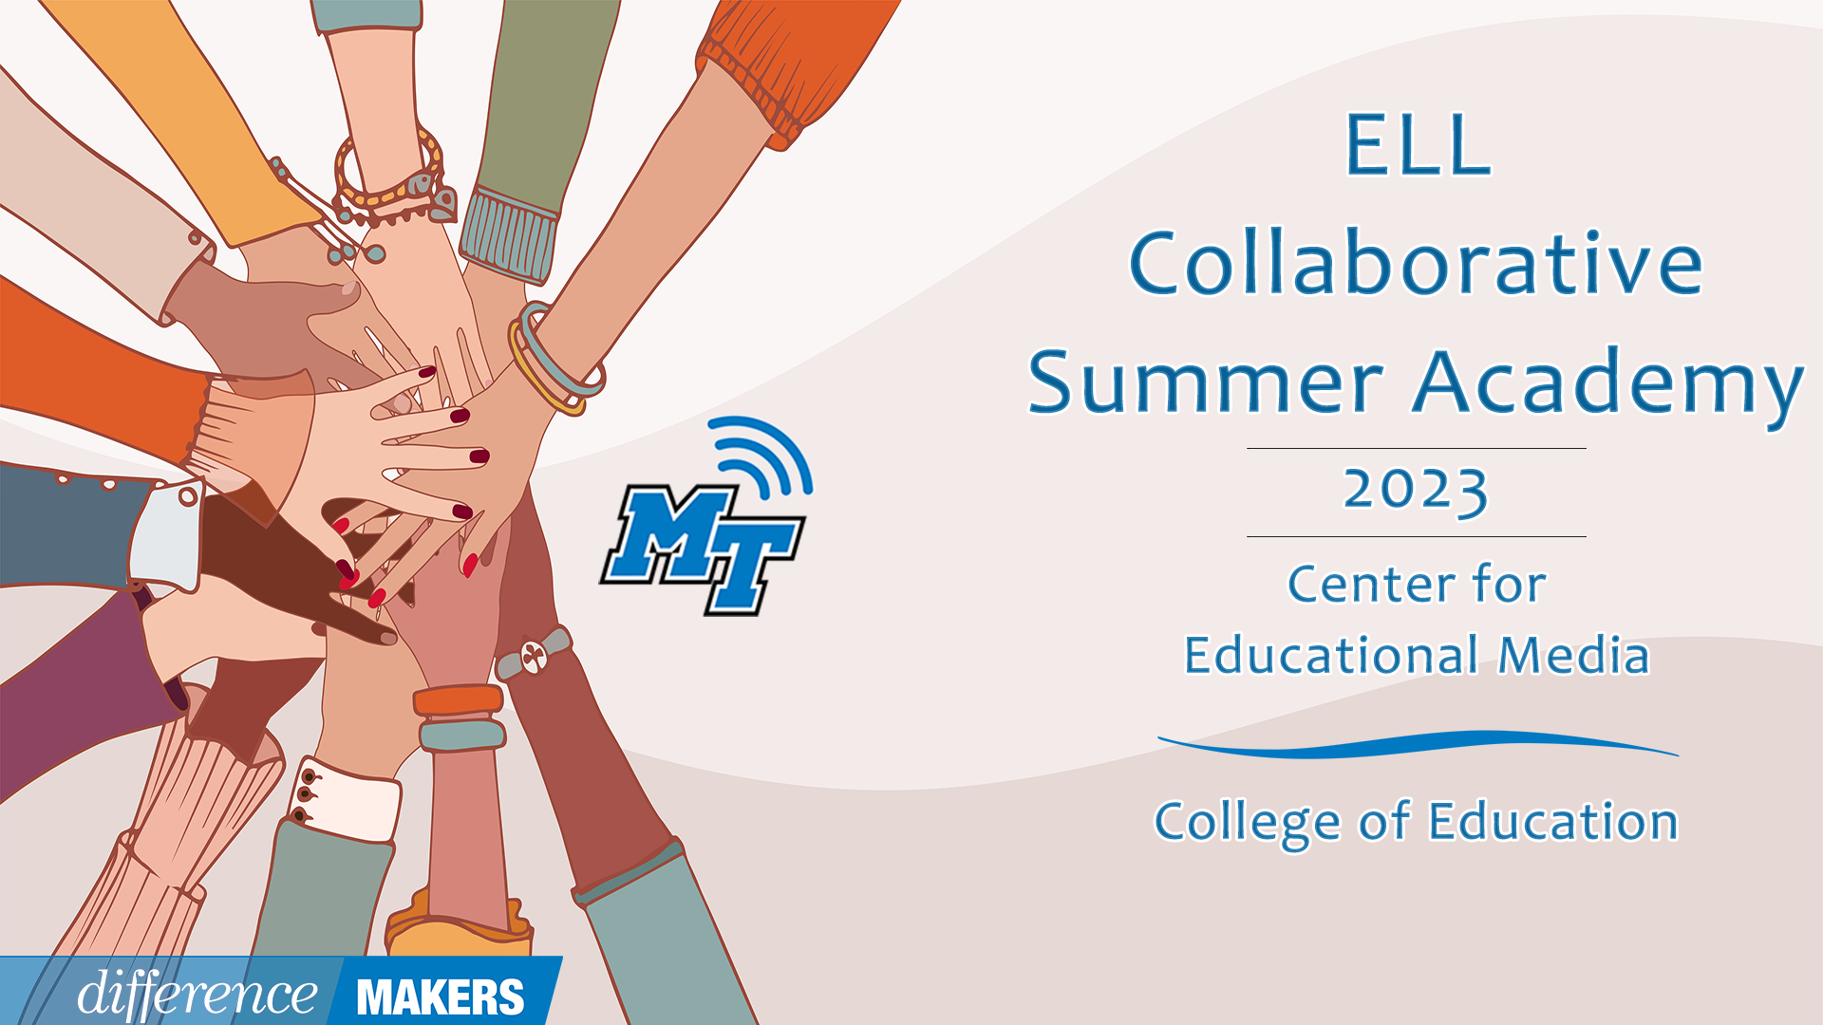
ELL Collaborative Summer Academy
Teacher Day
Onsite Conference
July 06, 2023

8:30am- 8:45am Welcome/Introductions
- Dr. Laura Clark, Director, Center for Educational Media, MTSU
- Dr. Janna Brown McClain, Asst. Professor, Elementary and Special Education, MTSU

8:45am-10:00am (Session 1) Scaffolding in Content Instruction for English Learners
- Sara Kathryn Hendrix, Statewide EL Coordinator, TDOE
- Q&A Facilitated by Dr. Laura Clark Dr. Janna Brown McClain

10:00-10:15 Break

10:15-11:30(Session 2) ESL Scaffolds for Gen Ed Teachers. That Work!
- Dr. Christine Tennyson, ESL Teacher Riverdale, Adjunct Professor at Trevecca Nazarene University
- Emily C. Davis, Secondary ESL Facilitator, Rutherford County Schools
- Andrew Raney, EL Educator, Rutherford County Schools
- Q&A Facilitated by Dr. Laura Clark Dr. Janna Brown McClain

11:30-12:45 Lunch

ELL Collaborative Summer Academy
Teacher Day
Onsite Conference
July 06, 2023

12:45-12:50pm Afternoon Welcome/ Back in Seats

12:50-2:05pm (Session 3) Language and Content in the Co-Taught Classroom
- Dr. Hannah Hopper, ESL Program Coordinator, Hamblen County
- Q&A Facilitated by Dr. Laura Clark Dr. Janna Brown McClain

2:05-2:20 Break

2:20-3:35 (Session 4) Who Has Time for a Silent Period? Facilitating Purposeful Student Engagement for Newcomers
- Raven Cleveland, Coordinator of ENL Academics & Instruction, Hamilton County Schools
- Q&A Facilitated by Dr. Laura Clark Dr. Janna Brown McClain

3:35-3:40 Close/Certificates
- Dr. Laura Clark, Director, Center for Educational Media, MTSU

