April
Newsletter

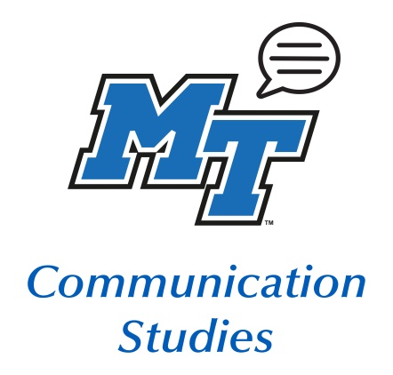
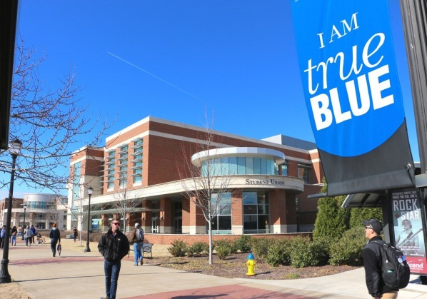
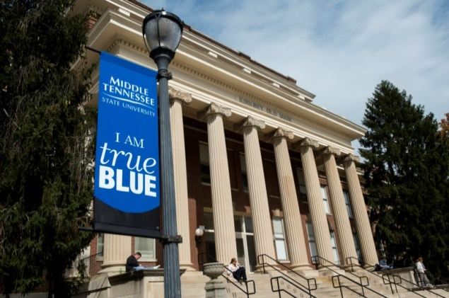

Features
- Student Academic Resources
- Student Health Resources
- Retirement Announcement
- Comm Studies Student of the Year Award
- Debate Team Announcement
- Get Involved
- Faculty Announcements

Student Academic Resources
Communication Studies Office
The Comm Studies Office is available virtually. Please contact Holly Kleiss at Holly.Kleiss@mtsu.edu or Dr. Hundley at heather.hundley@mtsu.edu.
Your Comm Studies professors are working from home and are available through email, phone, or Zoom. Please see https://www.mtsu.edu/communication/index.php for additional information.
Writing Center
The UWC is open for online appointment only. Appointments will be conducted in real time through https://mtsu.mywconline.com.
For more information, look at this page https://mtsu.edu/writing-center/appointments.php or contact the writing center at uwcenter@mtsu.edu with any questions.
MT One Stop
Now open and located in Room 210 of the Student Services & Admissions Center.
If you have any questions about financial aid, registration, tuition, and billing and transcripts, please contact your MT One Stop Enrollment Counselor or visit MT One Stop on campus.
Library
The MTSU James Walker Library website is always available with virtual services and resource. Chat online with a librarian for help with your research and library needs: http://library.mtsu.edu/.
Tutoring
Take advantage of the free tutoring offered for MTSU students!
Tutoring schedule and information can be found at https://www.mtsu.edu/studentsuccess/tutoring.php.
Supplemental instruction session opportunities can be found at https://www.mtsu.edu/si/sessioninfo.php.

Health Services
MTSU Student Health Services can be found in the Health, Wellness, and Recreation Center. They are open Monday-Friday, 8 a.m. to 4 p.m., and closed during university holidays. Go to www.mtsu.edu/healthservices to schedule an appointment online or call at 615-898-2988. Due to high volume, please allow an extra 30 minutes or ensure timely arrival for your appointment.
If you believe you have symptoms of COVID-19, call ahead.
Mental Health Resources
MTSU’s Counseling and Testing Services is here for you! Change of schedule and lifestyle can be very stressful.
Counseling Services offer personal counseling, assisting students in their emotional, intellectual, and social growth. Services are provided in a non-judgmental and confidential environment. They now offer online or phone counseling.
Contact them at www.mtsu.edu/countest/ or call at 615-898-2670.

A change of schedule and social isolation can cause mental stress. It’s okay if you are struggling during this time. MTSU has resources here for you to keep your mind and body well!

Student Health Resources

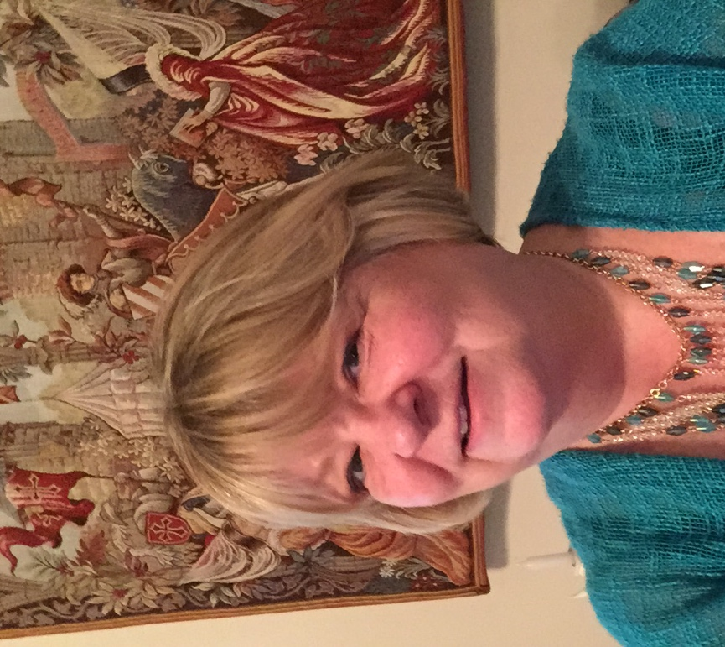
Dr. Linda Seward is retiring from our Communication Studies Faculty after this semester. She has been teaching since 1987, and has been at MTSU since 2002. When Dr. Seward was asked to share her prospective of her time here, this is how she answered:
I remember walking to school as a teenager when I suddenly stopped and realized what I wanted to do with my life: I wanted a career filled with life-long learning! Somewhere along the line, I realized that a career as a professor would be just that as I would learn by developing and updating courses. But there have been surprises as well. Learning that students could also teach me by providing perspectives I had not considered, insights I had not noticed, and examples that made theories come alive was a delightful aspect of teaching. Having opportunities to teach abroad were a true gift in providing first-hand experiences that I could incorporate into explanations of course theories. Even this last semester of my career has provided one last major learning opportunity as I joined many in being thrown into the pool of information and procedures needed to teach online. Now I will begin a new journey of knowledge as I return to Texas. While the future is filled with unknowns, one constant will remain as I plan to maintain a life of learning!

Feel free to send Dr. Seward a note at linda.seward@mtsu.edu.

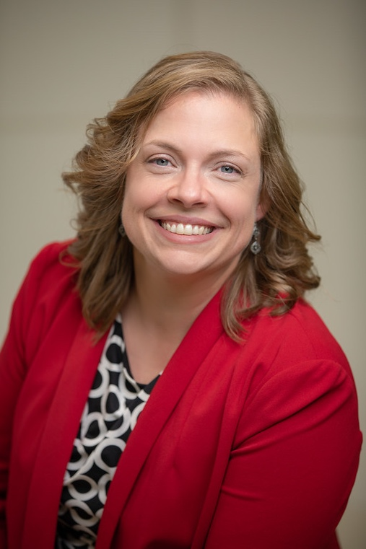
And the 2019-2020 Communication Studies Outstanding Student Award goes to...
Mary Kate Brown!
We are grateful for ALL of our diverse, talented, individual Communication majors and what you bring to our Department. Each year we have the difficult challenge of selecting just one person to receive the Outstanding Undergraduate Student Award. We are excited to present this year's award to Mary Kate Brown.
Among numerous accomplishments as a Communication Studies major, Mary Kate won the Tennessee Communication Association Outstanding Undergraduate Paper Award for her COMM 3100 paper, "Creating Value for Societal Outcasts in The Greatest Showman"; interned for The Center for Culturally Proficient Educational Practice; and became the Part-Time Executive Director of Transformation Nashville, a nonprofit organization committed to working with families facing economic challenges. She has also been active in extracurricular activities including Lambda Pi Eta, as President in 2019. During her studies at MTSU, Mary Kate developed her passions for intercultural communication, disability studies, and education advocacy, and will begin her M.Ed. in Learning, Diversity, and Urban Studies at Vanderbilt University this fall. We are excited for her continued journey and know she will make a difference!
In the words of Dr. Chevrette, "Mary Kate represents an outstanding level of academic excellence, skillful communication, commitment to serving her community, and global awareness. Her academic success as a non-traditional student, her commitments to equity, public engagement, and action, and her path of continued learning truly embodies MTSU’s excellence and the values that come with being True Blue."
Congratulations!

A note about the Facebook group: It is not “secret,” but it is private, so students will have to request to join.

Facebook: MTSU Comm Studies
Instagram: @mtcommstudies
Twitter: @mtcommstudies
Linkedin: MTSU Department of Communication Studies

The MTSU Debate Team makes us proud!

And the 2019-2020 Communication Studies Outstanding Student Award goes to...
In March, the MTSU Debate Team won big!

Mary Kate Brown!
We are grateful for all of our diverse, talented, individual Communication majors and what you bring to our Department. But each year we also have the difficult challenge of selecting just one person to receive the Outstanding Student Award. We are excited to present this year's award to Mary Kate Brown.
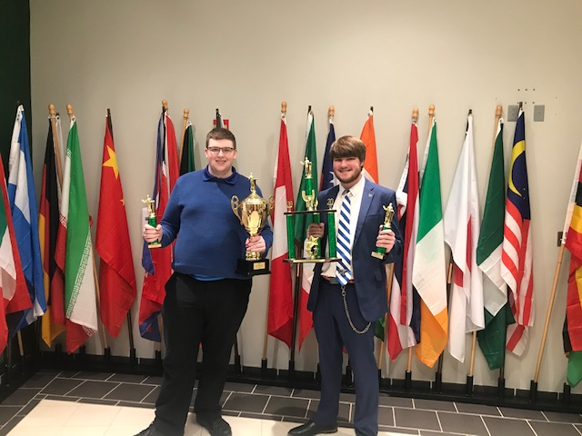
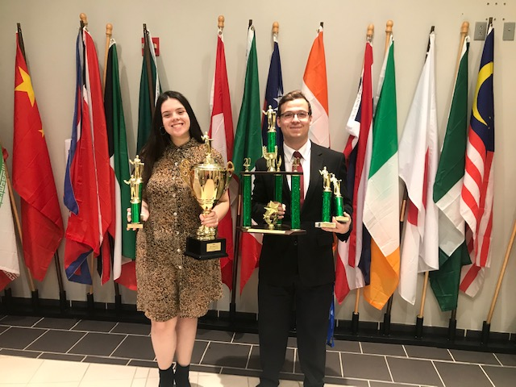
Among numerous other accomplishments as a Comm Studies major, Mary Kate won the Tennessee Communication Association Outstanding Undergraduate Paper Award for her COMM 3100 paper, "Creating Value for Societal Outcasts in The Greatest Showman"; interned for The Center for Culturally Proficient Educational Practice; and became the Part-Time Executive Director of Transformation Nashville, a nonprofit committed to working with families facing economic challenges. She has also been active in extracurricular activities including Lambda Pi Eta, as President in 2019. During her studies at MTSU, Mary Kate developed her passions for intercultural communication, disability studies, and education advocacy, and will begin her M.Ed. in Learning, Diversity, and Urban Studies at Vanderbilt University this fall. We are excited for her continued journey and know she will make a difference!
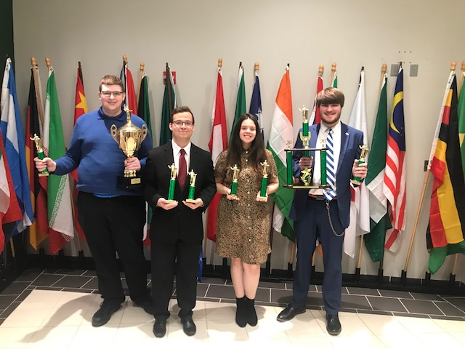
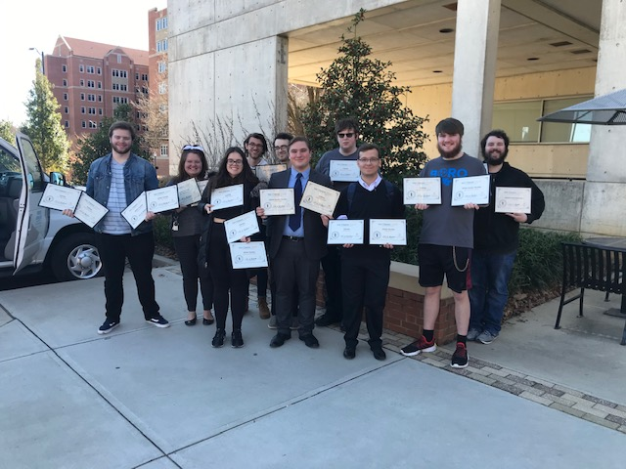
In the words of Dr. Chevrette, "Mary Kate represents an outstanding level of academic excellence, skillful communication, commitment to serving her community, and global awareness. Her academic success as a non-traditional student, her commitments to equity, public engagement, and action, and her path of continued learning truly embodies MTSU’s excellence and the values that come with being True Blue."
Congratulations!

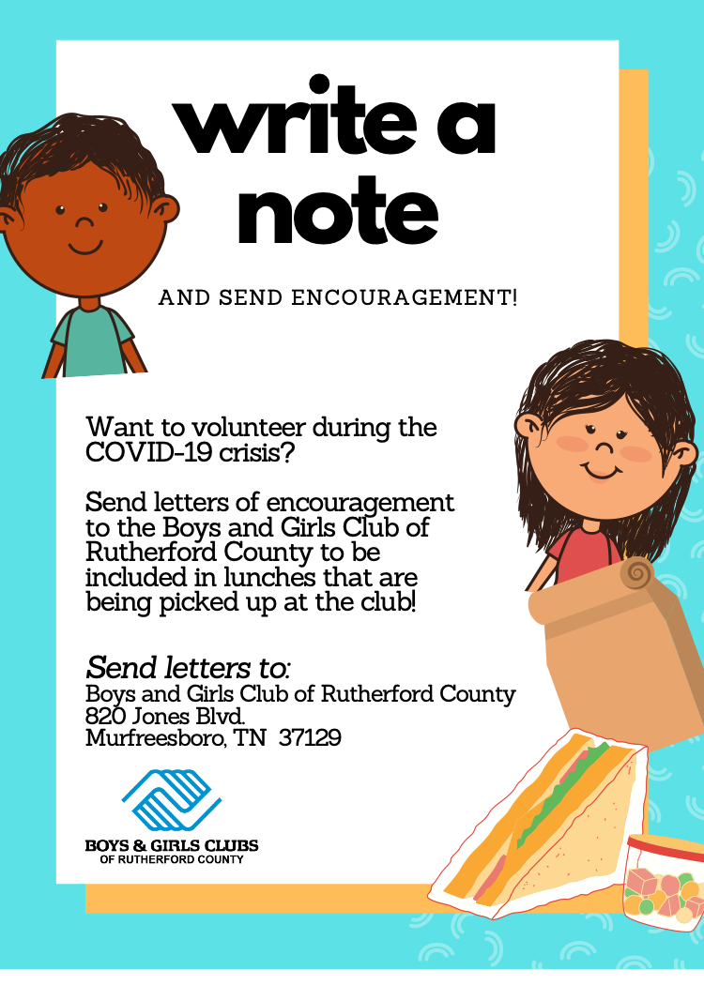
Communication Studies Club is an academic, social, and service organization meant to promote the Communication Studies program through philanthropic events and on-campus involvement, as well as benefit students within the program through networking and club activities. The CSC is open to all majors.
If you are interested in joining in the fall, please complete the Comm Studies Club interest form at https://forms.gle/KB1h6CxKfzYt6thb8 for updates and meeting info.
Additional questions can also be directed to Gaby Jaimes, President, or Advisor Dr. Priddis.

Lambda Pi Eta
The MTSU chapter of Lambda Pi Eta is Alpha Gamma Lambda. This is an honors society of the National Communication Association (NCA). The requirements to join are:
- Completed 60 semester credit hours
- A minimum overall cumulative GPA of 3.0
- Completed 12 semester credit hours in Communication Studies
- Have a minimum GPA of 3.25 for all Comm Studies courses
- Currently enrolled as a student in good standing
Check out https://www.mtsu.edu/communication/LPH.php for additional information and for an application for your life-time membership.
Get Involved

Dr. Andrew Dix was awarded the CLA Faculty Research & Creative Activity Award!

Please email Dr. Priddis at Deanne.priddis@mtsu.edu to add your announcement (new job, engagement, wedding, grad school, or other announcement) to our next newsletter

Dr. Xiaowei Shi just signed her first book contract with Lexington Books! The tentative title is Unquestioned Ease: Confronting Automaticity in Everyday Communication, and she is co-authoring it with Steven Mortenson.

Lori Kissinger is receiving the CLA Faculty Student Success Award!
Faculty Announcements

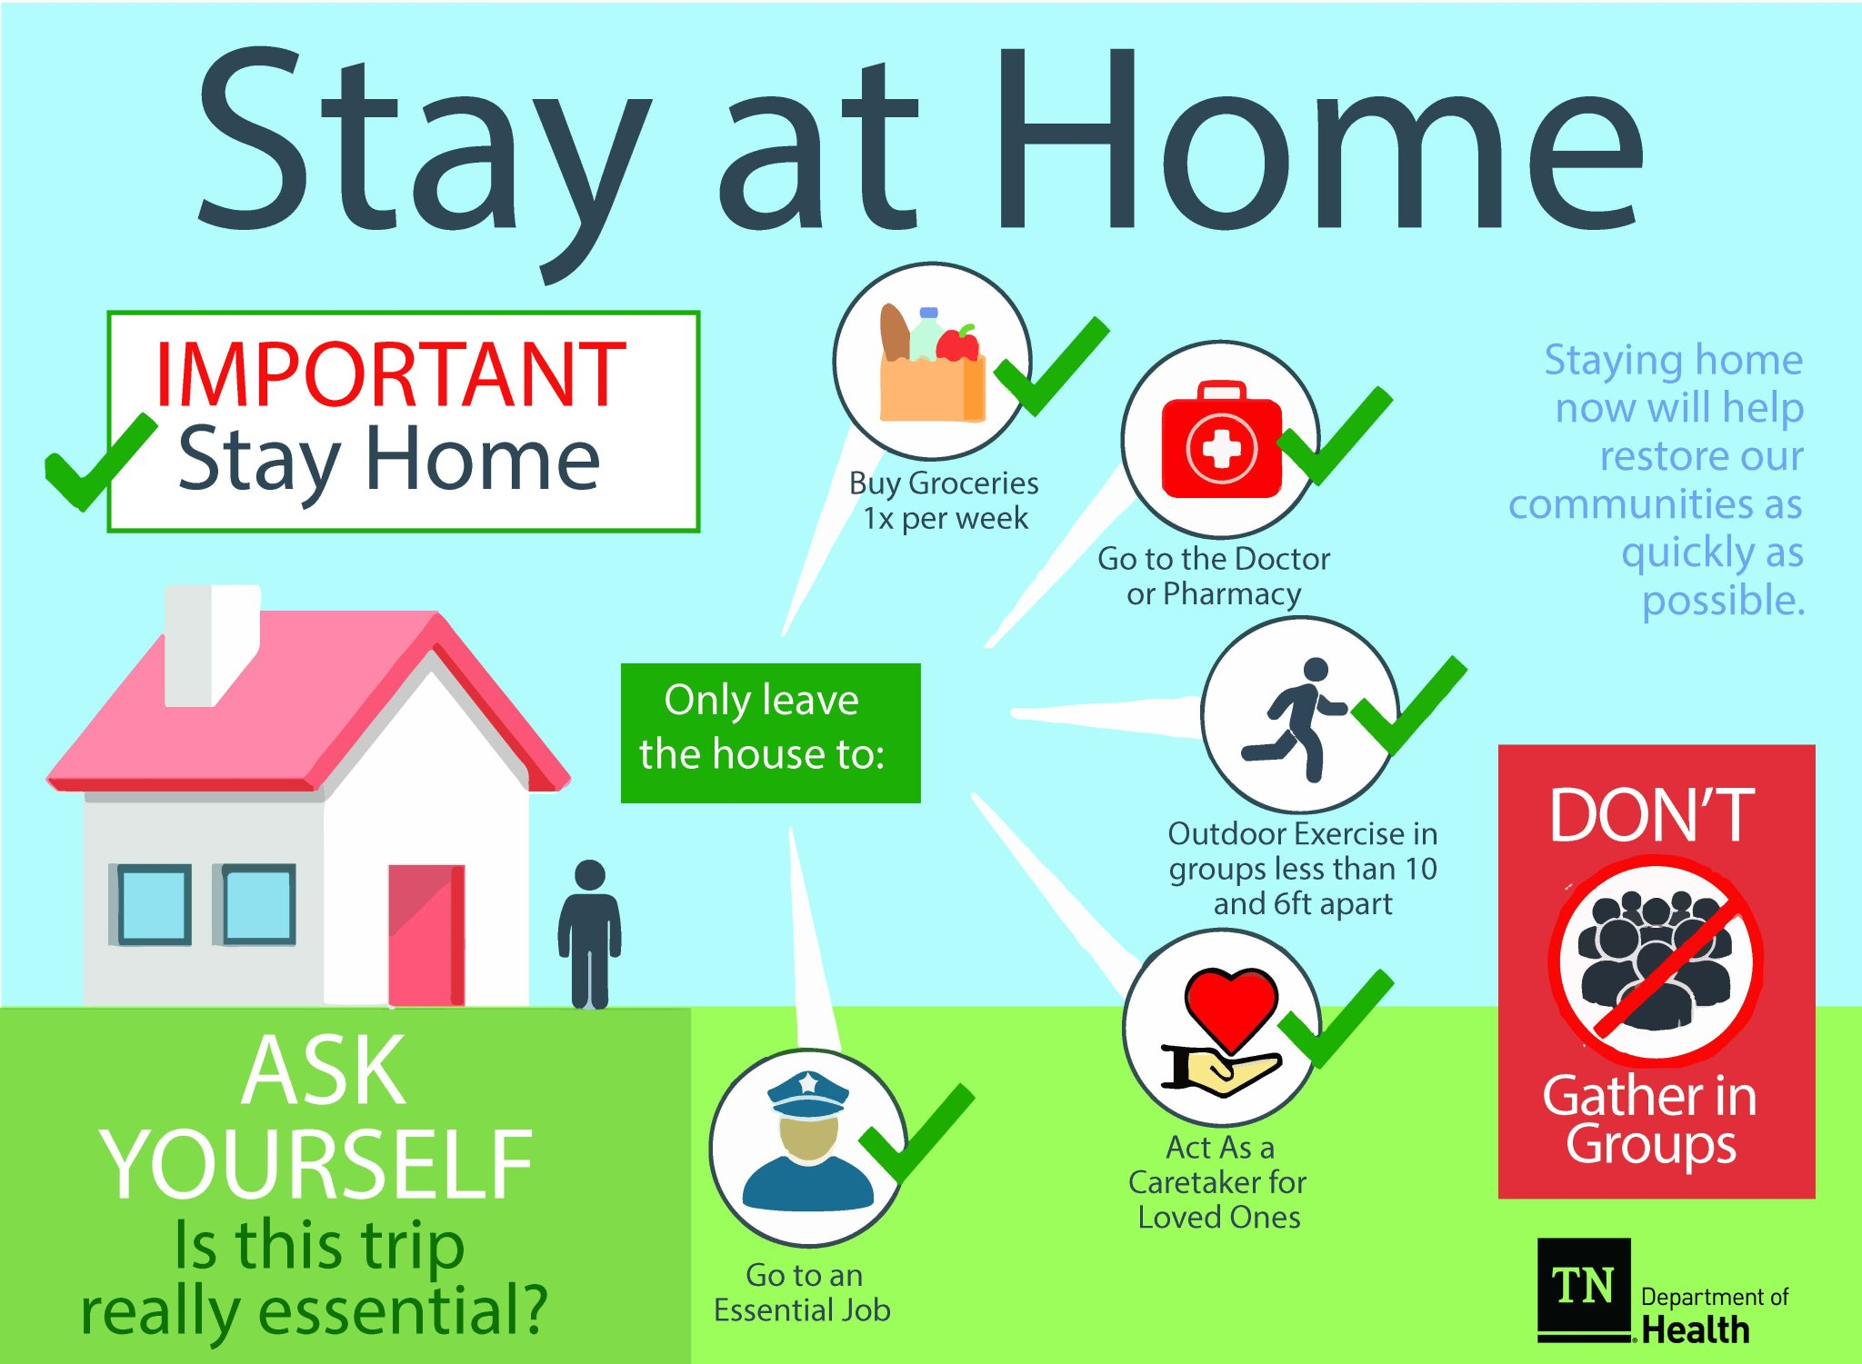

If you have anything you’d like to add to the next newsletter, contact Terry Barkley at tmb7g@mtmail.mtsu.edu.
Activity Ideas:
- Read a book
- Take a walk in your neighborhood
- Climb a tree
- Pillow fort and movies
- Bake bread
- Paint
- Make friendship bracelets
- Collage art
- Write a poem
- Pot a plant
- Sew an outfit or mask
- Games with roommates/family
Share your social distancing activities with Comm Studies social media!
Social Distance and Stay Safe!
Protect yourself and the community by staying home and practicing social distancing! Limit contact with those outside your household. Only go out for essentials. Use social media, or video calling to socialize. If going out, stay at least six feet apart from others.
Also practice healthy living by washing hands often, wearing a mask when going out, avoid touching your face, and cover mouth/nose when sneezing or coughing!
Find a way to get fresh air, exercise, and the sunshine.

