

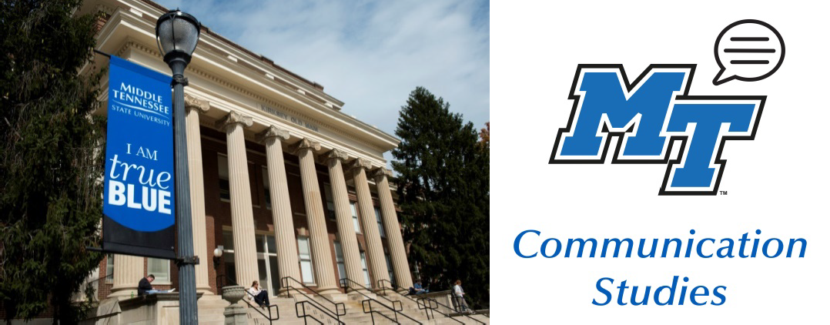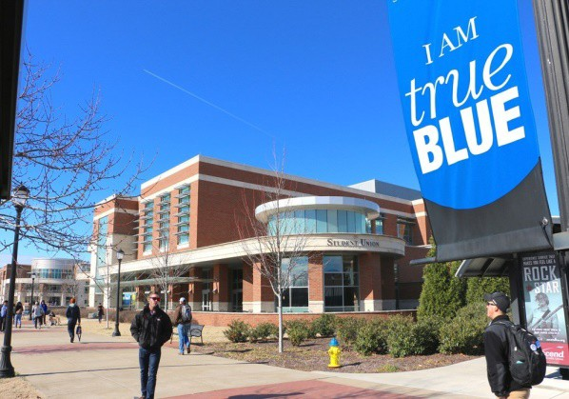

**April Dates:**

04/01 Annual Speech Contest @ Todd Hall 204 at 4:00 pm

04/02-4/04 LGBT+

Conference at MTSU

**Debate Dates:**

03/14-17 National Championship @ Tennessee Tech

**March Dates:**

03/03 Business Unplugged: Networking Night @ STU Ballroom 4:00-6:00 pm

03/20 MTSU hosts the *Irish Times* National Champions with public debate @ COE 160 1:00 pm

03/23 All-in-One Afternoon of Professional Development

@ KUC 324 4:00-5:30 pm

04/02 LGBT Conference Resume and Interview Session @ James Union Building, Tennessee Room 1:00-3:30 pm

03/28 Asian Student Conference

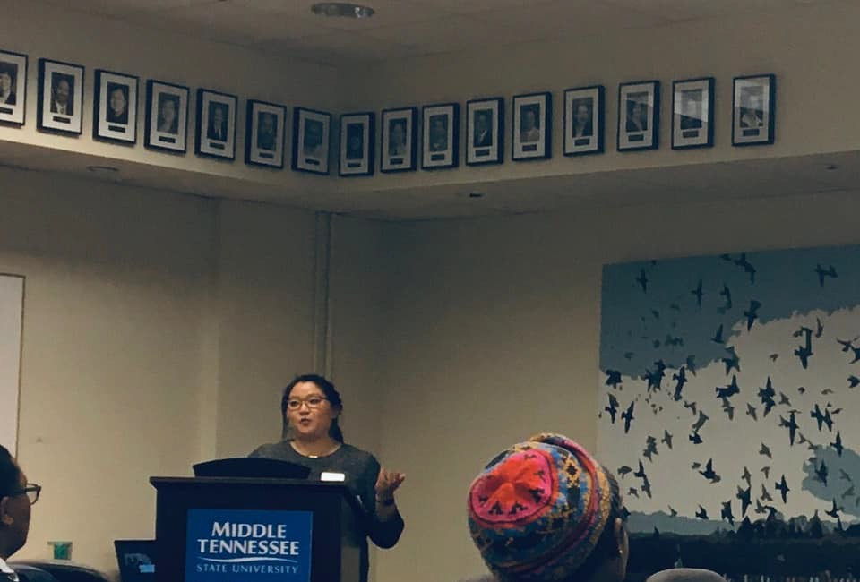

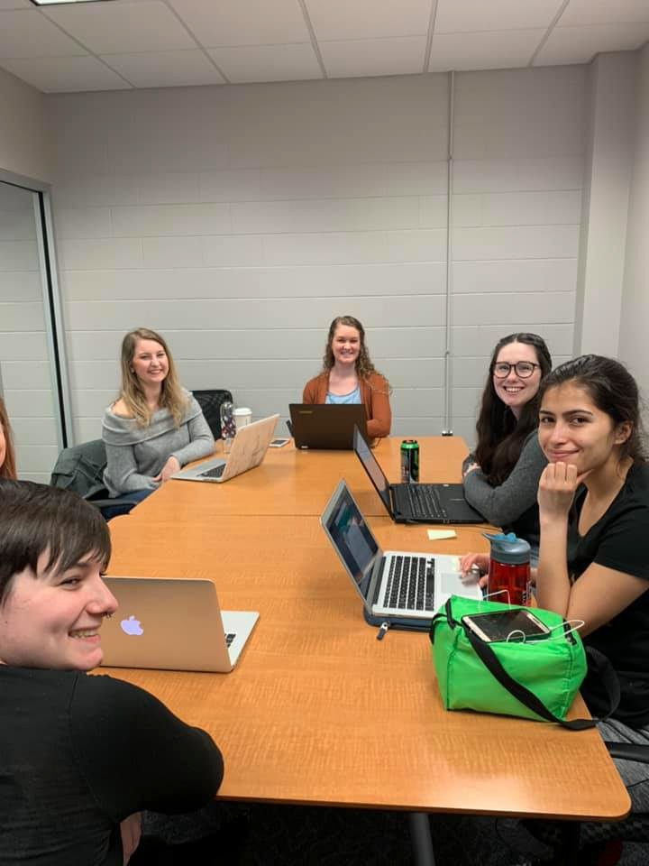

Dr. Scarlett Hester presented her research:

“I Ain’t Sorry: Discursive Style of the White Boy Anti-Apology” on February 20th from 3:00-4:00.

The MTSU Comm Studies Club hosted a LinkedIn Workshop on February 24th in which students worked on building a professional presence online.

Contact Gabby at [glj2r@mtmail.mtsu.edu](mailto:glj2r@mtmail.mtsu.edu) if you are interested in joining the club!

Watch for exciting new workshops and meetings from Comm Studies club.



The annual Communication Studies Dept. Speech Contest will be April 1st at 4:00 pm in Todd Hall room 204. Contestants will create and deliver an original persuasive speech to compete for cash prizes and awards. This event will be co-hosted by the College of Liberal Arts and is open to any current MTSU student who has completed or is enrolled in COMM 2200. For more info go to [http://www.mtsu.edu/speechcontest.](http://www.mtsu.edu/speechcontest)

Dr. McCormick is leading a session at the LGBT+ College Conference on April 2nd with a panel of corporate professional interviewers.

1:00pm - 3:30pm Concurrent Sessions Thursday, April 2, James Union Building

SESSION I - Interviewing Strategies for Success! Thursday, April 2, James Union Building Tennessee Room

Please join us for a highly interactive session designed to build your interviewing confidence! This session will include an overview of the importance of interview preparation in all its facets by Dr. Janet McCormick, Professor in Communication, along with inspiration and advice from professionals. We will provide key content and perspectives for students at any stage of the job/internship hunting process. You will learn the significance of research, questions, and the impact of your cover letter and resume, followed by interviewing skills needed to foster positive rapport.

Bring your resume or simply be ready to take notes. Our goal is to help you succeed!

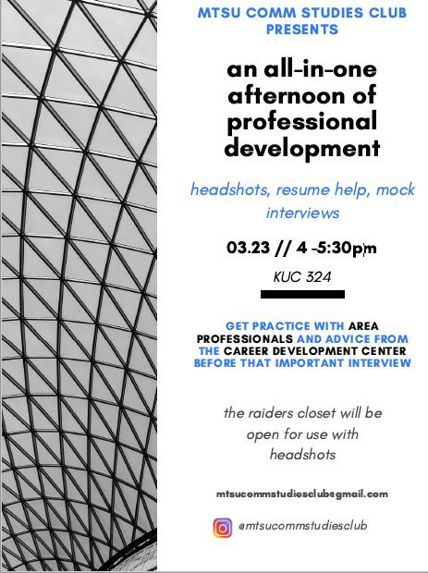

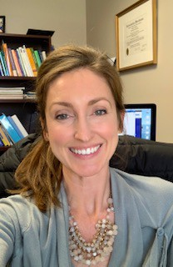

Dr. Betsy Dalton received her PhD in Communication & Information from the University of Tennessee, Knoxville in 2014 and joined the faculty at MTSU in 2016.

Her favorite things about MTSU students are the diversity, openness, and energy they bring to the classroom. Among Dr. Dalton’s favorite courses to teach are Intro to Health Communication, Intro to Organizational Communication, Sexual Communication, and Interpersonal Communication. She teaches both on-ground and online and is a big fan of discussion-based and case study approaches to learning.

As a researcher, Dr. Dalton’s current work focuses on communication in women’s health and nurse-patient relationships. She also loves working with marginalized populations to understand their unique needs and lived health experiences. Her favorite communication constructs to study are uncertainty, disclosure, trust, and sexual consent. Look for her latest research on trust in labor and delivery nursing coming out soon in the *Health Communication* journal!

At home, Dr. Dalton has a full, busy life with sons Will (6) and Stuart (4), daughter Fiona (1), and husband Rob. In her “spare time” she likes to be outside, especially at Radnor Lake near her home in Nashville. She is also an avid gardener and is going to try her luck with raspberries this spring. She does a lot of laundry as well. As a Nashville native, Dr. Dalton is fortunate to have a multitude of friends and family around to enrich her social life (and help with childcare).

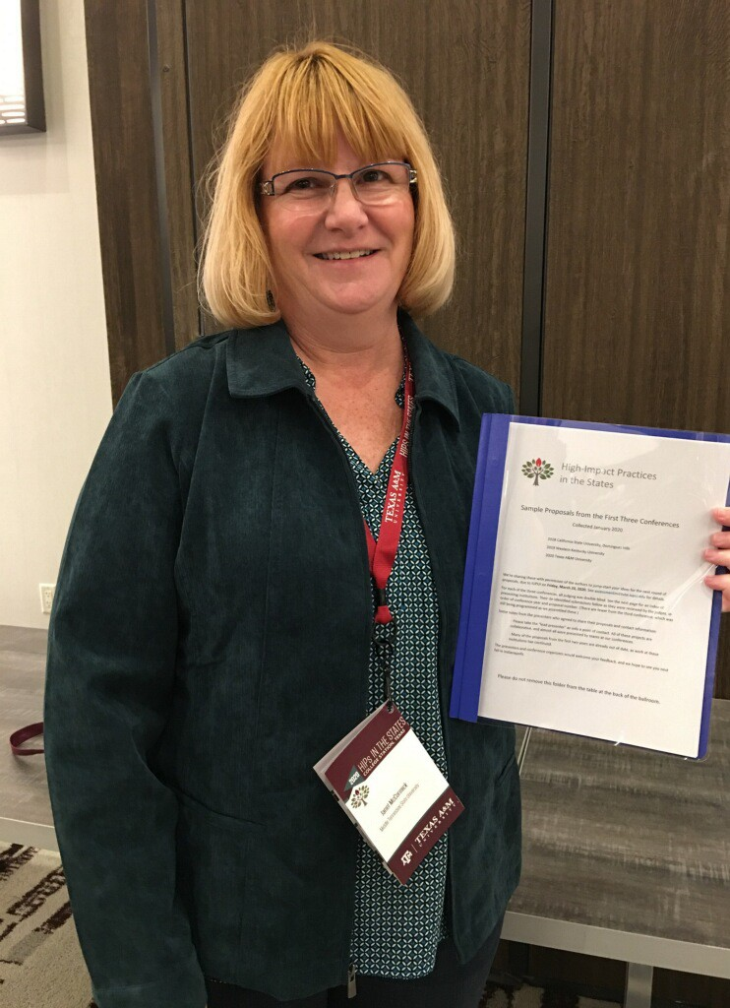

Dr. Yang Soo Kim’s *manuscript* “Adaptive personality, Communication Competence, and Psychological Health: An Exploratory Study of Cross- cultural Adaptation of Korean Expatriates in India” has been accepted for publication in the *Journal of Intercultural Communication*.

Dr. McCormick was one of four representatives from MTSU at the HIPs in the

States national conference at Texas A&M to share High Impact Teaching Practices (HIPs) with Carol Swayze, Mike Boyle, and Odie Blackmon.

Dr. McCormick’s contribution to the MTSU team’s program "Creating HIPs that Have a Lasting Impact" was to share 5-minute warm up techniques used daily in the Listening class (COMM 3050) following with 30 minutes of a highly interactive EXL demonstration.

Furthermore, they have been attending the HIPS conference for the last 4 years and at this conference in this year, McCormick, Swayze, and Blackmon were recognized as having one of the top three panels from ALL of the top panels in the last 3 years combined!

On Feb 15th Dr. McCormick presented *Powerful Listening* at the MTSU Bridge Leadership Summit



***40 th***

***Anniversary***

**This house values the environment over the economy.**

***Veneratio Pro Victoria***

**Thursday, March 20, 2020, 5:00 p.m.**

Doors open at 4:45 p.m., BAS 102 (State Farm Room)

**SUPPOR T ER S**

Department of Communication Studies League of Women Voters Communication Studies Club

College of Education College of Liberal Arts Office of the Provost

Office of International Affairs Irish Times

Pax Rhetorica

Center for Student Involvement and Leadership (CSIL) Student Government Association

0320-8835 / Middle Tennessee State University does not discriminate on the basis of race, color, national origin, sex, or disability. See our full policy at mtsu.edu/iec.

**MTSU DEBATE TEAM**

vs.

**IRISH TIMES NATIONAL DEBATE CHAMPIONS**

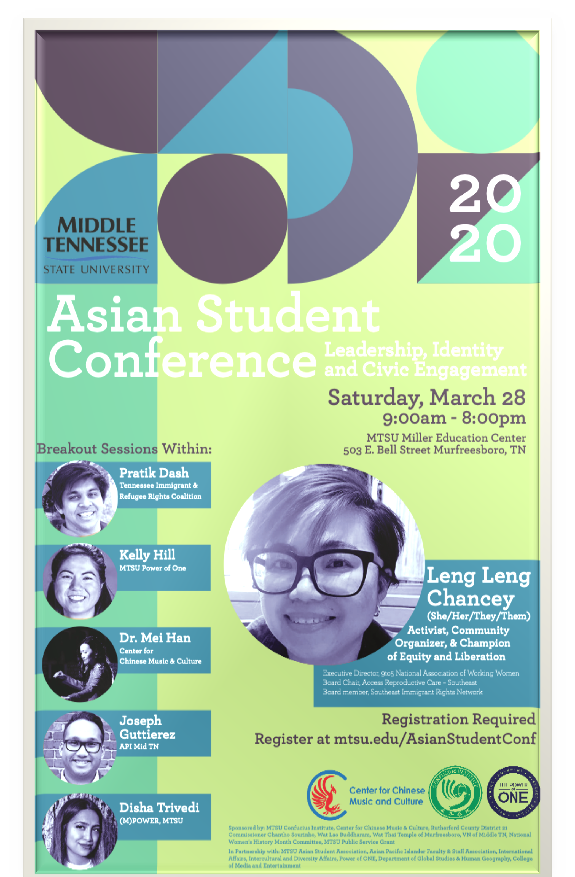





If you have anything you’d like to add to the next newsletter, contact Terry Barkley at [tmb7g@mtmail.mtsu.edu.](mailto:tmb7g@mtmail.mtsu.edu)

A note about the Facebook group: It is not “secret,” but it is private, so students will have to request to join.

**Facebook:** MTSU Comm Studies **Instagram:** @mtcommstudies **Twitter:** @mtcommstudies

**Linkedin:** MTSU Department of Communication Studies