

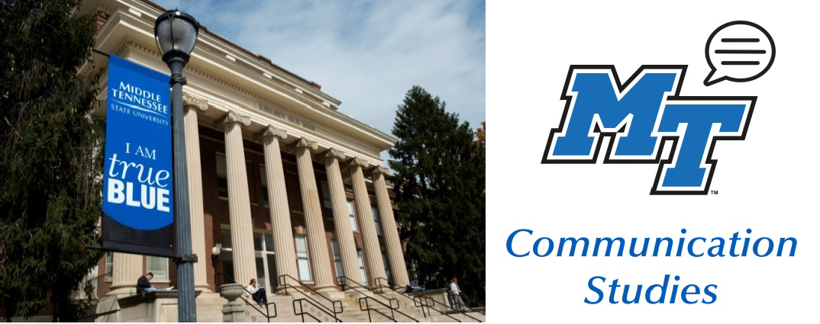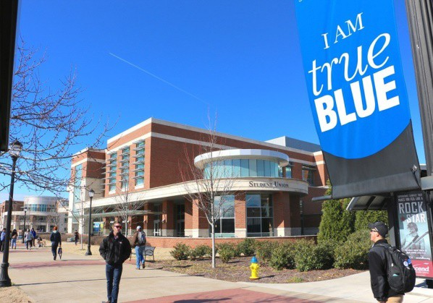

Features

Health Comm Concentration Faculty Spotlight Announcements

Video Conferencing Skills Graduate Announcements! COVID-19 Journals

Follow Social Media

•

•

•

•

•

•

•



The Communication Studies department is excited to be launching the new concentration in Health Communication this fall. If you’re not sure what Health Communication is, you don’t have to look very far to see it: You’ll see uncertainty in the faces of people shopping at the grocery store, and doctors walking into their shifts in the ER. You’ll see hospital administrators grappling with a shortage of personal protective equipment and how to convince staff that they are still valued by the organization. You’ll hear cutting-edge science being translated for a wary audience, where message framing to enhance public safety is everything. You’ll see people dropping off toilet paper on neighbors' front porches in acts of social support. You’ll wonder if that tweet about drinking hot stuff is true, and whether it’s worth retweeting. You might Google something, then wish you hadn’t. And you’ll hear stories about nurses reassuring frightened patients when no one else can be there.

These issues have come sharply into focus in recent days, but always have and always will exist in some form or another. Health Communication brings the skills, concepts, theories, and processes we talk about in our core communication classes and uses them to advance health and wellbeing. Courses such as Health Communication Technology & Social Media, Communication in Healthcare Organizations, The Dark Side of Health Communication, Patient-Provider Communication, and Social Support Communication will prepare students for successful careers in a variety of health-related fields and areas of graduate study. Classes will involve hands-on learning and community-based activities that fill both minds and résumés with valuable experiences.

With our new Health Communication concentration, you'll have the skills necessary to succeed in careers such as health administration, public health, crisis and risk management, health education, patient advocacy, care coordination, and more. Not sure if it’s for you? Check out

Intro to Health Comm (COMM 2400) with Dr. Dalton this fall on M/W at 12:40

OR

Relationships in Health Comm (COMM 3110) With Dr. Hoskins on M/W at 2:20

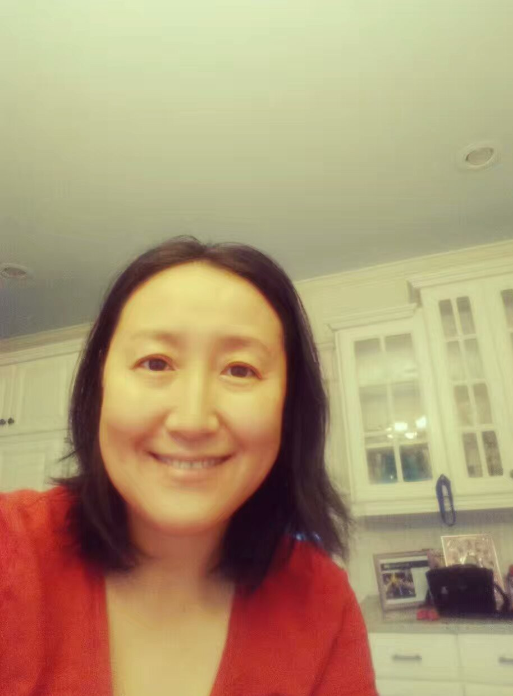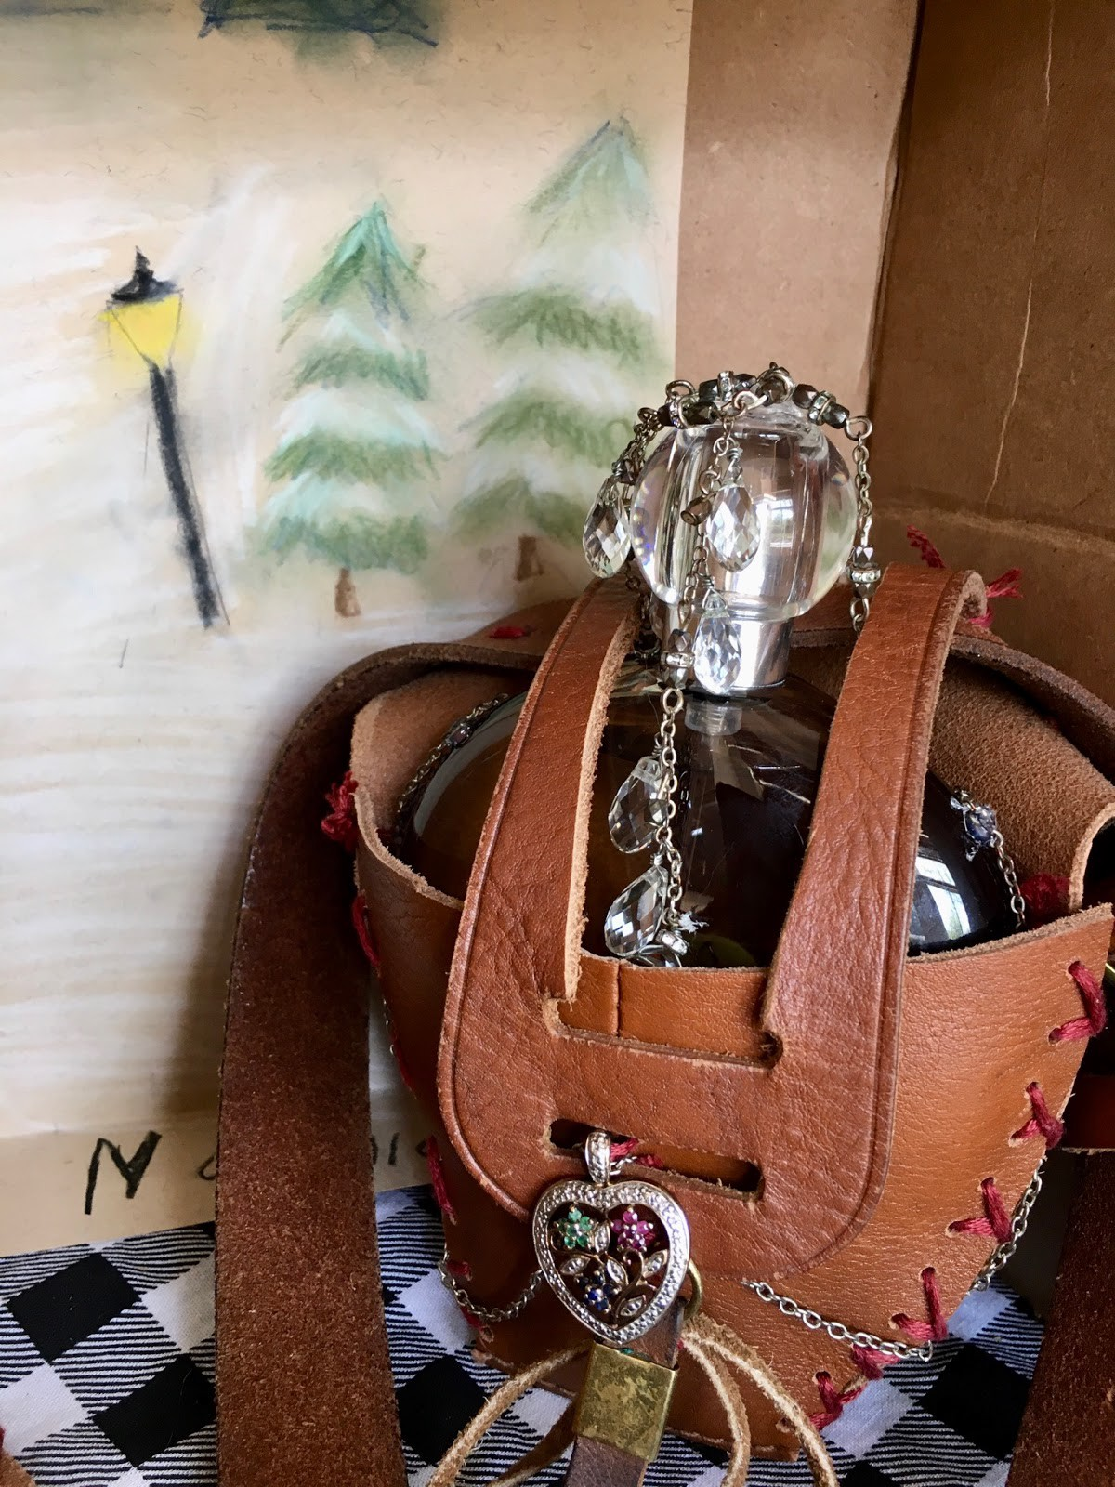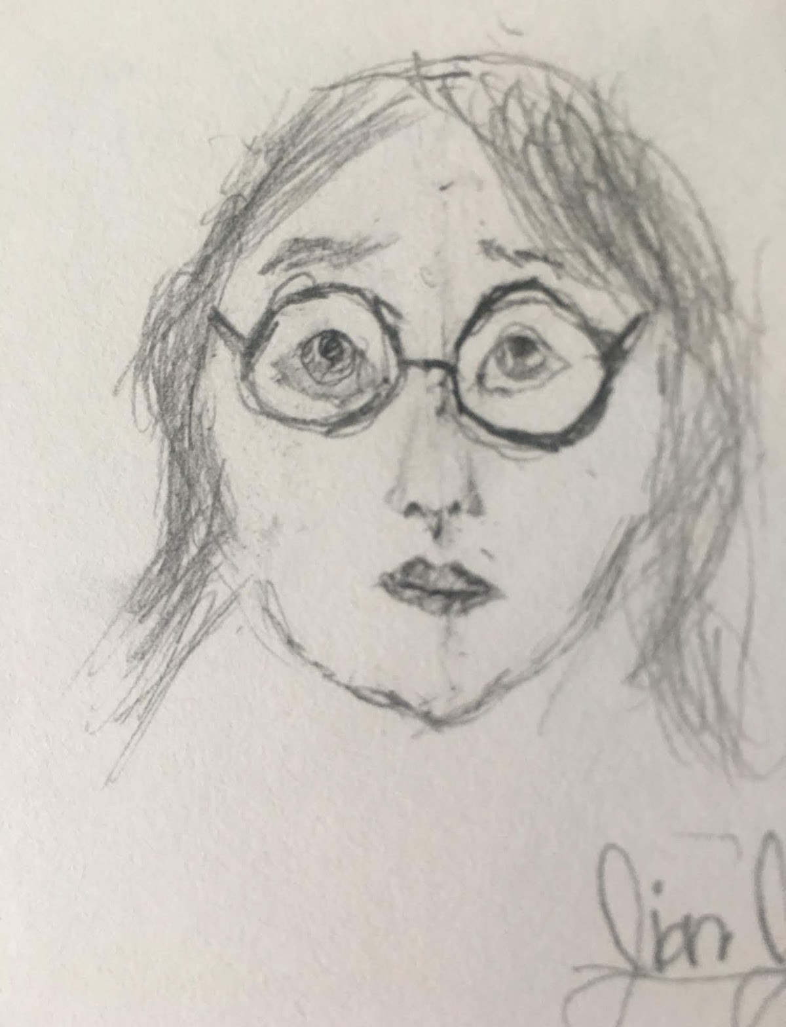

Faculty Spotlight: Dr. Xiaowei Shi

Dr. Shi loves Murfreesboro and feels grateful for being part of the MTSU community. She and her family moved here in 2010. She is always happy to see her students, colleagues, and friends at MTSU, day in and day out over the past 10 years. Dr. Shi likes to travel and do crafts together with her daughter, JianJian. Her most recent project is “Lucy’s Cordial in Narnia” for her daughter’s 10th birthday (see picture attached).

Dr. Shi has taught courses in Communication Research Methods, Romantic Relationship Communication, Interpersonal Communication, and Strategic Communication in Organizations. She is an affiliated faculty member in the Business and Economic Research Center at Jones College of Business. Her research interests focus on influence and supportive message production in the contexts of professional and close relationships.

As an instructor, she cares about the overall well-being of her students. In her teaching, she aims to raise students’ interests in studying communication, challenges them to think critically and creatively, and supports them with a loving heart. She has directed two major students’ research projects, including URECA grant on feminism communication study and National Communication Association (NCA)’s Undergraduate Honors Conference Presentation on leadership styles and group effectiveness.

Dr. Shi has established a solid record of publications. Her research findings have been cited over 200 times in peer publications and have earned her four “Top-4–Paper” Awards from the National Communication Association during 2011-2016. Recently she signed a book contract with Lexington Books. This summer she will work on this book, “Unquestioned Ease: Confronting Automaticity in Everyday Communication” with her coauthor, Dr. Mortenson, from University of Delaware.

She wishes everyone a healthy and productive summer ahead!

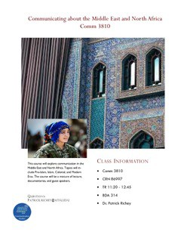

Announcements

Dr. Richey is teaching a new class “Communicating about the Middle East and North Africa” COMM 3810.

Check it out!

Carlie Cowan has a paper/poster accepted for Scholar’s Week. It is titled “The Rhetoric of Fortune’s Speech to Daniel ‘Rudy’ Ruettiger in the film *Rudy*. Her faculty mentor is Dr. Richey. See: https://mtsu.edu/scholarsweek/posters/college .

Dr. Andrew Dix was awarded Tenure!

He was also promoted to Associate Professor which begins August 2020. Congratulations Dr. Dix!

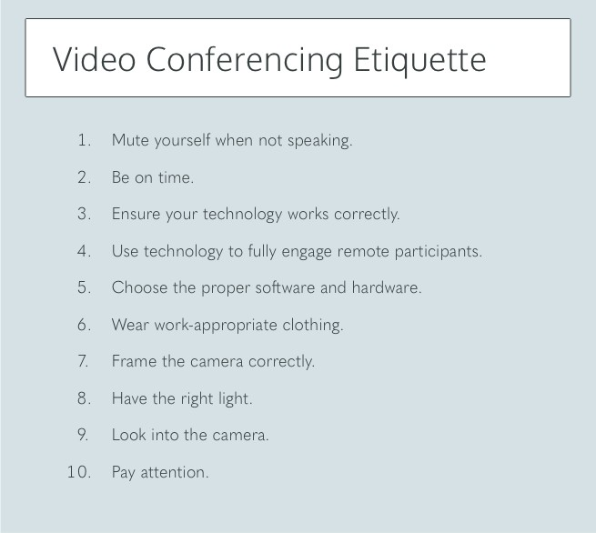

Reprinted from: https://[www.owllabs.com/blog/video-conferencing-etiquette](http://www.owllabs.com/blog/video-conferencing-etiquette)

See the article ***17 Video Meeting Mistakes That Are Making You Look Deeply Unprofessional*** when using Zoom and other video conferencing tools at: https://fairygodboss.com/articles/17-video-meeting-mistakes- that-are-making-you-look-deeply-unprofessional?utm_source=email- transactions&utm_medium=email&utm_campaign=community-missed-notification

In addition to the tips above:

Be well groomed, sit up straight, have an uncluttered and appropriate background, and turn on ‘do not disturb’ on your computer to avoid notifications.



Congratulations Graduates

MTSU Class of 2020!

Scott Austin Terry Barkley Janel Benton Grace Bolden Roy Briscoe

Gershunda Brown Mary Kate Brown Allie Burge Madison Callahan Ty Collier Demaries Curry Christian Feaster Jazzmine Fuentes Rissa Hall

Emily Hamby Ryan Hammonds Lauren Harrington Lea Harrington

Katherine Harrison

Natalia Jiron

Brianna Judd Alyson Lawrie Manuelle Lempin Annie Lombard Troy Marks Ontario McGregor Brianna Miller

Savannah Richardson Janice Robinson

Ally Rogers Kristen Rowesy Brian Schulist Hannah Stafford Jessica Ulinger Grace Vander Werf

Andrea Vazquez Bryana Wilson

Communication Minors:

Kaitlyn Demonbreun Stephanie Van Horn

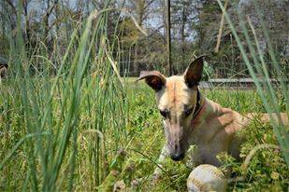

COVID-19 Journals: We Asked, You Answered

What is 1 new thing that you have enjoyed doing since we have been in quarantine

surrounding COVID-19?

“seeing my family all convert to our normal circadian rhythm. I now know we're all night owls! (That's why we're all so grumpy every morning!)”- Natonya Listach

“I have very much enjoyed running almost every day without fail, and not using an alarm clock!” - Dr. Roberta Chevrette

“I have enjoyed listening to audiobooks and working puzzles. I have also enjoyed catching up on all serial killer shows and documentaries so that, if needed, I can plan the perfect murder. Kidding! Or am I…. ? :-)”-Dr. Mary Beth Asbury

“I’ve enjoyed baking/cooking more and experimenting with new recipes. I’ve been cooking a lot more Korean and Indian food!” - Dr. Scarlett Hester

“Teaching at three high schools, I especially enjoy hearing from so many students via text and phone calls. My cell number is always on every syllabus, but students are often hesitant to call me and sometimes say, "I hate to bother you" and I have to explain they are NOT a "bother!" But especially the first couple of weeks we were quarantined, exponentially more students (mostly the A-range students) called and sent questions day and night by text because they wanted to make sure they would ace the rubrics or understand things which I normally explained more fully in class. Or maybe they were just lonely

and wanting a little socialization rather than distancing!” - Jeri Burnett

“I have given my dogs a lot more walks and attention during the work at home time.” - Dr. Heather Hundley

“My one new thing is Sophie! She is a rescue from al the Florida greyhound tracks closing at the same time because of COVID-19. We started out as her foster family training her to live in a house and to figure out the world as a pet, but we failed as fosters and we are adopting her ourselves. She has found her forever home.” -Nathan Wahl

“not having to feel guilty about not working. I think I need to work but it had been nice to have a break from work and focus

on school and myself mentally.” – Alec Tillman

“Time in much bigger garden.” – Dr. Patrick Richey

“playing the guitar (not necessarily well though)” – Terry Barkley “1 season of Law and Order per week” -Grace Cadle

“having time to slow down and rest”-Nicole Freeman “spending more time with my brother” -Jesse Penland “Seeing all my neighbors on our daily walks” – Katie Gruber

“doing my classwork with my dogs right beside me!!” – Alli Hobbs

“being able to catch up on school work at my own pace” Kaley Walker

“saving money on gas!”- Dr. Betsy Dalton

“an increase in outdoor walks”- Grace Bolden

“getting to spend more time with my family”-

Carlee Cowan

“having time to cook breakfast every morning”-

Gaby J

“reconnecting with friends through virtual card games and happy hours” – Dr Dee Priddis

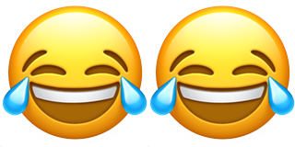

What is the 1 thing that you do NOT miss the most since we have been in quarantine surrounding COVID-19?

“Commute from Nashville to campus- what a time suck!” -Katie Gruber “Wearing anything besides sweatpants”- Dr. Betsy Dalton

“Grocery shopping and sometimes going to more than one store”- Dr. Dee Priddis

“I am desperate for a night at a restaurant. I do not care for cooking and always look forward to one or two nights of sitting

down at a restaurant. I have not even felt comfortable doing drive through. So....I would give big money even to just sit dow

at a McDonald's....ha.” - Lori Kissinger

“I don’t miss having to fill my car with gas!” - Dr. Scarlett Hester

“I don't miss the rush of business every single day. While we're still busy, it's much calmer without having four different schedules to follow.” - Natonya Listach

“I don't miss getting hit by tornados, as that was my life immediately before quarantine.” - Dr. Roberta Chevrette “trying to find a parking place on campus! :)” - Jeri Burnett

“I don't miss parking on campus and walking in the rain to class.” - Dr. Heather Hundley “Not fighting for parking 😂😂” - Dr. Patrick Richey

“I don’t miss the traffic in Murfreesboro” -Nathan Wahl “I don’t miss waking up early” -Lexie Thomas

“waking up early” -Terry Barkley

“spending 30 minutes looking for a parking spot”- Laccie Woodall “I don’t miss work clothes”- Dr. Betsy Dalton

“the struggle for parking on campus at 9am.”- Nicole Freeman “getting to wear my pajamas less” -Gaby J

“wondering what to expect everyday as far as weather goes.”- Carlee Cowan “group projects”- Grace Bolden

“finding a parking spot”- Alli Hobbs

“my drive to campus and having to find parking places” – Alec Tillman “the parking”- Jesse Penland

“running on a clock schedule day to day”- Kaley Walker

“leaving the house before noon”- Grace Cadle





The Comm Studies Office is being remotely staffed. Please contact Holly Kleiss at [Holly.Kleiss@mtsu.edu](mailto:Holly.Kleiss@mtsu.edu) or 615-898-2275 or Dr. Hundley at [heather.hundley@mtsu.edu.](mailto:heather.hundley@mtsu.edu)

Your Comm Studies professors are working from home and are available through email, phone, or Zoom. Please see https://[www.mtsu.edu/communication/index.php](http://www.mtsu.edu/communication/index.php) for additional information.

First Place – Joseph Howard Second Place – Jack Lockett Third Place – Pierce Creighton Fourth Place – Eliza Corder

Fifth Place – James McCampbell

Thanks to everyone that began following us on Facebook and Instagram and posted to the COVID-19 Journal.

**Winners:**

Grace Bolden Lexi Thomas

Nicole Freeman Kaley Walker

]



A note about the Facebook group: It is not “secret,” but it is private, so students will have to request to join.

**Facebook:** MTSU Comm Studies **Instagram:** @mtcommstudies **Twitter:** @mtcommstudies

**Linkedin:** MTSU Department of Communication Studies

MTSU Public Service Announcement:

MTSU Graduate Studies is TEMPORARILY offering a $1 application fee (which is normally $35) to help support our prospective students during the COVID-19 crisis. We are also waiving admission tests (GRE, GMAT, etc.) for many of our programs. A full listing of participating programs can be found here: https://mtsu.edu/graduate/gre-waivers.php . This only applies for summer and fall 2020 start terms.