Middle Tennessee Consumer Confidence Index
September 24, 2010

The Office of Consumer Research
at Middle Tennessee State University
Director -- Timothy R. Graeff, Ph.D.

"Consumer Confidence Falls Heading into Autumn”

Confidence among Middle Tennessee consumers has waned since June of this year. This is a reversal of the positive trend in confidence that began earlier this year. The overall confidence index dropped to 76 from 102 in June. This negative shift in feelings about the economy was due to eroding perceptions of the current economy, continued concerns about the job market, and a decline in the purchasing index.

Negative perceptions of the current economy continue to put a drag on consumers’ sentiment. The current situation index moved downward to -93 from -86. The negative score indicates that the percentage of consumers who hold negative views of the current economy is still larger than the percentage of consumers who hold positive views of the current economy. The last time that the current situation index was in the positive range was back in February of 2008. Consumers have experienced more than two years of morose feelings toward the U.S. economy.

The future expectations index remained relatively stable, rising only one point to 99 from 98. The fact that the future expectations index is positive indicates that consumers still hold out some hope for an economic turnaround, even if they do not expect an immediate rebound in the economy. However, the lack of a significant uptick in positive feelings about the future of the economy might not bode well for consumer spending as we look forward to the ever important holiday season. The future expectations index has never been in the negative range since these surveys began in 2000. Its lowest level was 11 in May of 2008.

The purchasing index fell to 70 from 90. This reflects consumers’ continued apprehension regarding spending money in times of economic uncertainty.

The current poll of 309 randomly selected adult residents of Davidson, Rutherford and Williamson counties was conducted the evenings of Monday, September 20 and Thursday, September 23.

The Middle Tennessee Consumer Confidence Index and Components

 | Oct  ‘08 | Dec  ‘08 | Feb  ‘09 | Apr  ‘09 | May  ‘09 | Sept ‘09 | Dec ‘09 | Feb  ‘10 | Apr ‘10 | Jun ‘10 | Sept ‘10
Overall Cons. Conf. Index | 1 | 4 | -66 | 105 | 113 | 142 | 83 | 53 | 99 | 102 | 76
Current Situation Index | -57 | -109 | -160 | -121 | -118 | -107 | -101 | -125 | -99 | -86 | -93
Future Expectations Index | 59 | 56 | 21 | 109 | 110 | 143 | 94 | 106 | 117 | 98 | 99
Purchasing Index | -1 | 57 | 73 | 117 | 121 | 106 | 90 | 72 | 81 | 90 | 70

The consumer confidence index scores are based on consumers’ responses to eleven questions measuring their perceptions of the current economy, the future economy, jobs, personal finances, and whether or not now is a good time to make large purchases. Four questions make up the current situation index, four questions make up the future expectations index, and three questions make up the purchasing index. The overall confidence index is based on all eleven questions combined.

The scores for each index are computed by adding the percentage of favorable responses to each question and subtracting the percentage of negative responses to each question. A score of zero would indicate that the percentage of consumers who hold negative views of the economy is equal to the percentage of consumers who hold positive views of the economy. A positive score would indicate that the number of consumers who hold positive views of the economy outnumber those who hold negative views of the economy.

Current Situation

The current situation index remains firmly stuck in the negative range indicating that consumers recognize that the current economy is still in bad shape. The percent of local consumers who said that business conditions in the country as a whole are “good” dipped to 5 from 7. Views of the local Middle Tennessee economy showed a similar negative change. The percent who said that business conditions in Middle Tennessee are “good” dropped to 20 from 25.

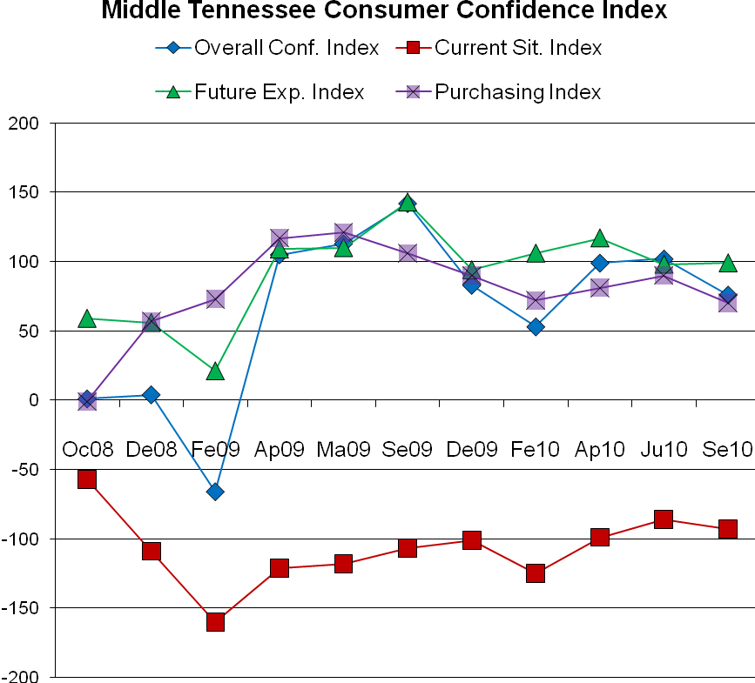

Employment and the Job Market

Local consumers remain very concerned about the labor market and the difficulty that many people are experiencing finding jobs. Hardly any local consumers (3 percent) said that jobs in Middle Tennessee are “easy to find.” The majority (51 percent) said that jobs are “hard to find.”
There is also decreasing hope that the local job market will improve soon. The percent who said that there will be more job openings in the next six months remained relatively stable, decreasing only two percent to 35 from 37. Similarly, the percent who said that there will be fewer job openings in the next six months edged upward slightly to 12 from 10.

Personal Finances

Expectations regarding personal finances can have a significant effect on consumers’ purchasing decisions. Fortunately, we see some positive change in this area. The percent who said that compared to a year ago they are “better off financially” improved to 17 from 12. The percent of consumers who feel that they are “worse off” financially than they were a year ago remained relatively steady, moving down slightly to 30 from 31. Optimism for the future might be growing, though. The percent who said that in the next 12 months they will be “better off financially” improved significantly to 40 from 26.

Purchasing Index

Even though consumers might be gaining optimism regarding their future financial situations, they still have reservations about spending large amounts of money in the current economy. The percent of consumers who said that now is a good time to make large purchases for the home dropped to 32 from 36. Similarly, the percent who said that now is a good time to buy a car also fell to 38 from 46. However, the percent who said that now is a good time to buy a home rose to 68 from 63.

Taxes

When consumers must pay more in taxes they have less money to spend on consumer purchases. When asked to predict whether their overall level of taxes will increase, decrease, or stay the same in the next year, a solid majority of consumers (66 percent) expect to pay more in taxes. Such expectations can have a dampening effect on consumers’ desire, willingness, and ability to make consumer purchases.

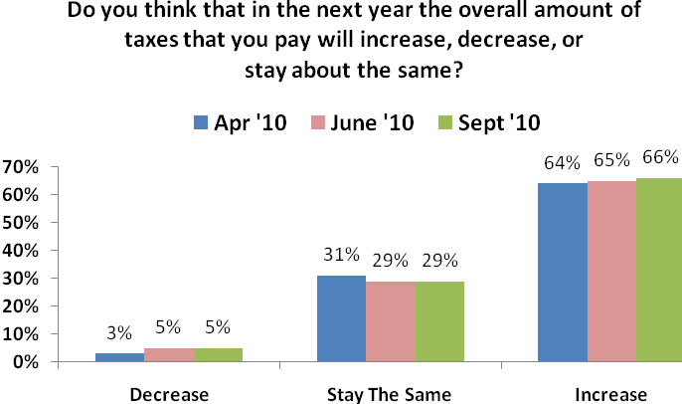

Consumer Investments: The Stock Market

In addition to income from employment, consumers also make spending and budgeting decisions based on their overall level of wealth. As investments grow, consumers feel wealthier. Alternatively, as investments shrink, consumers feel less wealthy. Consumers were asked whether they expected the stock market to be higher 12 months from now, lower, or remain about the same. Of those who responded, only 13 percent expect the stock market to decrease in value in the next 12 months. Almost half, (49 percent) of consumers expect the stock market to increase in value in the next 12 months. This is a sharp increase compared to June when only 36 percent expected the stock market to increase. And, this could partly explain the increase in the percent of consumers who expect their personal financial situation to improve in the next 12 months.

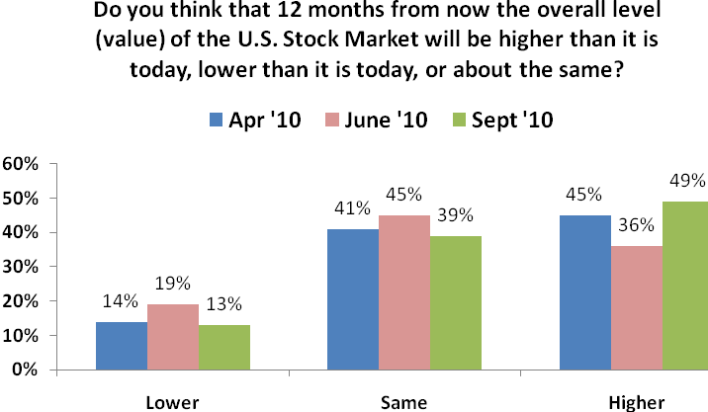
The Bottom Line: Consumer Spending

A key question for local retailers is whether or not this continued pessimism regarding the U.S. economy will have a depressing effect on consumers’ desire to spend money. Unfortunately, negative views of the current economy and continued fears about the current job market suggest that even if some consumers decide to increase their level of spending, many consumers might keep a tight grip on their wallets a little while longer. Decreases in the purchasing situation index indicate that many consumers will remain cautious when it comes to making purchase decisions and spending money.

When asked about their overall level of consumer spending, only 24 percent expect to spend more than they did last year. This is an increase from June when only 19 percent expected to increase their spending. However, the percent of consumers who expect to reduce their overall level of consumer spending also increased slightly to 35 from 33 in June. Even though this does not offer much hope for local retailers (more consumers expect to decrease their spending than increase their spending), it does suggest that some local consumers have not completely given up on consumer spending. Whether or not these consumers actually increase their spending from last year remains to be seen.

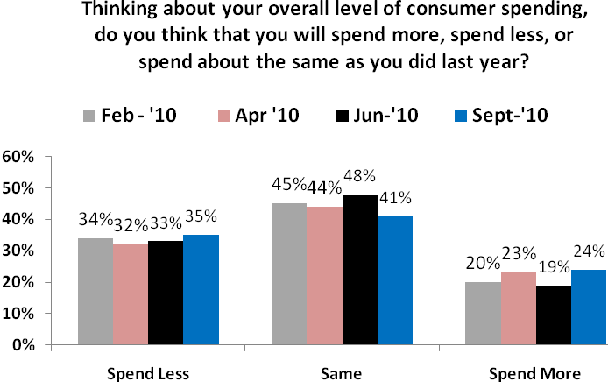

In sum, any hopes that consumers have for a quick economic turnaround are tempered by their negative views of the sluggish current economy, concerns about the tight job market and fears of higher taxes in the future.

Consumer Saving

Consumers were also asked about their current level of saving compared to their level of saving before the recession began. Although some consumers (22 percent) are saving more now than prior to when the recession began, an even greater number of consumers (37 percent) are saving less.

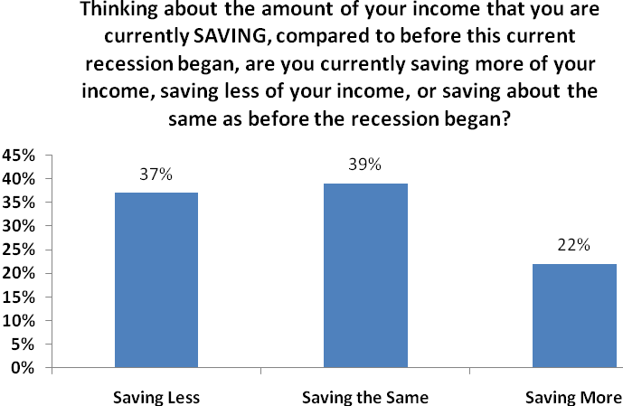

Consumers were also asked to look ahead and predict their level of saving after the current recession ends and the economy strengthens. Almost half (47 percent) expect to save more of their income than they are currently saving. Relatively few (9 percent) expect to decrease their level of saving. This suggests that some consumers who would like to be able to save a greater amount of their income are currently unable to do so. Perhaps the current economic slowdown has revealed to consumers the importance of having a secure nest egg for retirement as well as an emergency fund for weathering tough economic times.

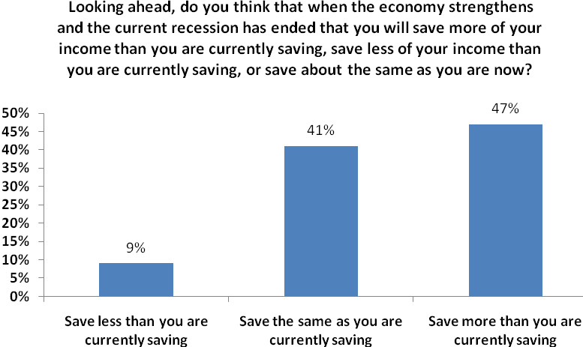

Who Will Save More in the Future?

It is also interesting to note the comparisons in expectations for saving across consumers. Of those consumers who are currently saving more of the income than prior to the recession, almost half (46 percent) expect to increase their level of saving after the economy strengthens. Alternatively, of those consumers who are currently saving less of their income than prior to the recession, almost two thirds (62 percent) expect to increase their level of saving after the economy strengthens. Apparently, those who are unable to save now recognize the value of saving and expect to increase their level of saving when they can – i.e., when the economy strengthens. Very few consumers expect to decrease their level of saving after the economy strengthens and the current recession has ended.

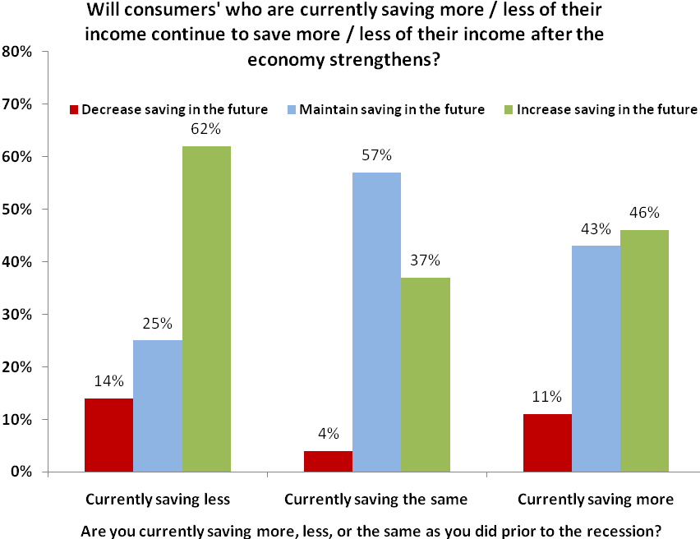

Perceptions of the Economy: Comparison To The Nation

Compared to consumers across the country as a whole, local consumers have traditionally held more positive perceptions of the economy. Even though local consumers have slightly more negative views of the current economy and the current job market, local consumers are relatively more optimistic about the future of the overall American economy, are more optimistic about the future of the job market, and are more optimistic about their personal financial situation in the next year. The table below illustrates some of these differences in consumers’ responses to selected survey questions.

 | Nation  (%) | Mid.  Tenn.  (%)
Business conditions in the U.S. are good. | 9 | 5
Six months from now, business conditions in the U.S. will be better. | 17 | 33
Jobs are easy to find (plentiful). | 4 | 3
Six months from now, there will be more job openings. | 15 | 35
In 12 months my personal financial situation (income) will be better. | 11 | 40

The Psychology of Consumers

The psychology of consumers can have dramatic effects on the future of the economy. Consumer spending makes up two-thirds of the American economy. Decreases in consumer confidence that translate into reduced purchasing patterns can have significant negative effects on the economy. Conversely, increases in consumer confidence that translate into accelerated consumer spending can have significant positive effects on the economy. When consumers begin to feel comfortable about the future of the economy and their own personal financial situation, they will increase their spending. Such spending would then help to grow the economy as retailers and manufacturers begin to fill jobs to meet increased consumer demand. This type of self-fulfilling prophecy is illustrated below in the Consumer Confidence Cycle.

The Self-Fulfilling Prophecy of the Consumer Confidence Cycle:

Consumer Optimism |  | Consumer Pessimism
Increased consumer confidence,  leads to … |  | Decreased consumer confidence,  leads to …
Increased consumer spending,  which leads to … |  | Decreased consumer spending,  which leads to …
Retailers hire more employees and purchase more inventory from suppliers,  which leads to … |  | Retailers hire fewer employees and purchase less inventory from suppliers,  which leads to …
Suppliers (manufacturers) must make more products,  which leads to … |  | Suppliers (manufacturers) must make fewer products,  which leads to …
Suppliers (manufacturers) hire more employees,  which leads to … |  | Suppliers (manufacturers) hire fewer employees,  which leads to …
More retail and manufacturing employees,  which leads to … |  | Fewer retail and manufacturing employees,  which leads to …
More consumers with pay checks who are able to spend,  which leads to … |  | Fewer consumers with pay checks who are able to spend,  which leads to …
Growing economy,  which leads to … |  | Slowing economy,  which leads to …
Increased consumer confidence,  which leads to … |  | Decreased consumer confidence,  which leads to …

Changes in Consumers’ Perceptions of the Economy

The table below shows how consumers’ responses to selected survey questions have changed since June 2010.

 | September  2010  (%) | Change from  June  2010
Business conditions in the U.S. are Good. | 5 | 2%
Six months from now, business conditions in the U.S. will be Better. | 33 | 6%
Business conditions in Middle Tennessee are Good. | 20 | 5%
Six months from now, business conditions in Middle Tennessee will be Better. | 38 | 2%
Jobs in Middle Tennessee are Easy To Find. | 3 | No Change
Six months from now there will be More Job Openings in Middle Tennessee | 35 | 2%
I am Better Off Financially than I was one year ago. | 17 | 5%
12 months from now I will be Better Off Financially than I am today. | 40 | 14%
Now is a Good Time To Make Large Purchases. | 32 | 4%
Now is a Good Time To Buy A Home. | 68 | 5%
Now is a Good Time To Buy A Car. | 38 | 8%

About the Survey

The results reported here are based on telephone interviews with 309 randomly selected adult residents, 18 years and older, from Davidson, Rutherford, and Williamson counties. Phone interviews were conducted between 4:00 pm and 8:30 pm on Monday, September 20 and Thursday, September 23. With a sample of 309 people, we can say with 95% confidence that the amount of survey error due to taking a random sample instead of surveying all members of the population is ± 5.7%. Other factors such as problems with question wording and question interpretation can also introduce additional bias or error into the results. Results from the Middle Tennessee consumer confidence surveys can be compared to national consumer confidence surveys published monthly by the Conference Board (www.conference-board.org). This report is also available on the Office of Consumer Research web page (www.mtsu.edu/~consumer).

The Consumer Confidence Index is based on all 11 survey questions outlined below. The score is computed by adding the percentage of positive responses to each question, and subtracting the percentage of negative responses. The Current Situation Index is based on questions 1, 3, 5, and 7 (see the following tables of results). The Future Expectations Index is based on questions 2, 4, 6, and 8. The Purchasing Index is based on questions 9, 10, and 11.

About the Office of Consumer Research at MTSU

In 2000, the Management and Marketing Department at Middle Tennessee State University received funding from an MTSU Technology Access Fee grant to create a telephone survey research lab and the Office of Consumer Research to be housed in the department. The Office of Consumer Research uses the telephone survey lab to conduct surveys of consumer confidence in Middle Tennessee. The surveys measure consumers’ perceptions of economic conditions in the country as a whole as well as in Middle Tennessee. Similar consumer confidence surveys conducted by the Conference Board and the Survey Research Center at the University of Michigan have been shown to be very predictive of key economic indicators such as inflation, interest rates and consumer spending.
Students in Professor Timothy R. Graeff’s marketing research courses conduct the telephone surveys. For further information contact Timothy R. Graeff, Professor of Marketing and Director, Office of Consumer Research (898-5124; tgraeff@mtsu.edu).

Consumer Confidence |  | Oct | Dec | Feb | Apr | May | Sept | Dec | Feb | Apr | Jun | Sept
Recent Results: |  | 08 | 08 | 09 | 09 | 09 | 09 | 09 | 10 | 10 | 10 | 10
 |  | (%) | % | % | (%) | (%) | (%) | (%) | (%) | (%) | (%) | (%)
Are business conditions | Good | 7 | 5 | 2 | 5 | 4 | 7 | 7 | 2 | 7 | 7 | 5
in the U.S. | In Between | 52 | 47 | 42 | 54 | 57 | 59 | 60 | 58 | 59 | 61 | 54
 | Bad | 41 | 48 | 55 | 41 | 39 | 33 | 32 | 39 | 33 | 32 | 41
Six months from now, | Better | 40 | 38 | 30 | 47 | 47 | 49 | 40 | 44 | 42 | 39 | 33
will business conditions | About same | 37 | 41 | 43 | 38 | 36 | 36 | 44 | 39 | 42 | 43 | 45
in the U.S. be: | Worse | 18 | 19 | 24 | 13 | 16 | 13 | 15 | 15 | 15 | 16 | 18
Are business conditions | Good | 29 | 18 | 11 | 17 | 14 | 18 | 16 | 15 | 17 | 25 | 20
in Middle TN: | In Between | 57 | 61 | 57 | 61 | 64 | 64 | 60 | 62 | 59 | 60 | 63
 | Bad | 13 | 21 | 31 | 22 | 20 | 17 | 22 | 21 | 22 | 14 | 16
Six months from now, | Better | 30 | 32 | 28 | 40 | 49 | 52 | 35 | 42 | 42 | 40 | 38
will business conditions | About same | 50 | 49 | 48 | 50 | 39 | 38 | 51 | 45 | 48 | 51 | 51
in Middle TN be: | Worse | 15 | 17 | 21 | 10 | 12 | 9 | 13 | 11 | 10 | 7 | 9
Are jobs in Middle TN: | Easy to find | 10 | 4 | 2 | 2 | 3 | 2 | 4 | 1 | 2 | 3 | 3
 | Found w/effort | 49 | 47 | 34 | 39 | 39 | 37 | 39 | 33 | 38 | 38 | 41
 | Hard to find | 33 | 43 | 58 | 54 | 54 | 58 | 53 | 61 | 55 | 56 | 51
In Middle TN six months | More | 19 | 21 | 19 | 31 | 29 | 41 | 32 | 34 | 35 | 37 | 35
from now there will be | About same | 50 | 50 | 47 | 52 | 50 | 42 | 47 | 52 | 48 | 50 | 50
(# of job): | Fewer | 25 | 25 | 31 | 15 | 17 | 14 | 16 | 12 | 14 | 10 | 12
Compared to a year ago, | Better | 18 | 13 | 10 | 12 | 12 | 12 | 13 | 12 | 15 | 12 | 17
is your personal financial | About same | 47 | 48 | 49 | 47 | 50 | 49 | 54 | 53 | 55 | 57 | 54
situation: | Worse | 34 | 37 | 41 | 40 | 38 | 38 | 34 | 34 | 30 | 31 | 30
In 12 months will your | Better | 39 | 37 | 31 | 38 | 38 | 46 | 38 | 34 | 45 | 26 | 40
personal financial | About same | 44 | 51 | 56 | 52 | 54 | 44 | 53 | 54 | 46 | 62 | 52
situation be: | Worse | 11 | 11 | 11 | 9 | 8 | 9 | 7 | 10 | 8 | 11 | 8
Is now a good time to | Good time | 17 | 34 | 35 | 39 | 41 | 39 | 39 | 33 | 33 | 36 | 32
buy large items for | In between | 33 | 30 | 28 | 32 | 35 | 34 | 31 | 34 | 38 | 36 | 38
the home? | Bad time | 45 | 34 | 34 | 27 | 23 | 24 | 28 | 29 | 27 | 24 | 28
Is now a good time to | Good time | 57 | 63 | 66 | 77 | 75 | 73 | 69 | 65 | 70 | 63 | 68
buy a house? | In between | 12 | 15 | 14 | 13 | 17 | 13 | 17 | 17 | 14 | 24 | 16
 | Bad time | 28 | 21 | 17 | 10 | 8 | 12 | 13 | 15 | 14 | 13 | 14
Is now a good time to | Good time | 34 | 44 | 50 | 57 | 53 | 51 | 47 | 42 | 42 | 46 | 38
buy a car? | In between | 27 | 26 | 22 | 23 | 27 | 26 | 27 | 31 | 33 | 34 | 33
 | Bad time | 36 | 29 | 27 | 19 | 17 | 21 | 24 | 24 | 23 | 18 | 26

The Middle Tennessee Consumer Confidence Survey:

- Turning first to business conditions in the country as a whole, would you say that business conditions in the country as a whole are good, bad, or somewhere in between?

- And how about 6 months from now, do you expect that in the country as a whole business conditions will be better than they are today, worse than they are today, or just about the same?

- Now turning to business conditions in Middle Tennessee, would you say that business conditions in Middle Tennessee are good, bad, or somewhere in between?

- And how about 6 months from now, do you expect that in Middle Tennessee business conditions will be better than they are today, worse than they are today, or just about the same?

- Now turning to the availability of jobs in Middle Tennessee, would you say that jobs are easy to find, can be found with effort, or hard to find?

- How about in the next 6 months, do you expect that in Middle Tennessee there will be more job openings than there are now, fewer job openings than there are now, or about the same number of job openings?

- We are interested in how people are getting along financially these days. Would you say that you, and any family members living with you, are better off financially than you were a year ago, worse off financially than you were a year ago, or about the same?

- Now looking ahead, do you think that 12 months from now you, and any family members living with you, will be better off financially, worse off financially, or about the same?

- About the big things people buy for their homes -- such as furniture, a refrigerator, stove, television, and things like that, generally speaking, do you think now is a good time for people to buy major household items, a bad time, or somewhere in between?

- How about buying a house? Is now a good time to buy a house, a bad time to buy a house, or somewhere in between?

11. How about buying a car? Is now a good time to buy a car, a bad time to buy a car, or somewhere in between?

The score is computed by adding the percentage of favorable responses to each question and subtracting the percentage of negative responses to each question.
Source: August 31, 2010 Consumer Confidence Report – The Conference Board (www.conference-board.org). The next consumer confidence report from The Conference Board is scheduled for Tuesday, September 28.

