Where is the ePortfolio (eP)?

The eP is a tool inside of D2L course sites. Every user has his/her own eP space inside of D2L: unless something is shared, everything in this space is completely private.

You can access the eP via a link on both the D2L home and course navigation bars.

-Home Navigation Bar-
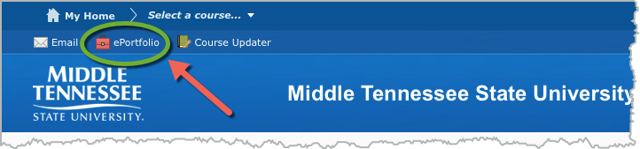

-Course Navigation Bar-
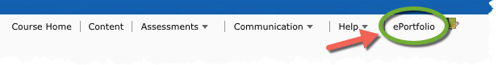

eP Dashboard

Once inside the eP space, you will see your Dashboard. This area will provide you with the latest activity in your eP and links to the eP tools.

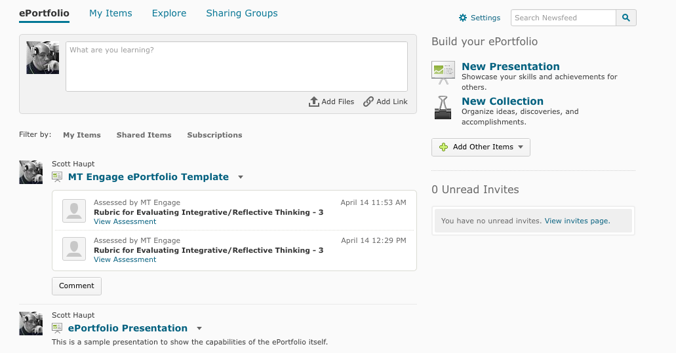

What are Artifacts?

Artifacts are the building blocks of everything that you can do in the eP. You use Artifacts to make Collections of your work or web Presentations of your work. In general, Artifacts can be almost any kind of file, such as Word documents, PDFs, PowerPoints, images, or short audio or video clips.

What are Reflections?

In the D2L eP, Reflections are independent items in your eP that you can associate or link to Artifacts, Collections, or Presentations. In other words, unlike comments, they are not tied to any single file. You can use them to discuss the relationship between items. You can also use Reflections to define long-term goals that are met by the various items.

As with all the tools in the eP, the actual use of this item is up to you. So, for example, while you can create a web-based Presentation in your eP to display a number of different items, you can use a Reflection to discuss the relationship between items.

What are Collections?

Collections are kind of like folders of items: they are groups of Artifacts, Reflections, and/or Presentations that you can create and use for organizing your eP items.

Sharing Groups

Sharing groups let you save permissions for different users and groups of users. You can then apply the sharing group to items rather than specifying each user or group's permissions each time. You can have multiple sharing groups that you apply in different situations or to different types of items. A common example would be setting up a Sharing Group for a class you are instructing or taking, and then using it to share a Presentation or other item.

NOTE: Sharing Groups are not available to all users at MTSU. If you do not see the "Sharing Groups" button in the left panel, the feature is not currently available to you.

What is a Presentation?

The Presentation tool in the eP allows you to create, display and share web sites that contain the items in your eP. You won't need to know any HTML code or specialized knowledge to build these sites: you'll just need to go through a series of steps to determine what is included and how it will be displayed.

In this sense, the eP Presentation tool allows you to focus on designing and arranging your web sites rather than having to build them from scratch.

Presentations: Properties tab

To create a new Presentation, click on "New Presentation" in the navigation bar.

You'll see a page open up with a series of tabs (4) at the top of it. As we make the presentation, we'll move across the tabs from left to right. Give your Presentation a name and click "Save."

Adding content (or "Components") to your Presentation

After giving your Presentation a name, you may move to the second tab, "Content/Layout," to add content to the Presentation. To add content to your Presentation, it is important to know that only items within your eP can be included in your Presentation. Why is this the case? There are features in the Presentation tool that allow you to comment on and share your Presentation items, so these items need to be a part of your eP already. You may add simple text areas, however, in which you may include links, images and embedded objects, such as YouTube videos (if you choose).

Multimedia Content / "Insert Stuff"

The most typical and efficient way to add multimedia content to an eP Presentation is through embedding. "Embedding" simply means that you are making a viewable link to a file that is located or streaming elsewhere.

Reflections and Allowing Comments

If you choose to add a "Reflection" to the Presentation, you can allow someone (a classmate, instructor) to comment on that Reflection right in the Presentation.

Presentations: Banner

After adding as many pages and Components as you like, and arranging them how you see fit, you may now move to the third tab and edit the banner for your Presentation. The banner will appear on every page above the Content areas and navigation area.

Choosing Themes

After building your Presentation, you may now move to the fourth tab, "Theme."
In this area, you can choose from a number of already existing themes or templates for your Presentation. To choose a theme that is not the default theme for the Presentation, simply scroll down and click on "Select" for the Theme that you wish to use.

While you may choose to use one of the Themes that are available for your Presentation, you may also edit the Themes to make them more personalized. To do so, click on the icon to the right of the Theme that you've selected to use.

Note: when you make changes here, you are only changing the Theme for this individual Presentation! The Theme will still be available in its default form for other Presentations. The Themes available to you in the eP are not available for customization as Themes: in other words, you can't create your own Theme and then save it for use as a personal template. However, you can accomplish the same task by making a new Presentation in which you develop your own Theme and simply copy that Presentation for use later.

Presentations: Permissions

The D2L eP Presentations are in fact web sites that can be shared with individuals or groups within D2L or outside of D2L altogether, making it a public web site available to anyone.

To share your Presentation with someone, click on the key icon in the dropdown menu to the right of the Presentation’s name. A new window will open up, allowing you to do one of the following:

1. "Allow public viewing of presentation" checkbox: Anyone with the accompanying URL can access this item. You can now copy the URL (http://...), paste it into an email and send it to whomever you like. It will be viewable outside D2L.
2. To share with another D2L user, click on "Add Users and Groups."

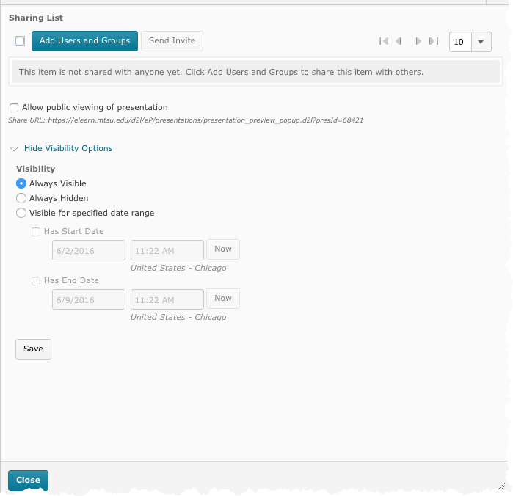

In the next screen, you can search for individual users or Sharing Groups for sharing your Presentation. The "All" tab includes both individuals and groups, and the tabs to the right filter results by individual "Users" or "Sharing Groups."

To share (or make a link to) an eP Presentation in a Discussion Forum

1. You'll first need to share the Presentation with your class or instructor or groups of students.
2. Once the sharing permissions are set, you’re ready to share it in the Discussion Forum. Go to the Discussion Forum and enter the Topic in which you are going to post your Presentation.
3. Click on “Compose” to create your posting. A new window will open, and you may type whatever you’d like here. When you are ready to place a link to your Presentation in your message, select the icon from the tool bar; this will allow you to Insert a Quicklink into your posting.
4. After clicking on this icon, a new window will open up. In this window, do the following:
>> First, select “URL.”
>> On the next page, enter the URL provided by the eP Share option earlier in the URL field.
>> You will then be able to give the link a Title.
>> Then, in the “Target” area, you’ll have to decide whether you would like your Presentation to open in the “Whole Window” of your browser, in the “Same Frame,” or, in a “New Window” (either the second or third option is recommended).
5. Once you’ve made all of the necessary choices, click “Insert.”

NOTE: Wherever you see the Quicklink icon, you can insert an eP item.

To submit an eP item to a Dropbox

Submitting an eP item (such as a Presentation) to a Dropbox in D2L is the same as "turning in" an eP item. In other words, the user who submits the item can no longer make changes to it.
1. Students should click on the Dropbox to which they are to submit the item.
2. Click on 'Add a File.'
3. In the window that pops open, click on the eP icon to the left. Navigate to the item to submit, select it, and click "Upload."
4. At the Dropbox, click "Submit."

NOTE: When turning in Presentations, students need only submit the Presentation itself, as all the items within the Presentations will be included with it. Upload times will vary depending on the overall size of the eP being submitted.

Questions

As you can see, there are a lot of possibilities for using the eP in your classes. If you have any questions or ideas on how to use the eP, please feel free to contact Scott Haupt (scott.haupt@mtsu.edu) in the LT&ITC.

