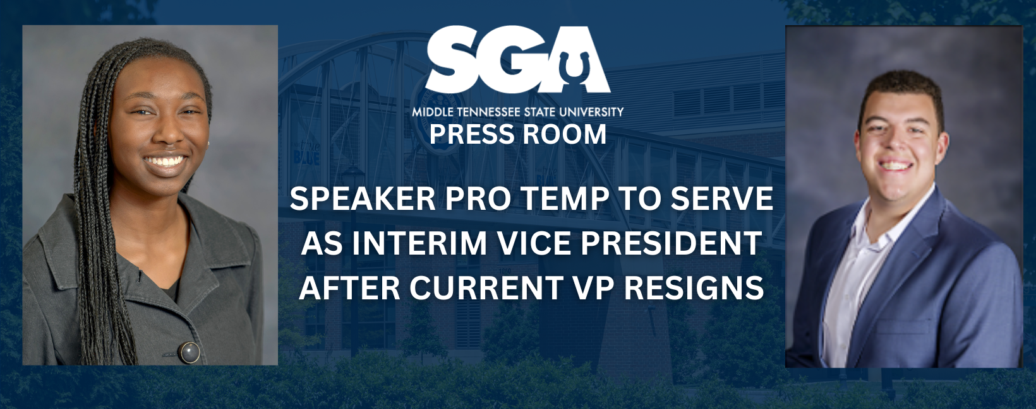

On November 01, 2022, Vice President Cameron Paschal tendered a notice of resignation to President Powell that would go into effect at the end of the month. On yesterday, November 30th, Vice President officially submitted a letter of resignation to SGA Executive Board and Senate.
Due to this vacancy, Jada K. Powell, SGA President, immediately appointed Trinity Henderson, Speaker Pro Temp of the Senate, as the interim SGA Vice President. The results of the current referendum, will determine if Interim VP Henderson will continue to serve in this role permanently for the remainder of the semester. Below you will find the resignation letter in it’s entirety along with a brief statement from President Powell.
----
November 30, 2022
Dear MTSU Student Body,
It is with much thought and consideration that I announce my resignation as Vice President, Speaker of the Senate, and Freshman Council Director from the 2022-2023 Student Government Association. During the spring semester, I have a class that is held during when the SGA Senate meets. As my role in the SGA is entirely dependent upon my ability to lead senate meetings, I have no other choice than to step aside. If I were not to take this class, I would not be a student at MTSU in the Spring of 2023 either as it is my only one. My resignation will go into effect on December 1st, my last day being November 30th. I have enjoyed my time as Vice President, Director of the Freshman Council, as well as serving as a Judicial Board member in 2020-21, and as a CBAS Senator in 2021-2022. I send the warmest of well wishes to all the Student Government Association for the Spring of 2023. I have the utmost respect and faith in the Powell administration and know that they will do great things to improve our beautiful campus and steadfast student government.
On a personal note, stepping aside will help me immensely with my personal well-being. For as long as I can remember, I have always been the one to put in effort- whether that relates to friendships, relationships, jobs, or positions held. Selflessness can only be given so freely if there is positive affirmation and recognition for the effort that is put in; and when it is not received, then there is no ability to give more.
Furthermore, what I have appreciated most about serving in my many positions across campus has been and is the ability to work with people who have different thoughts, backgrounds, and life experiences. One of the best traits I have gained while at MTSU is the respect for the diversity of thought.
The beauty of the diversity of thought is that it encompasses all beliefs and ideals, not just the ones that you agree and are comfortable with. Words cannot begin to express how thankful I am to all that voted for me and my ideas; I promise your words did not fall upon non-listening ears. In closing, I thank you all for the opportunities that have come with working for you. You are the reason it matters, so stick with it.
God bless,
Cameron J Paschal.
-“Every new beginning comes from some other beginning’s end.” – Semisonic”

In all, I, Jada K. Powell, have made the executive decision to appoint the current Speaker Pro Tempore, Trinity Henderson, as the Interim Vice President until she can be officially sworn into office on January 26, 2023, the first Senate Meeting of the Spring Semester. Per SGA Bill 8-22-F: A Bill to Update the Current Line of Succession within the Student Government Association Executive Branch, Section 11, Subsection E and F reads, “In the event that the Vice President position becomes vacant after spring elections and up until the first day of fall classes, a campus-wide election to fill the vacancy must take place no sooner or later than three weeks into the fall semester. If the Vice President position becomes vacant any other time during the year, the President shall have the authority to appoint a new Vice President with the appointment being approved by the SGA Senate.” She has met with Cameron regularly throughout the last few weeks of his term to ensure a smooth transition of power. Although the Executive Board is deeply saddened with Vice President Paschal’s resignation, we know he is going to achieve everything he sets his mind to accomplish. Please welcome Miss Trinity Henderson into the position with open arms.
True Blue,
Jada K. Powell
Your Student Government Association President

Cameron Paschal, Vice President & Speaker of the Senate
Michai Mosby, Chief of Staff
Zoe Spikner, Communications Director
Robert Carey, Election Commissioner
Nicolas Morgan, Attorney General
Jasper Sanders, Events Director
Kimberly Garvey, Homecoming Director

