A Beginner’s Guide to Inclusive Advising
Because advising is a form of one-on-one teaching, according to NACADA, we believe that advisors’ best internal resources on inclusive practices are housed in the Office of Teaching and Learning. We provide additional resources here, that are more specialized to advising, but also do overlap with OTL's resources.
The work of developing inclusivity is on-going and cannot be contained in a single checklist. We have gathered essential resources, predominately from the University of Denver’s Office of Teaching & Learning Inclusive Teaching Practices resource, that are also applicable to the teaching work of advising.

Get to know your advisees
- Who are you?
- What is your history? (Jewell & Durand, 2020)
- What stories of your life have shaped you into who you are today? (Jewell & Durand, 2020)
- What are stories you don’t know enough about and would like to know more about? (Jewell & Durand, 2020)
- What has your educational journey been like up to today?
- What is important to you as a learner?
- What do you hope to take away from your academic study at DU?
- What feels challenging?

Adapted from Dr. Valentina Iturbe-LaGrave's 2020 Inclusive Teaching Checklist

Tell your advisees about yourself

Aim to humanize yourself and connect to students by sharing your story, blind spots, educational biography, passions and how you can support their academic journey.
- Who are you?
- What is your history? (Jewell & Durand, 2020)
- What stories of your life have shaped you into who you are today? (Jewell & Durand, 2020)
- What are stories you don’t know enough about and would like to know more about? (Jewell & Durand, 2020)
- What was your educational journey like?
- What is important to you as an advisor?
- How does your worldview/discipline/research area help you understand/solve issues in the world?
- Why is advising important to you?
- How will you support your advisees?

Adapted from Dr. Valentina Iturbe-LaGrave's 2020 Inclusive Teaching Checklist

Engage in self-inquiry
This video comes from the Equity Toolkit created by the Colorado Department of Higher Education (CDHE). After watching it, please consider the questions listed below, adapted from the Examining Identity exercise and So You Call Yourself An Ally exercise in the CDHE Equity Toolkit.

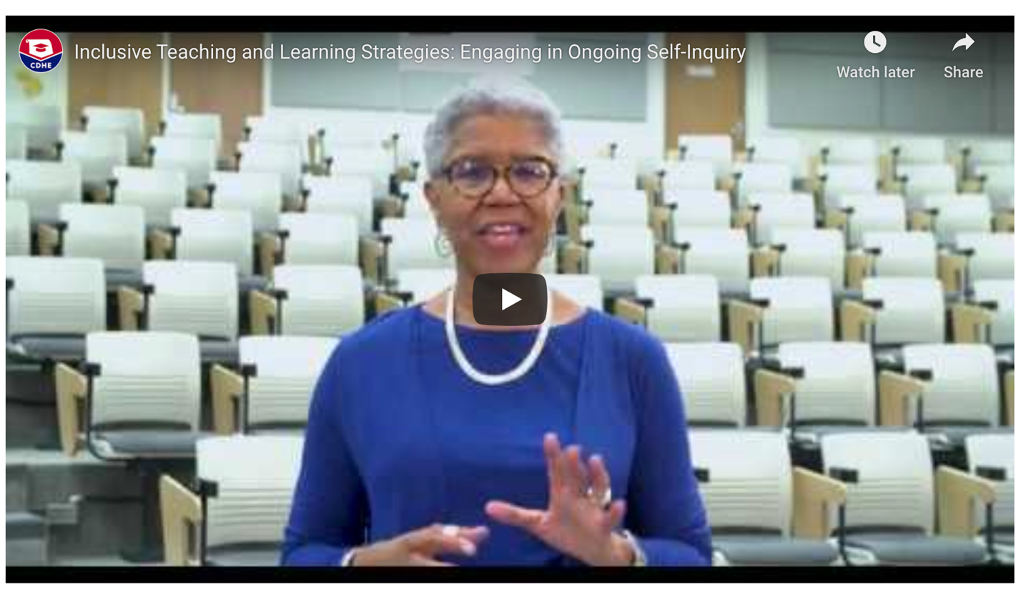

- What are the complexities of any one (or more) of your identities?
- How has the understanding of your identities changed over time?
- How do your social identities have an impact on your work? daily life?
- Do you consider yourself an ally for any social identity group? If so, which one(s)? Why?
- Which, if any of the "10 Things All 'Allies' Need to Know" are you already doing?
- Which of them would you like to improve?
- How does being an ally matter to creating culturally relevant advising support?

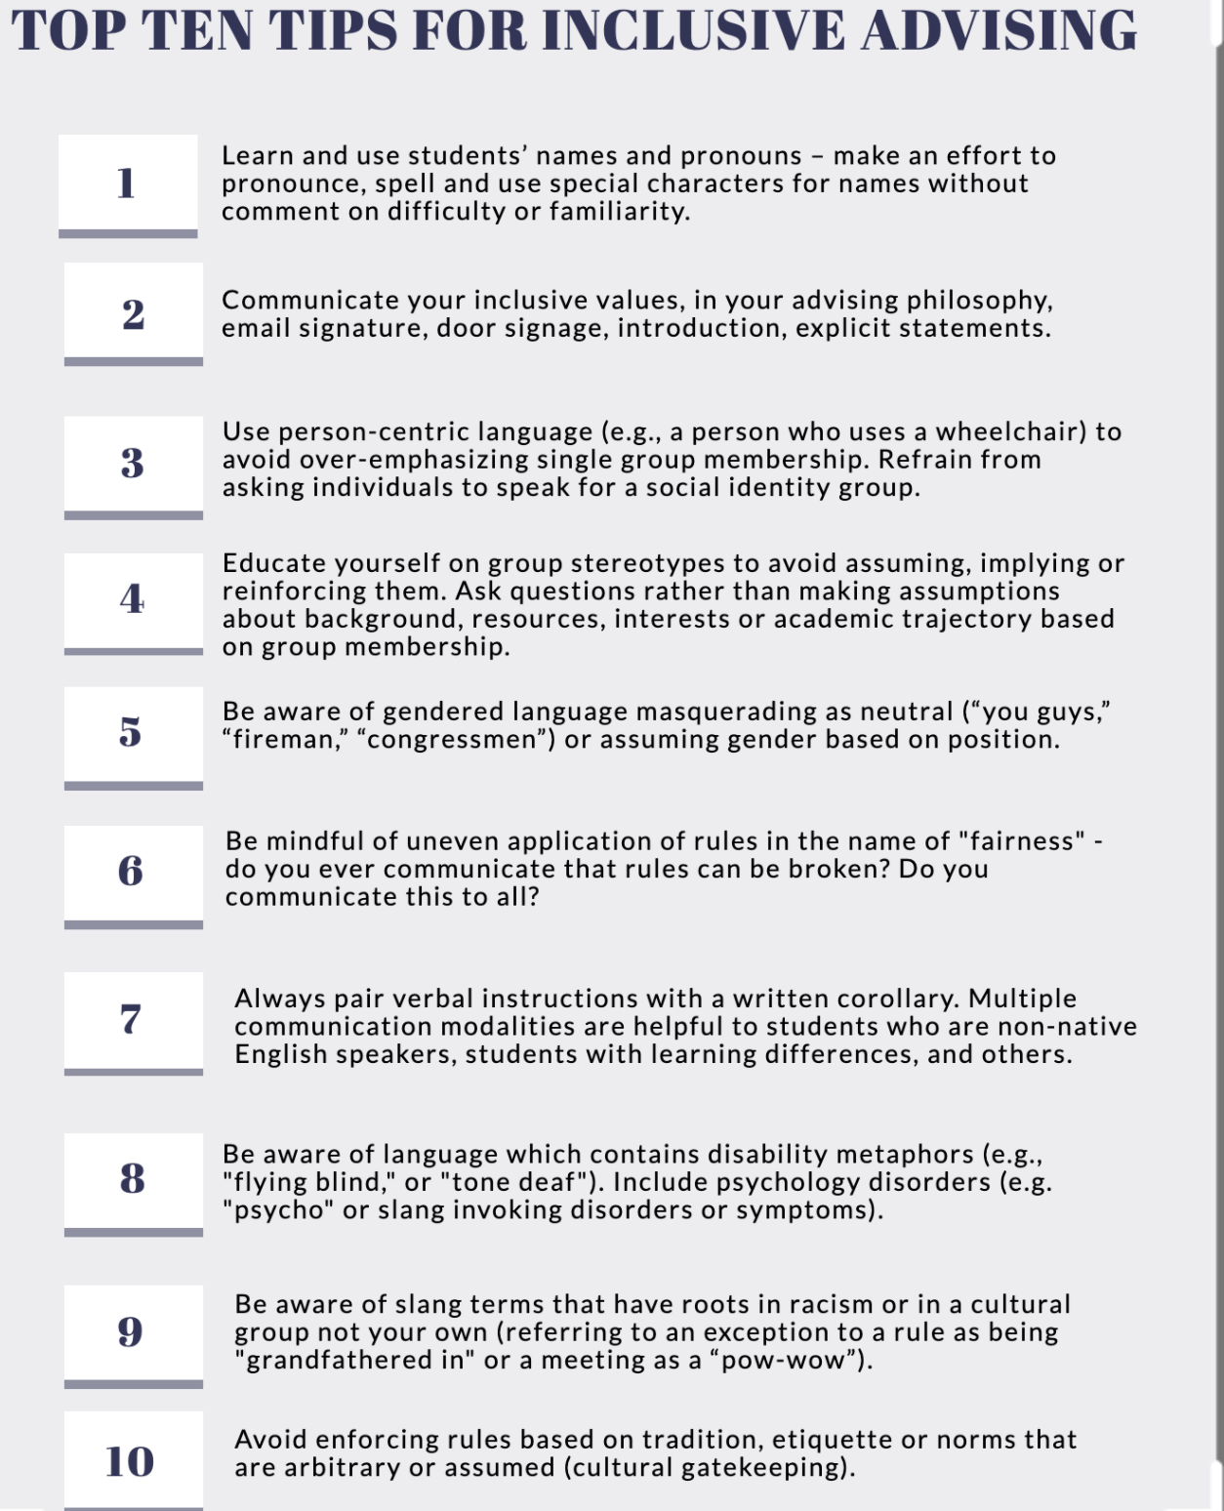
Created by Kateri McRae, Faculty Director of Faculty Advising

Because advising is a form of one-on-one teaching, according to NACADA, we believe that DU's best resources on inclusive practices are housed in the Office of Teaching and Learning. We provide additional resources here, that are more specialized on advising, but also do overlap with OTL's resources.
- Examples of microaggressions (NACADA)
- Advising students from special populations (NACADA)
- Intersectional growth mindset for serving first generation students (CSU)
- Roseburr-Olutu, D. (2019, June). The sunken place: Using the public achievement model to empower marginalized students. Academic Advising Today, 42(2).
- Cunningham, L. (2016). Multicultural awareness issues for academic advisors, 2nd edition. Retrieved from the NACADA Clearinghouse of Academic Advising Resources
- Equity Toolkit Glossary (CDHE)
- Responding to Trauma in the Classroom (OTL)
- Teaching Through A Pandemic: Cognitive Load, Mental Health, and Learning Under Stress (OTL)
- 2020 Inclusive Teaching Checklist (OTL)

Questions/feedback/suggestions:

Sarah Hoffman
Assistant Provost for Student Success
University of Denver
sarah.hoffman@du.edu
303-871-4301
She/her/hers

