Leveraging your systems for students seeking virtual advising

Let’s first clarify – sites are different in terms of advisor-student ratios, culture of site, behavior of students, front-desk staff, etc. So please collaborate and determine the best course of action regarding availability and options for advising. When that’s determined, communicate that to your students. Use clear and concise language.

Official message from university leadership

Conducting advising via the phone
Though this happens already, especially at times between the semesters when the student is not on campus, phone is a perfectly suitable option for connecting with and providing advising services and support for your students.

Addressing Limitations…
You will obviously be limited in showing the student resources that you would share in person, so please utilize your e-mail in both documenting the results of the meeting as well as sharing pertinent links, attachments, and web resources.

Providing Accommodations…
It’s possible that your student may have a limitation in their ability to hear or they may be in a place that has bad service. Advisors are encouraged to be accommodating. Do not end a meeting and move on to another task or student meeting if a call is dropped. Do not move a phone meeting to an e-mail transaction, as e-mail diminishes the ability advisors have to forge and sustain an authentic connection with the student.

Being Personable…
Just like with in person meetings, the advisor may have to convey bad news to a student as it pertains to their major, expected graduation timeline, or academic standing at the university. Advisors are to try to communicate with sensitivity around how the student would receive such message and use verbiage that is supportive, encouraging, and solution-focused if and when possible. This may mean sharing the bad news and asking the student if they need time to process the given information.

If using Campus Connect for phone meetings…
…You can put in your Campaign message that if a student prefers a phone meeting that they are to put the best number to reach them in the comments box when confirming their appointment.

…If conducting walk-ins or call-ins, you can post your main office number in your availability.

Conducting advising via Zoom
Zoom offers a platform for face-to-face, chat, screen/file sharing, and audio aided conversations. This would be best utilized with walk-ins or a possibly more nuanced advising appointment with a student in jeopardy of being off-track, removed from major, or dismissed from the university. Sensitive issues like that necessitate a more personalized approach.

Note that although Zoom does offer camera and microphone connections, advisors can still use their office phone when selecting “join by audio”. Their phone number will not display to the student.

Set up/login to Zoom via ITS website
https://Its.fsu.edu/zoom

Use a Zoom personal meeting room – a static link for all of your students
A personal meeting room allows an advisor to have a unique URL to their meeting. Staff can send this URL by clicking the “Copy the invitation” button and then pasting the message to students in e-mails or Campus Connect outreaches. See figure A on the following page for more details.

Managing the Zoom Waiting Room
When in the Personal Meeting Room tab, click “enable waiting room”. This will allow the staff to manage a virtual waiting room of students. Without this checked, everyone who has the link can join the meeting and everyone will be in the meeting at the same time. This way, an advisor can send a link out to students but still manage their appointments. Students can join the meeting early and when the staff is ready they can add the student to the room.

See Figure A on the following page for more information on how to set up a waiting room.

Setting up your Personal Meeting Room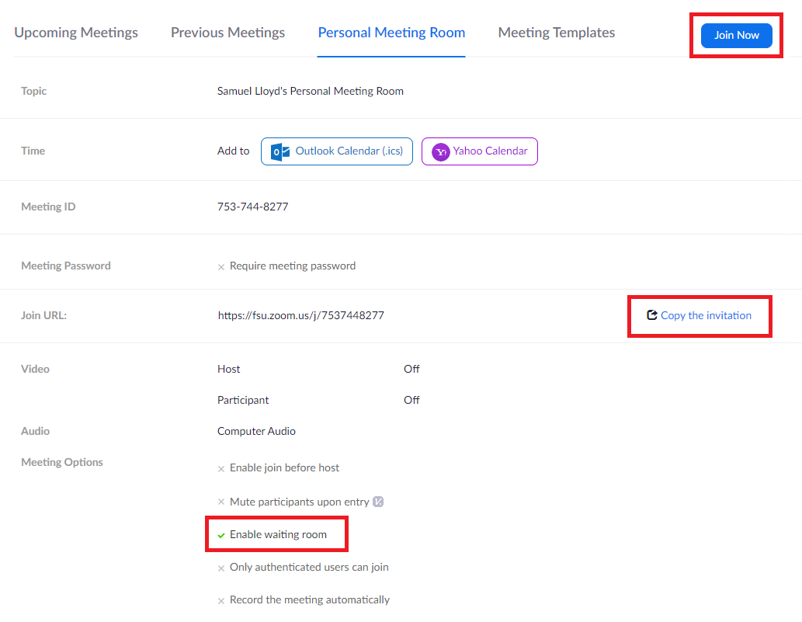Figure A: This is where your personal meeting room preferences are managed. You can click “join now” at the top right to join the meeting. On the middle-right of the page is where you can click to copy the invitation and use the URL provided when sharing your meeting link with students. Toward the bottom is where you need to click “enable waiting room” to ensure that you can manage when you meet with a particular student.

After you’ve set up your room and sent out appointment details, you can now meet with students via Zoom.

Managing the Waiting Room
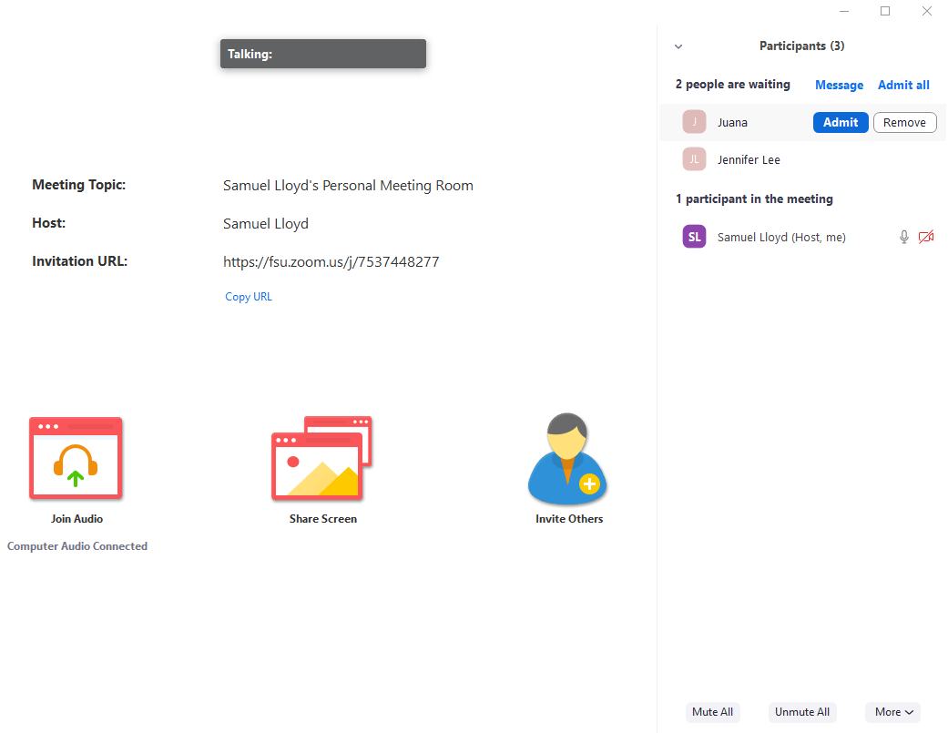
You have sent the personal meeting room link and now you have students click the link and arrive in your waiting room. For this example, Juana and Jennifer Lee are both waiting for advising. I can see them in the top right of the platform under “2 people are waiting”.
The waiting room will populate in order of who attends first, so Juana clicked the link and entered the room before Jennifer Lee. This may be fine when handling walk-ins who receive first-come-first-serve advising, but if Jennifer Lee had an appointment prior to Juana you should see Jennifer Lee first.

Moving a student from the waiting room to the meeting
Note that no student can hear your audio or see you share a screen when they are in the waiting room.

When you hover over a student’s name you can “admit” them and this will have them enter the actual meeting space.

Managing the Student Meeting

You have some additional functionality toward the bottom of the platform. See below for more details.
Mute – this is where you can mute your audio
Start Video – you can elect (if you have a webcam) to share video
Invite – you can invite others to the meeting (unnecessary assuming that you sent the link out to other students)
Manage Participants – This opens the sidebar that allows you to see and manage who is in the meeting. This also shows your waiting room as well.
Polls – not necessary for advising purposes
Share Screen - you can elect to share your screen during the meeting. This can be very beneficial as you may choose to show the student’s requirements report or show other essential websites or web resources.
Chat- this opens up a sidebar for a text chat box. If you are using audio then this feature is not necessary.
Record – you can record a particular meeting but this is probably not necessary either.
Breakout rooms – Again probably not necessary.
End Meeting – This is where you will end the meeting for everyone both in the individual meeting and in the waiting room. It may seem logical at first to click this when done with a meeting with a student, but instead you need to manage them and remove them from the meeting, or they need to leave the meeting on their own.

Removing or moving a student currently in a meeting…
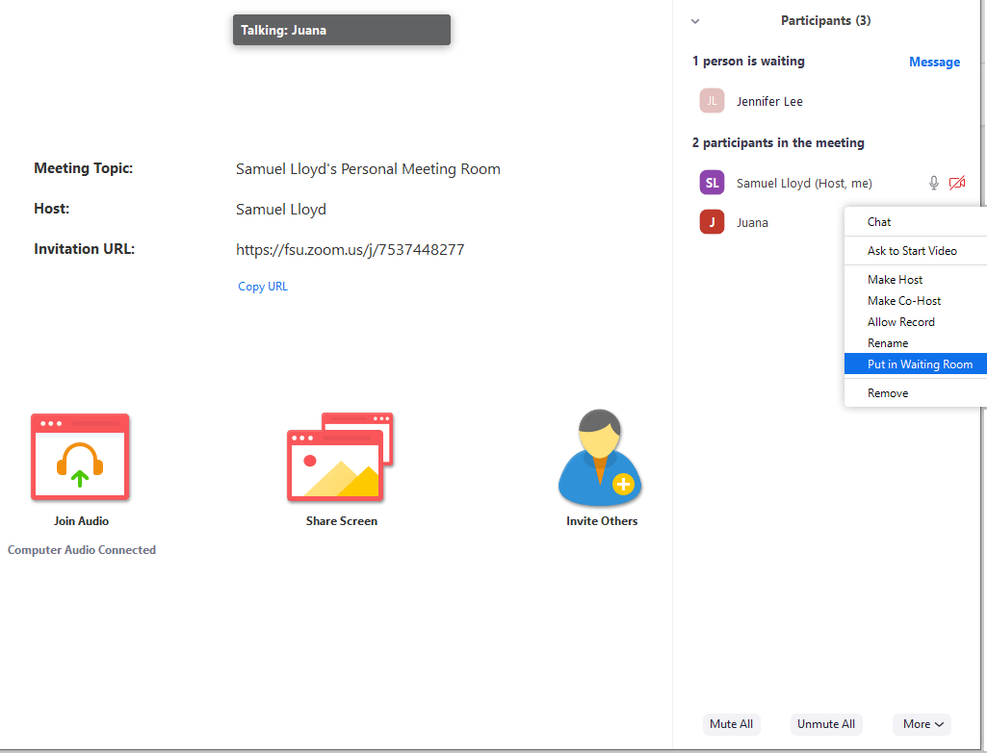
When a student is in your meeting, you can either put them back in the waiting room if it was a mistake or they aren’t ready/present, or you can remove them if the meeting is complete. Simply right-click the name of the student in the meeting and you can either move or remove them.

