Certificate of Completion
 ACKNOWLEDGES THAT

Name:

 COMPLETED MTSU’S FERPA
TRAINING MODULE

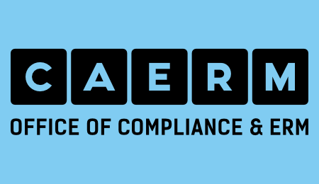
Date:
/ /2021

