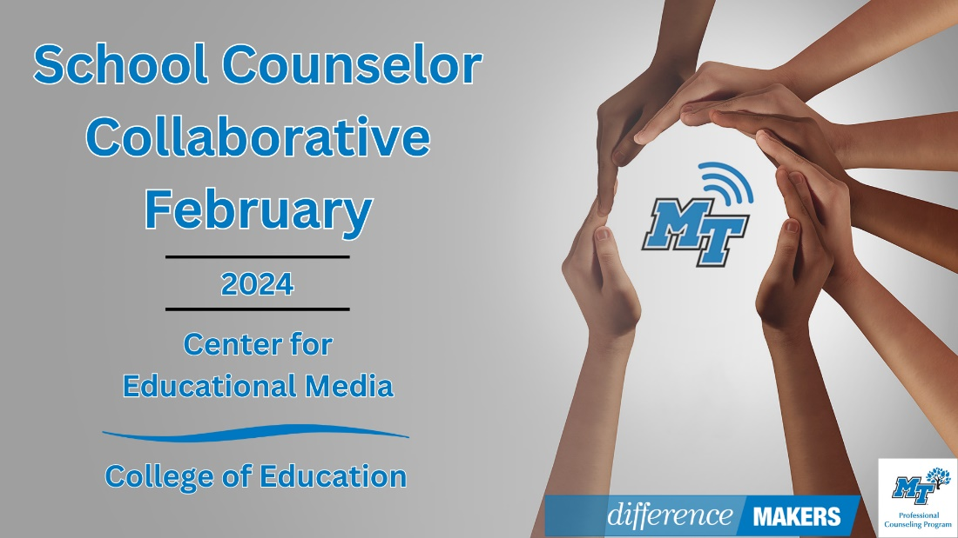

9:00- 9:20am Welcome/Introductions
- Dr. Laura Clark, Director, Center for Educational Media, MTSU
- Dr. Neporcha Cone, Dean, College of Education, MTSU

9:20-9:30 TSCA Announcements
- Dr. Tiffany Wilson, Assistant Professor, MTSU
9:30-9:45 Updates for School Counselors from the TN Department of Education
- Dr. Karey Lowdermilk, Manager of College & Career Counseling, TDOE
- Q&A Facilitated by Dr. Laura Clark and Dr. Tiffany Wilson
9:45 –10:00 Break

10:00-12:00pm (Session 1) From Here to There: Bridging the Gap for Students Experiencing Homelessness
- Dr. Kisha Napper, NCC, Educational Advocate and Special Populations Consultant
- Q&A Facilitated by Dr. Laura Clark and Dr. Tiffany Wilson

12:00-12:10 Close

