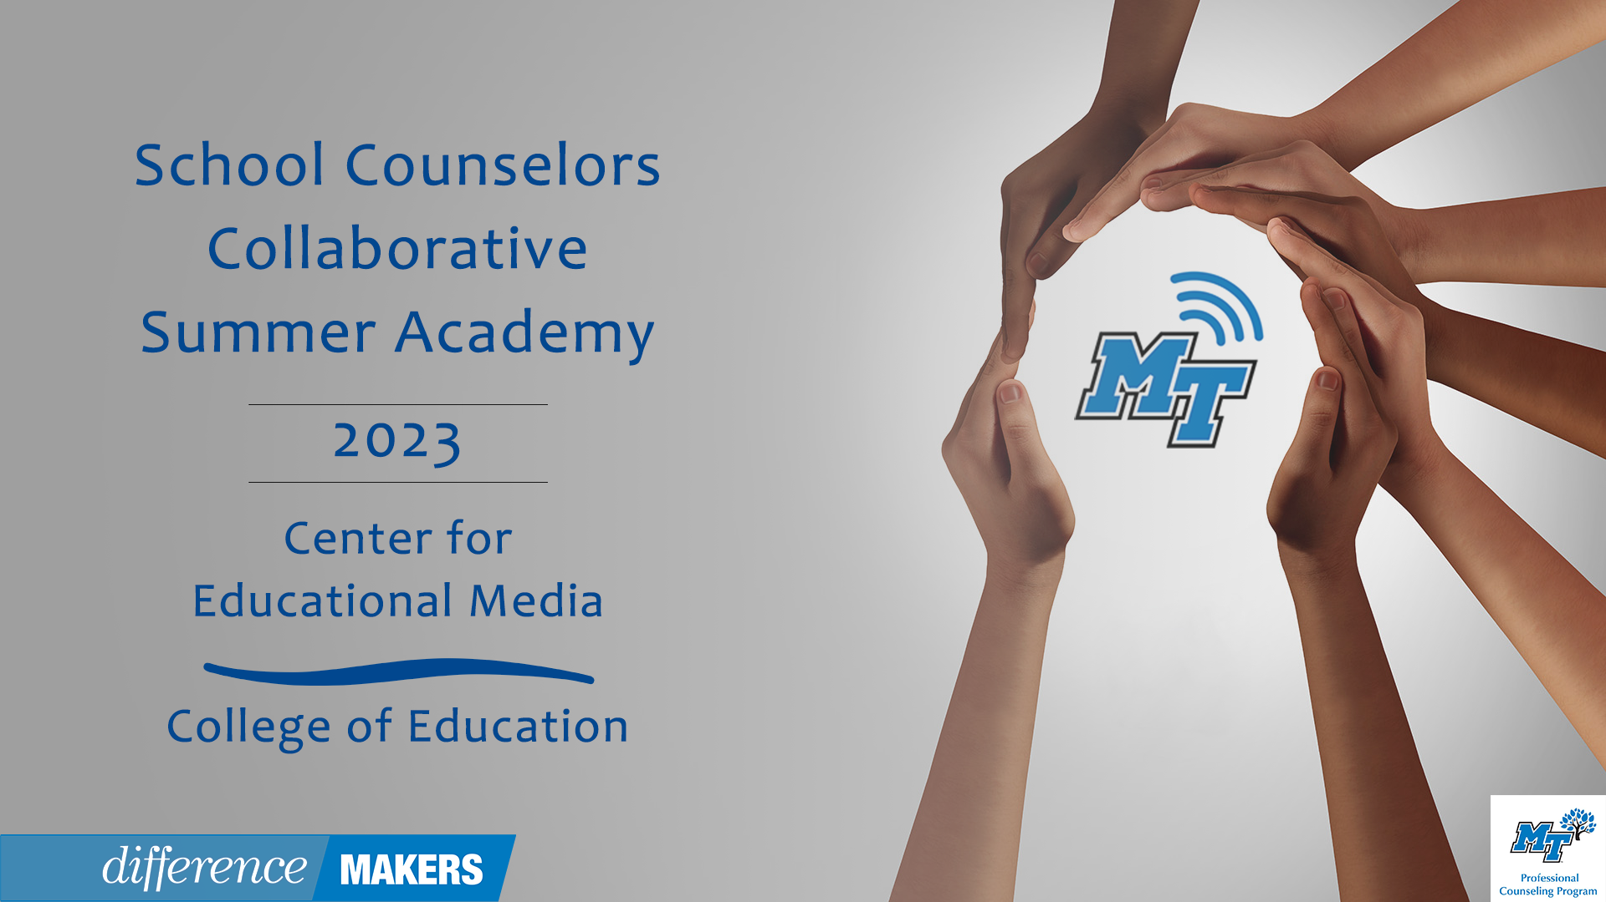
School Counselors Collaborative Summer Academy
Onsite Conference - July 13, 2023

8:30- 8:40am Welcome/Introductions
- Dr. Laura Clark, Director, Center for Educational Media, MTSU
- Dr. Tiffany Wilson

8:40-9:40 (Session 1) RAMPing Up your School Counseling Program
- Joyce Hollins, Ed.S., School Counselor
- Desirae Skelley, Ed.S., School Counselor
- Q&A Facilitated by Dr. Laura Clark and Dr. Tiffany Wilson

9:40-9:50 Break

9:50-11:35(Session 2- P1) Section 504: What School Counselors Need to Know
- Dr. April Ebbinger, NCSP, Director of Psychological and Behavioral Services, TDOE
- Q&A Facilitated by Dr. Laura Clark and Dr. Tiffany Wilson

11:35pm-1:00 Lunch

1:00-1:10 Welcome back/Introductions
- Dr. Laura Clark, Director, Center for Educational Media, MTSU
- Dr. Karey Lowdermilk, Former Assistant Principal and School Counselor, Manager of College and Career Counseling, TDOE

1:10pm–2:55pm (Session 2- P2) Section 504: What School Counselors Need to Know
- Dr. April Ebbinger, NCSP, Director of Psychological and Behavioral Services, TDOE
- Q&A Facilitated by Dr. Laura Clark and Dr. Tiffany Wilson

2:55pm-3:05pm Break

3:05pm-4:05pm (Session 4) Behavior Management- Boots on the Ground Practices with Individual Students and Whole Class instruction
- Emily Gill, Ed.S. & M. Ed. School Counseling, TASC School Counselor of the Year '22-'23, & Rutherford County School Counselor Team Lead
- Q&A Facilitated by Dr. Laura Clark and Dr. Tiffany Wilson

4:05pm-4:15pm Close/ Certificates
- Dr. Laura Clark, Director, Center for Educational Media, MTSU

