

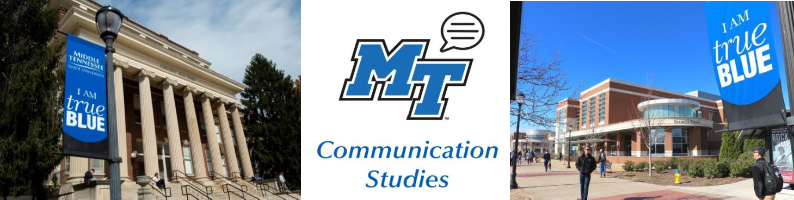

**January Dates:**

1/20 Martin Luther King, Jr. Day

1/21 First day of classes

**December Dates:**

**Debate Dates and Communication Studies Club Meetings:**

Will resume after winter break, look out for the new meeting dates in the January Newsletter!

12/12 Last Day of Term

12/14 Commencement

12/16 Deadline for Final Grades



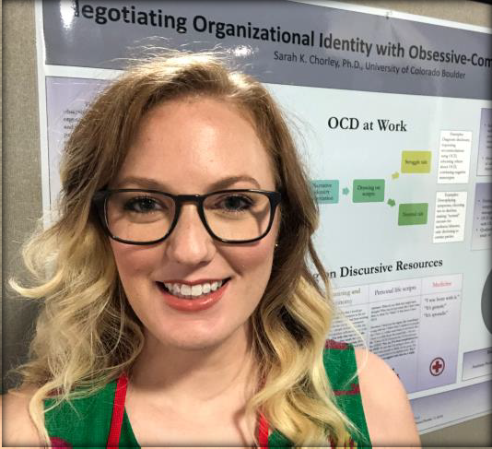

Meet Dr. Chorley!

Dr. Sarah Chorley graduated with her Ph.D. in Communication from the University of Colorado and has been a faculty member at MTSU since 2018.

As an instructor, Dr. Chorley loves to talk about organizational communication. One of her favorite classes to teach is Women, Leadership, and Communication (COMM 3245), in which students learn about gender, organizational leadership, and critical perspectives on power.

As a researcher, she investigates the intersections among organizational communication and obsessive- compulsive disorder (OCD), that is, ways in which adults with OCD can gain improved quality of life through a productive and satisfying career. Her current research is creating and testing a vocational rehabilitation program for individuals in intensive treatment for OCD.

As a volunteer, Dr. Chorley donates her time to educate physicians about OCD and its social implications. She has been invited to speak at such institutions as Oklahoma State University Hospital and the University of Colorado Anschutz Medical School. She has also spoken at three International Obsessive-Compulsive Disorder Foundation conferences on managing school, work, and self-disclosure with OCD.

In her free time, Dr. Chorley teaches kickboxing at the MTSU Rec Center and would love to see you at her next class!

A note about the Facebook group: It is not “secret” but it is private, so students will have to request to join.

**Facebook:** MTSU Comm Studies

**Instagram:** @mtcommstudies **Twitter:** @mtcommstudies **Linkedin:** MTSU Department

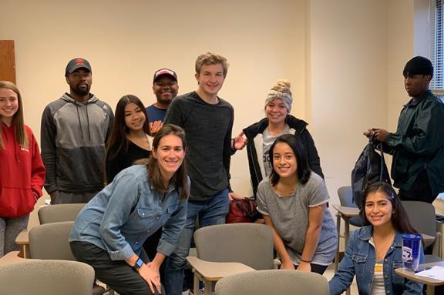

**Liberal Arts M.A.| MTSU**

**Communication Studies Club**

This semester we reactivated the Communication Studies Club. Our goal was to create an academic, social, and service organization, meant to promote the Communication Studies program through philanthropic events and on- campus involvement, as well as benefit students within the program through networking and club activities. We did this through setting up professional workshops including resume building and interview’s Do’s and Don’ts from Dell Technologies!

MTSU’s Master of Arts in Liberal Arts is an innovative program allowing students to earn a 30 credit hour graduate degree through a course of study built around the subjects that they find most interesting and captivating

https://mtsu.edu/programs/liberal- arts-ma/index.php

Anyone holding a bachelor’s degree can pursue long-held or new passions through a personally customized program developed around individual interests. Lifelong learners, professionals, students returning to school after a break, and recent graduates can find flexibility to fit their educational needs through this unique master’s program. Students attend engaging courses and have opportunities to participate in projects in the region or even enroll in education-abroad courses around the world. Top-quality professors bring varying research and teaching interests to the classroom through inspiring instruction. The M.A. in Liberal Arts allows students to refine skills, expand horizons, learn for the joy of it, and obtain the graduate degree they have always wanted! For more information, please contact: Dr. Janet McCormick, Master of Arts in Liberal Arts, Interim Director, [janet.mccormick@mtsu.edu.](mailto:janet.mccormick@mtsu.edu)

Please reach out to Dr. Priddis for more information or sign-up on this Google Form: [https://forms.gle/4nNheNvW4YR981h](https://forms.gle/4nNheNvW4YR981hP6) [P6](https://forms.gle/4nNheNvW4YR981hP6)

<https://forms.gle/NanngrosZSXS6B6s5>.

**OPPORTUIntNernshIipTs**

**IES**

**STUDY ABROAD**

**COMM 3220 Small Group Communications in Canada**

MTSU’s Signature Program: Canadians

Communicate Live!

The Primary goal of this course is to enhance students’ understanding of the principles of small group communication while encountering the people and culture of Ontario, Canada. Students will learn the principles of small group communication tasks, roles, theories, conflict resolution, goal strategizing, and leadership so they may become more competent communicators in group settings.

Includes two Broadway shows, three dinner theaters, 23 out of 29 meals

**Communication Department Intern: Spring Semester**

During the 15-week internship for credit (unpaid) of 8 hours a week, the Communication Intern will be given a broad range of task to ensure an understanding of communication and development in public relations, content marketing, recruitment and retention. Under the direct supervision of Dr. Priddis, the intern will:

-Create monthly department newsletters

-Create flyers for Communication Department events, clubs, news, and opportunities

-Help draft and design communications and outreach materials

-Help maintain the organization of communication supplies

-Attend communication workshops

-Assist the Communication Studies club in project coordination, recruitment, execution of events and administrative work

-Additional responsibilities may include: Assist faculty members with research and projects, and work with Department Executive Aide on other projects

•

•

•

•

Program fee: $2,372.00 June 19-28, 2020

Financial Aid May Apply! Scholarships Available!

**Qualifications:**

-Proficiency with Microsoft Office and graphic design

-Strong verbal and written communication skills

-Motivated and able to take direction

Contact: [Jeri.Burnett@mtsu.edu](mailto:Jeri.Burnett@mtsu.edu)

*If interested, please email Dr. Priddis at* [*Deanne.Priddis@mtsu.edu*](mailto:Deanne.Priddis@mtsu.edu)



Beginning in Fall 2020, Communication Studies will have a **Health Communication** track available in addition to the existing tracks Organizational Communication and Culture and Social Influence (CSI). The track will focus on different perspectives on patient and provider experience in healthcare. Classes include Relationships in Health Communication, Health Risk Communication, Social Support Communication, and Patient-Provider Communication.

Do you want to get a head start? Dr. Dalton is teaching **COMM4800: Intro to Health Communication** on T/R 9:40-11:05.

*This class will count as an elective for other tracks.*

**COMM SOCK DRIVE**

We are proud to partner with Murfreesboro Cold Patrol by donating new and gently used socks!

Please bring donation items to the collection box located in the Communication Studies Department office, Jones Hall Room 233!

Last year we donated over 300 pairs of socks, and we hope to do so again this year.

The drive will run from November 5th through December 5th!

WHAT’S

**HAPPENING**

IN COMMUNICATION

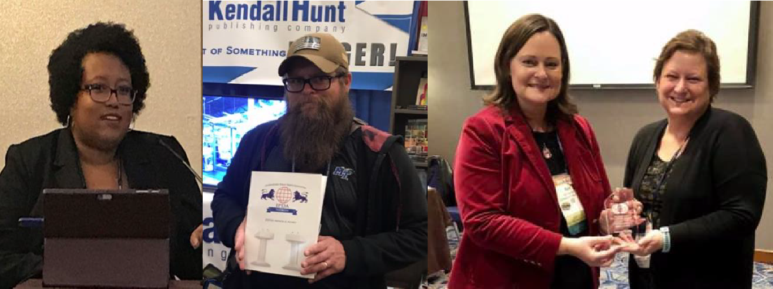

National Communication Association

The National Communication Association (NCA) annual convention was held in Baltimore

November 14-17, 2019. MTSU Communication Studies faculty members Roberta Chevrette, Betsy Dalton, Heather Hundley, Rob Layne, Natonya Listach, Dee Priddis, Patrick Richey, Xiaowei Shi, and Andy Tinker participated in panels, paper panels, workshops, business

meetings, legislative assembly, and networking events.

Awards

**Dr. Andrew Tinker** received Top Journal Article of the Year award from the Communication Ethics division

of NCA for his article entitled "Communication Ethics and the Rejection of Paternalism in John Stuart Mill's *On Liberty*." *Communication Quarterly* vol. 67, no. 3, 312-332.

**Dr. DeAnne Priddis** was awarded the 2019 National Communication Association (NCA) Training &

Development Service Award.

.



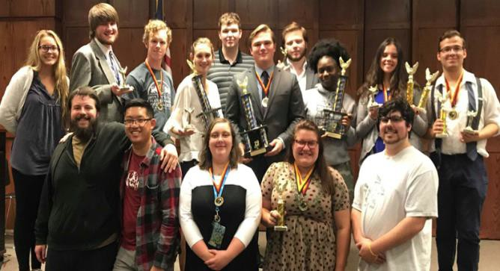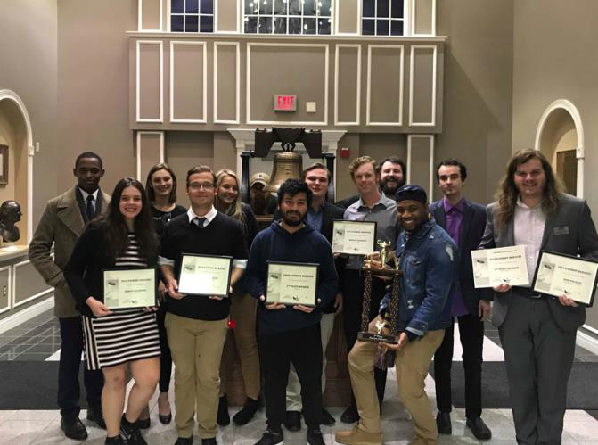

**To the Debate team!**

The MTSU Debate Team had a strong fall semester winning multiple awards throughout the South. The team travelled to Tennessee Tech, Walters State CC, The University of Southern Mississippi, The University of the Cumberlands, and many EXL students participated here at MTSU’s home tournament. Communication Studies majors and minors shined as part their EXL project in Comm 3210 Debate & Argumentation. Many won and broke into sudden death elimination rounds as well as won awards for their speaking skills. The team has a busy Spring starting in Arkansas and heading to Mississippi, finishing with three tournaments in Tennessee including the State and National Championships. The team will also host the Irish Times National Champions on their 40th Anniversary tour of the US as well as a model debate for the League of Woman Voters with our friends from Belmont University. MTSU’s Debate Team is housed in the Department of Communication but any student in good academic standing is more than welcome to join at any time throughout the year.

For more information, please contact Dr. Patrick Richey ([Patrick.richey@mtsu.ed](mailto:Patrick.richey@mtsu.edu)

[u](mailto:Patrick.richey@mtsu.edu)) or Mrs. Natonya Listach ([Natonya.listach@mtsu.edu](mailto:Natonya.listach@mtsu.edu)).

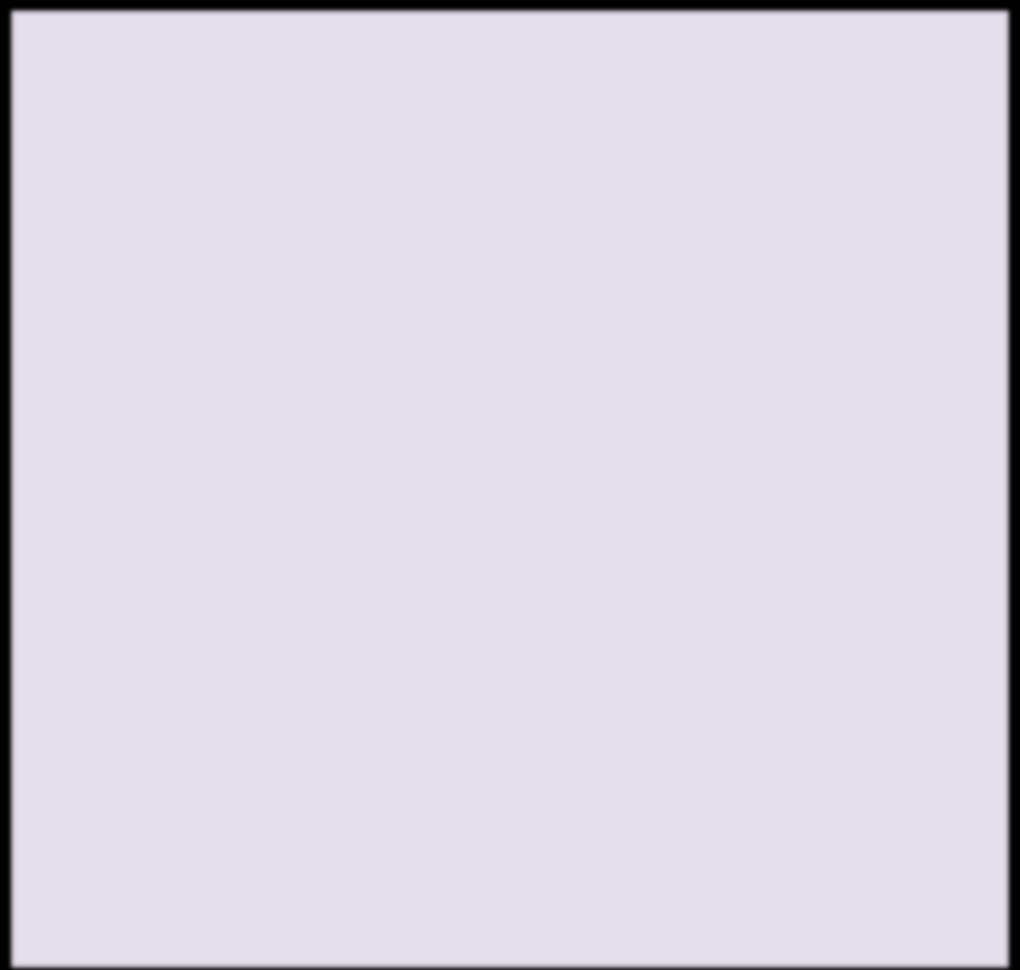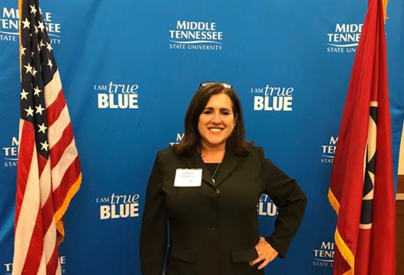

L’Oreal Stephens coordinated the **Women Warriors event**, an event to celebrate Women Veterans. The guest speakers were Dr. Miller, the director of MTSU Charlie and Hazel Daniels Veterans and Military Family Center and Beverly Groogan, the Women’s Health Coordinator and Maternity Care Coordinator. AAUW gave awards to Honorees including Teresa Carter, Brittany Dinaso, Beverly Henley, Dr.

Anita Herron, Lesa Prime, and Tabatha Wadford.

**CONGRATULATIONS!**

**Dr. Andrew Tinker**, Communication Studies Instructor, for successfully defending his dissertation "An Exploration of Communication Ethics Scholarship and Economic Spheres" at Duquesne University, Pittsburgh, PA.

He will graduate on December 20, 2019.

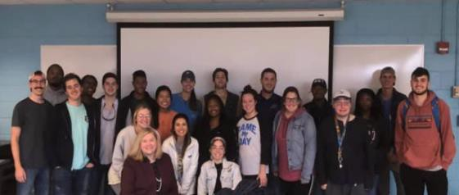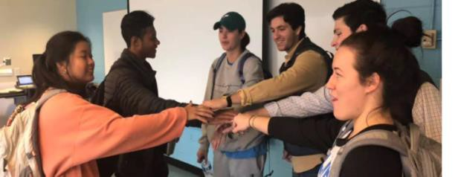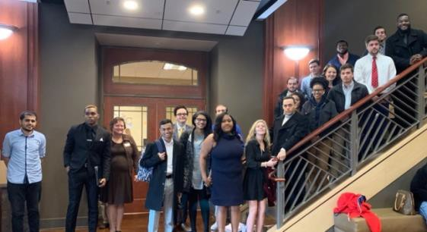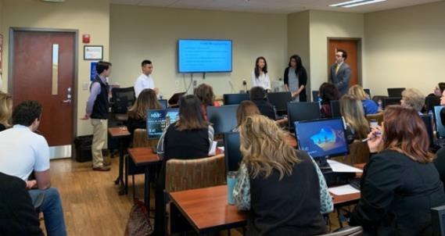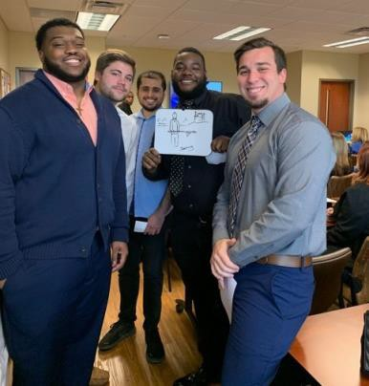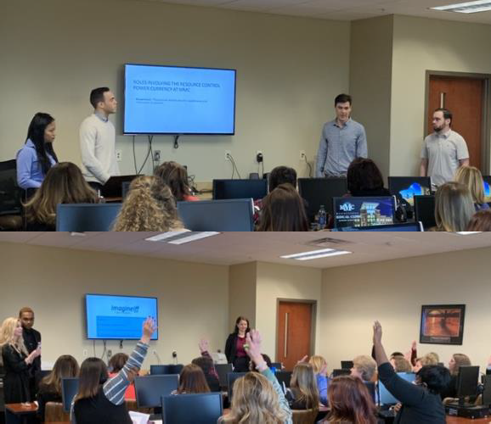

**Dr. Asbury’s COMM 3220, Small Group Communication, class this**

**semester completed their group projects recently. Each group**

**conducted a training session for “tweens” in Grundy Country, TN (i.e., the poorest country in TN). Groups helped “tweens” with peer relationships, self-disclosure, self-esteem, and listening.**

**Dr.Priddis’s COMM 3650, Conflict in Communication, class created and presented a training program to leadership team at Murfreesboro Medical Clinic (MMC) on conflict in intergenerational workgroups.**

**What’s happening in the classroom:**



Sending warm thoughts and big congratulations to our graduates, we are so very proud of you!

King Bahati Hanna Bowlin Maggie Burchett Abigail Butler Holly Cheatham Charity Cole Jonathan Day Kirk Dodd Braden Eutsler Kelsey Goodwin Antonio Green

Brandilyn Guerrero Katherine Harton Marissa Hurley Neily Jimenez Alyson Lawrie Manuelle Lempin Christina Mahan Peyton Muncy Tiffany Muzik Jameson Olson Maria Pagan Vincent Rodgers Antameka Sullivan Ashley Tsan

Caleb Walton Stephanie White Matthew Zotti