



**February Dates:**

2/24 Comm Studies Club LinkedIn Workshop

@ KUC 328, 4-5pm

**March Dates:**

3/03 Business Unplugged:

**Debate Dates:**

2/22-23 TN Intercollegiate Forensics Association

at Vol State

Networking Night @ STU Ballroom

4-6pm

3/23 All-in-One Professional Development Workshop

@ KUC 324, 4-5:30pm

TBA: IPDA Nationals at Tennessee Tech





A note about the Facebook group: It is not “secret,” but it is private, so students will have to request to join.

**Facebook:** MTSU Comm Studies **Instagram:** @mtcommstudies **Twitter:** @mtcommstudies

**Linkedin:** MTSU Department of Communication Studies









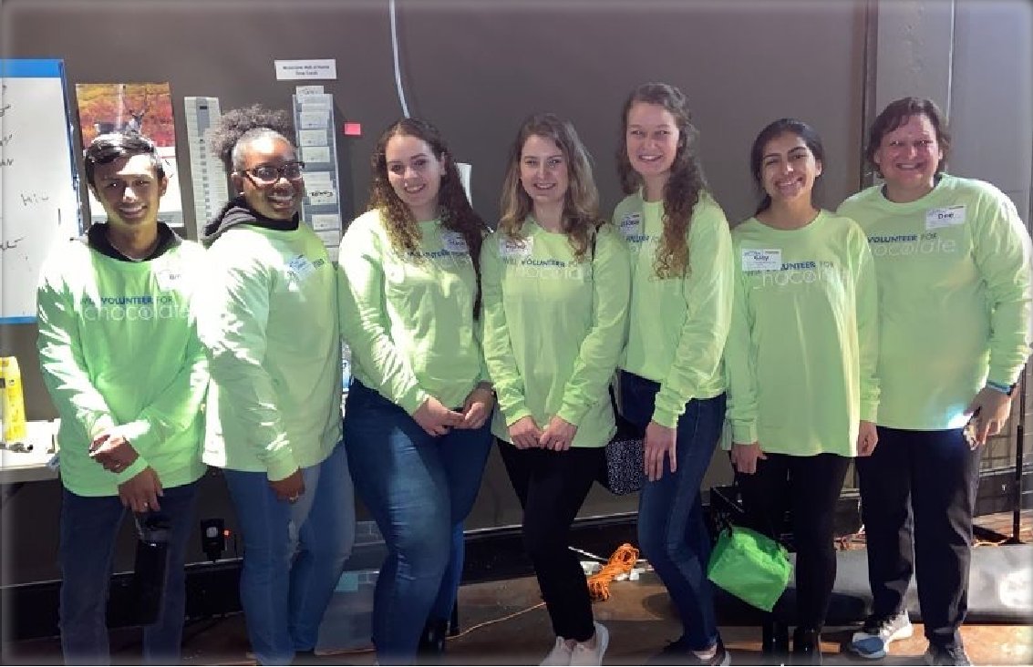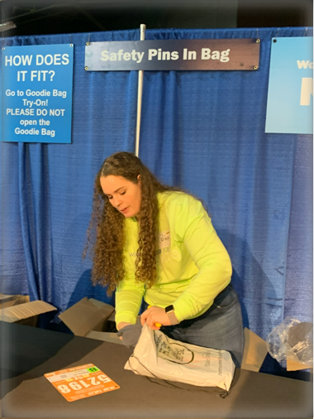

Lambda Pi Eta

Lambda Pi Eta is the official communication honor society of the National Communication Association since 1955. Requirements to join are: completion of 60 or more credit hours, minimum cumulative G.P.A. of 3.0 for all courses taken, completion of 12 semester credit hours in

communication (COMM), and a minimum G.P.A. of 3.25 for all communication courses.

The Lambda Pi Eta officers this semester are: President: Grace Bolden

Vice President: Janecia Gales Secretary & Treasurer: Meredith Craig

Lambda Pi Eta volunteered at the Allstate 5k/15k Packet Pick-up on February 13th, with the help of

Comm Studies Club.

Our New Members: Briley Ward, Meghan Hickman, and Rachel Robertson!

If you are interested in joining Lambda Pi Eta and meet the requirements, contact Grace Bolden or

click here.

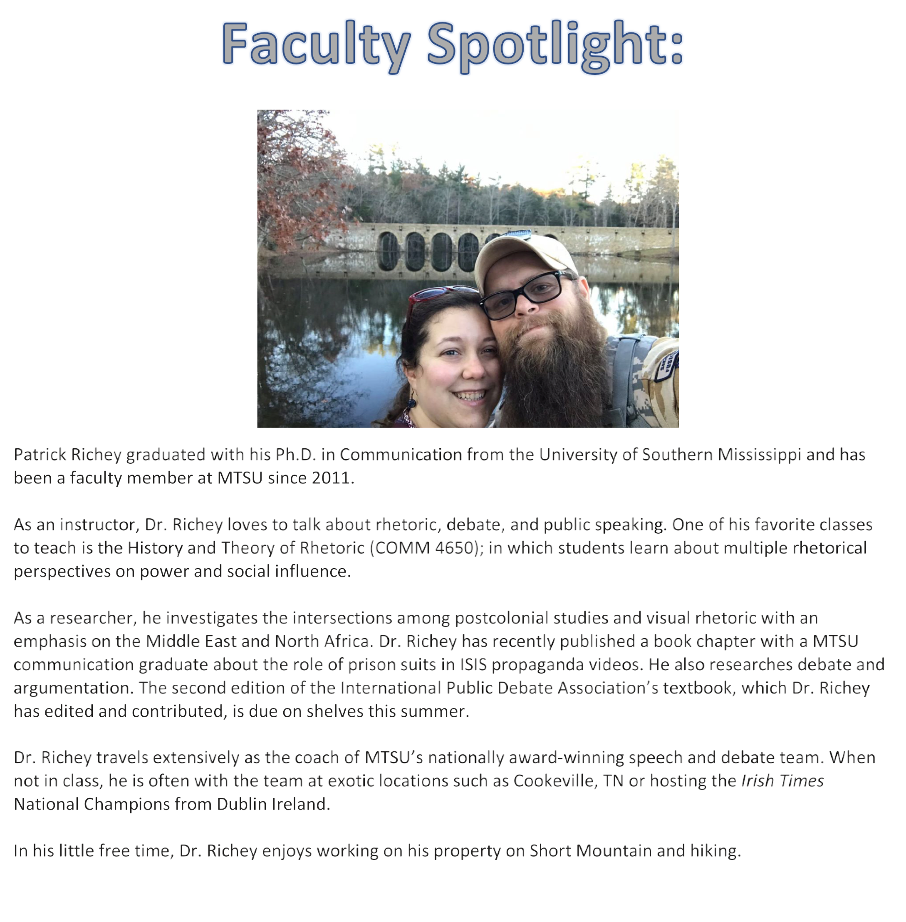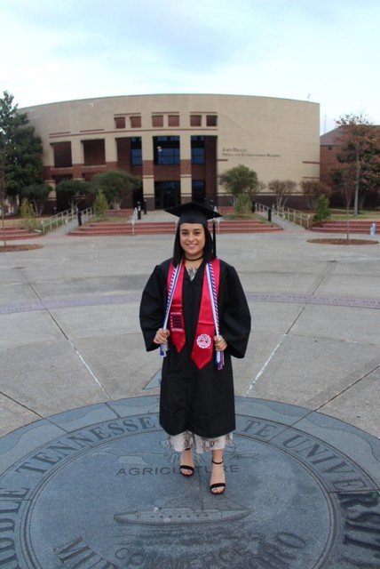

If you have anything you’d like to add to the next newsletter, contact Terry Barkley at [tmb7g@mtmail.mtsu.edu.](mailto:tmb7g@mtmail.mtsu.edu)

Johnny Locke will be presenting his research, which he wrote in Dr. Hundley’s History of Rhetorical Theory class, at the Undergraduate Honors Research Conference, which is a part of the Southern States Communication Association. His faculty mentor is Dr. Richey, who will attend and support Johnny.

Undergraduate Mary Kate Brown has been accepted to Vanderbilt to pursue graduate school.

Neily Jimenez, who graduated in December 2019, started a position as an Inside Sales Representative for Dell Technologies. Congratulations, Neily!

Lori Kissinger is the new LT&ITC At-Large Faculty Board member, which is a competitive selection.