**January /February Newsletter**

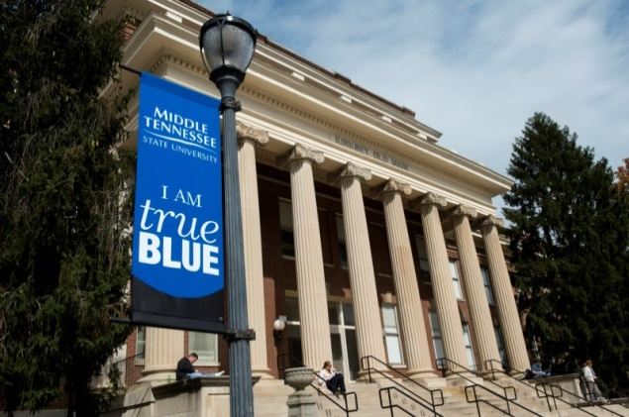

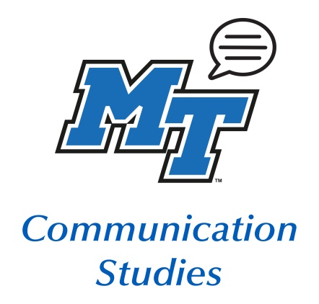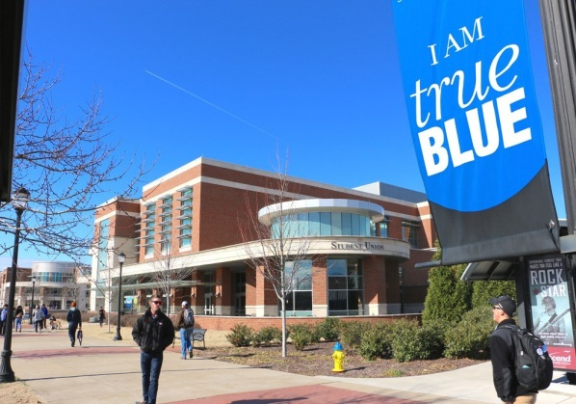

**Debate Dates**

2/01-02 Debate at UTK

2/22-23 TIFA Volunteer State

3/14-15 IPDA Nationals

3/26-28 Irish Times National Debate Champions

**March Dates:**

3/31 Scholars Week CLA Day

3/8-3/14 Spring Break

3/19 Hundley/Chevrette WGST Event JUB100

4/01 Speech Contest

**February Dates:**

2/3 Comm Studies Club

4-5:15 in BDA 214

2/20 Dr Hester 3-7 PM at

WGST Event JUB100

2/21-24 WCA Conference

**MTSU Debate team**

The MTSU Debate Team has a busy Spring starting in Arkansas and heading to Mississippi, finishing with three tournaments in Tennessee including the State and National Championships. The team will also host the **Irish Times National Champions** on their 40th Anniversary tour of the US as well as a model debate for the **League of Woman Voters** with our friends from Belmont University.

MTSU’s Debate Team is housed in the Department of Communication but any student in good academic standing is more than welcome to join at any time throughout the year.

For more Debate Team information contact Dr. Patrick Richey ([Patrick.richey@mtsu.edu](mailto:Patrick.richey@mtsu.edu)) or Natonya Listach ([Natonya.listach@mtsu.edu](mailto:Natonya.listach@mtsu.edu)).



*Facebook Note: The group is private, so you will have to request to join.*

**Facebook:** MTSU Comm Studies

**Instagram:** @mtcommstudies

**Twitter:** @mtcommstudies

**Linkedin:** MTSU Department of Communication Studies

**Opportunities**

**Communication Studies Club** is an academic, social, and service organization meant to promote the Communication Studies program through philanthropic events and on-campus involvement, as well as benefit students within the program through networking and club activities. The CSC is open to all majors.

If you are interested, please complete the Comm Studies Club interest form: <https://forms.gle/KB1h6CxKfzYt6thb8>. Additional questions can be directed to Gaby Jaimes, President, or Advisor Dr. Priddis.

Next Meeting: **Monday, February 3rd from 4:00-5:15 in BDA 214.**

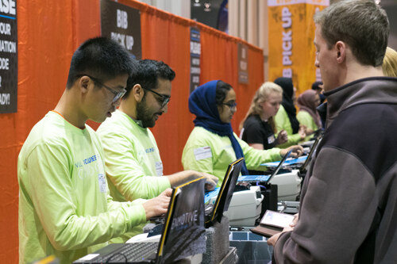

**Do you want volunteer with Lambda Pi Eta or Comm Studies Club?**

Bring your family, friends, or come alone. We will hand out race packets for the Hot Chocolate 15K/5K that takes place on February 15. All volunteers must register by Monday 2/3 to get a free shirt & help the two clubs. We would like 15 or more volunteers to join us on February 13 from 2-7 PM at the Musicians Hall of Fame & Museum in Nashville . Partial shifts are available – please let Grace Bolden at [geb2y@mtmail.mtsu.edu](mailto:geb2y@mtmail.mtsu.edu) know if you only can be there for part of the shift.

**ALL** group members (including yourself) must register through this link and this link **ONLY**  [MTSU Lambda Pi Eta](https://urldefense.com/v3/__https:/ramraces.enmotive.com/events/volunteer/2020-allstate-hot-chocolate-15k-5k-nashville/job:5e20c146-2540-4f5d-b7b4-33e2c0a80a41__;!!Cx0GcAwIk107!qeo4dGSJCBvV4iZNalwSl0NCP9-S-J9l2Kkjf9GdZjeb45Sgb5DJresd-Cl9E6OjSiI_$)

**STUDY ABROAD DEADLINE IS APPROACHING**

**COMM 3220 Small Group Communication in Canada**

**June 19-28, 2020**

MTSU’s Signature Program: Canadians Communicate Live!

The primary goal of this course is to enhance students’ understanding of the principles of small group communication while encountering the people and culture of Ontario, Canada. Students will learn the principles of small group communication tasks, roles, theories, conflict resolution, goal strategizing, and leadership so they may become more competent communicators in group settings.

Includes two Broadway shows, three dinner theaters, 23 out of 29 meals

* Program fee: $2,372.00
* Financial Aid May Apply! Scholarships Available!

Contact: Jeri.Burnett@mtsu.edu



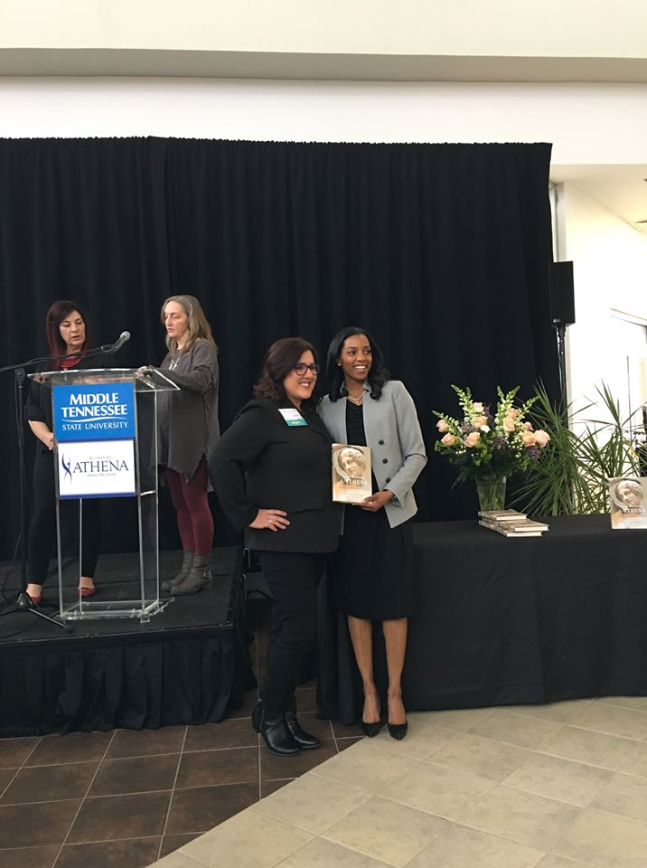**Congratulations** **L’Oreal Stephens** - Athena Nominee 2020! Award winner to be decided in April.

IN COMMUNICATION

The Athena award celebrates women who excel in their professions, give back to their communities and help develop other leaders, especially women.

**What Are You Up To?**

**Lindsey Rogers** (Spring 2019 graduate) is the new TSEC Outreach and Events Coordinator at MTSU. Regarding how the major prepared her for this position, she says: "I am super excited to be able to continue working at my alma mater! Several of my communication courses uniquely prepared me for this position, including Conflict in Communication, Intro to Organizational Communication, Small Group Communication, Gender Communication, Interpersonal Communication, and Intercultural Communication, among others. These classes have informed me on how to effectively communicate and collaborate with others and will help meA person standing in front of a brick building
 in delivering presentations on STEM support to other organizations to develop partnerships and maintain them as well."

**Braden Eutsler** (Fall 2019 graduate) accepted a full-time offer from his internship with Enterprise Rent-A-Car. In addition to his other job duties, he's been tasked with using his communication skills to do an upcoming Instagram takeover to promote content related to the company's inclusive treatment of same sex and LGBTQI+ employees.

Over the winter break **Dr. Chevrette** got engaged to Jordan Knight on a trip to Sedona, AZ. They plan to get married at Bonnaroo this summer.



Please email Dr. Priddis at [Deanne.priddis@mtsu.edu](mailto:Deanne.priddis@mtsu.edu) to add

your announcement to our next newsletter