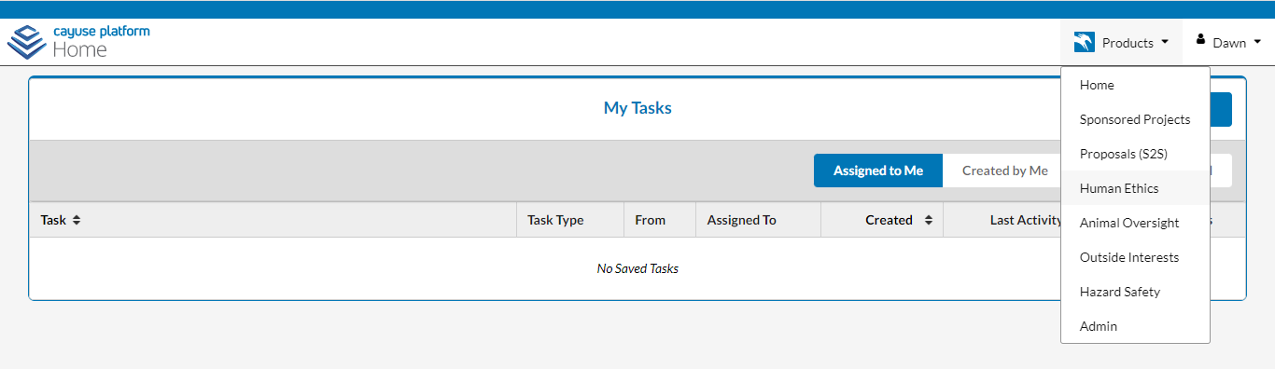
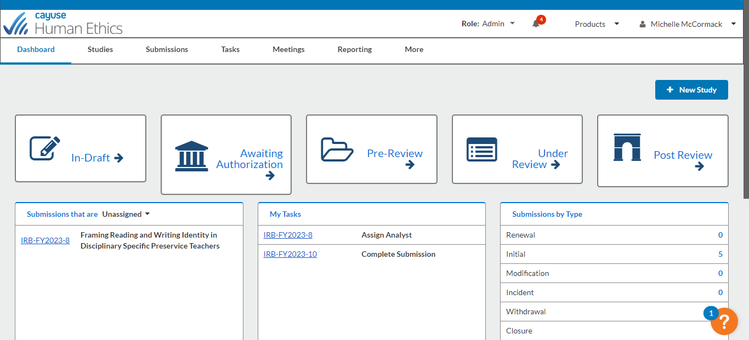
MTSU Cayuse IRB Quick Start Guide
- Go to https://www. mtsu. edu/irb/ and read over the information as there are updates in procedure, forms, and links.
- The link “Check Here for Important Cayuse Notes” will have the latest updates and notices as we roll out the new system.
- From the link on the IRB website, enter Cayuse.
- If you cannot access Cayuse (this will be true for most employees who began in August 2022 or later and all students), fill out the Cayuse Account Request Form under “Check Here for Important Cayuse Notes. ” Once your account is set up, it may take a few hours for the IRB module to open.
- If you have problems accessing Cayuse or the IRB module, send a screenshot and/or describe what occurred to Emily.Badger@mtsu. edu, so that we can help you. For questions regarding the IRB questions or process, please email irb_information@mtsu. edu.
- Once you are on the Cayuse homepage, click the small triangle in the upper right corner to the right of “Products”. This will open a drop-down menu. Select “Human Ethics.”

- Once you are in the Human Ethics Module, click the blue box at the upper right of the screen labeled, “+New Study. ”

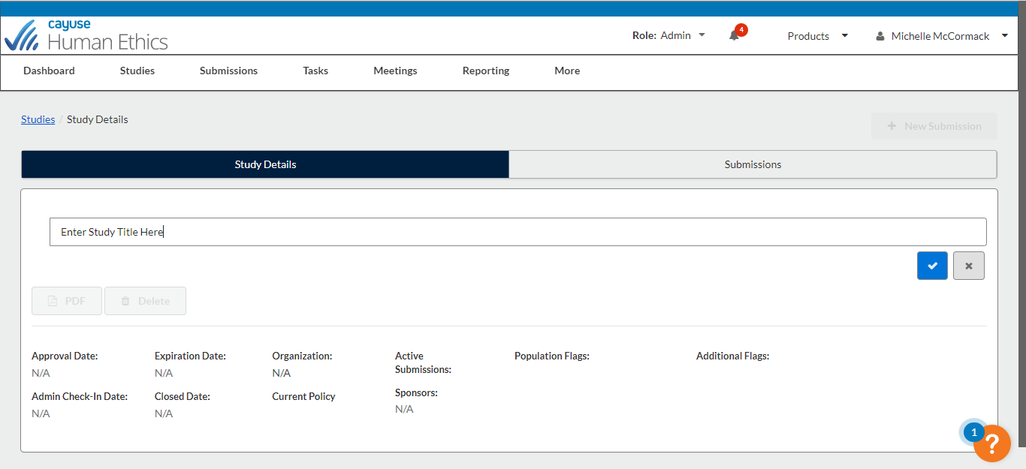
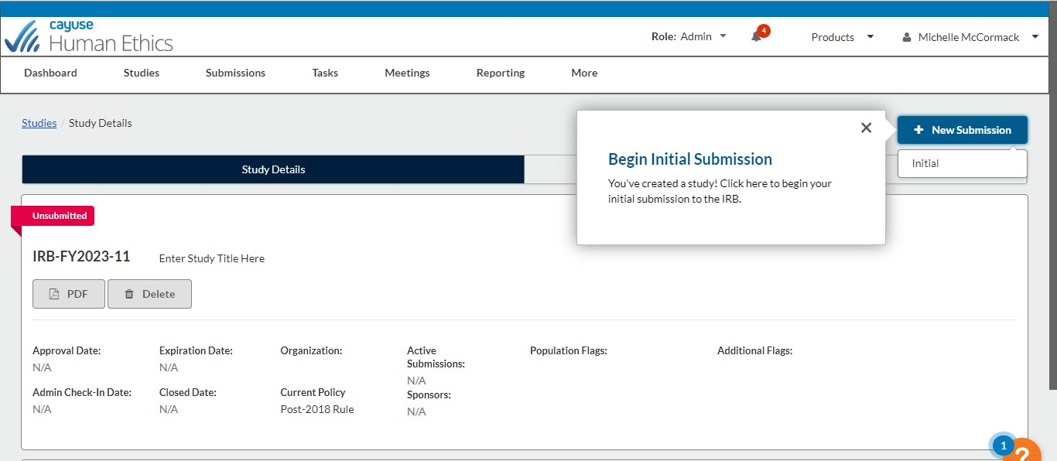
- Enter your study title (it is possible to change this later), and click the blue check mark.

- You are now on the Study Details page. Select the blue “+ New Submission” box in the upper right of your screen and select “initial. ”

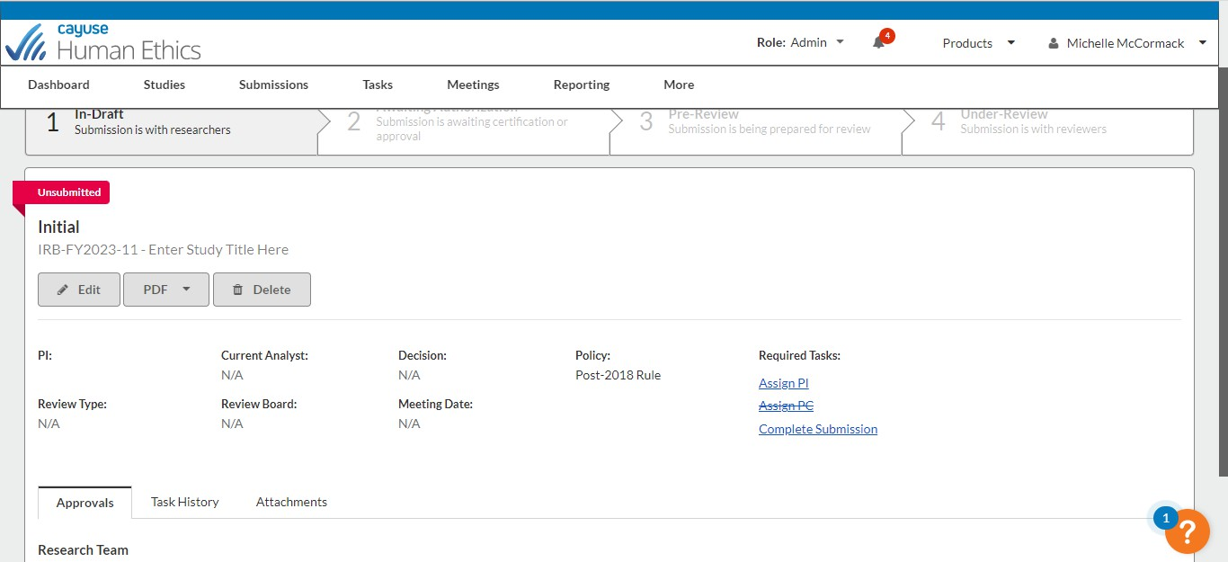
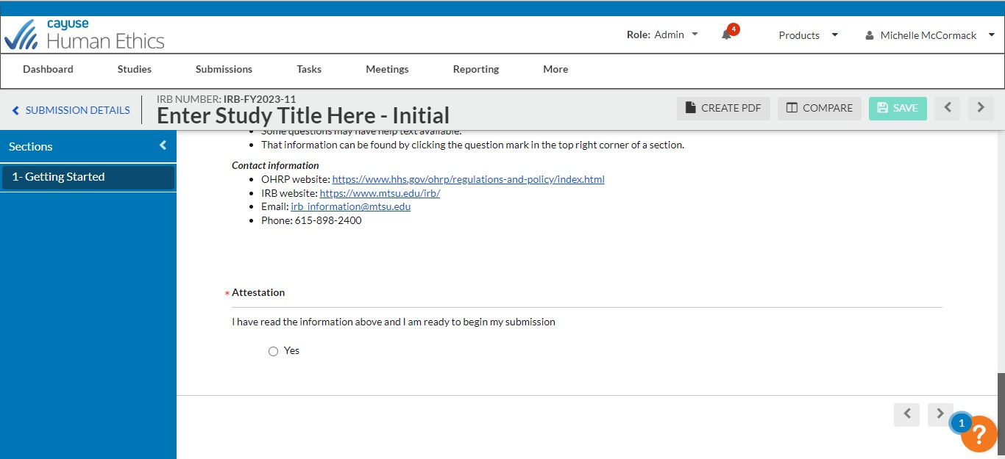
- Select “Assign PI” in the Required Tasks.

- You will now be at the “Getting Started” page which has information about the process. After you read the information, select “Yes” in the attestation section. Then click on “save. ”

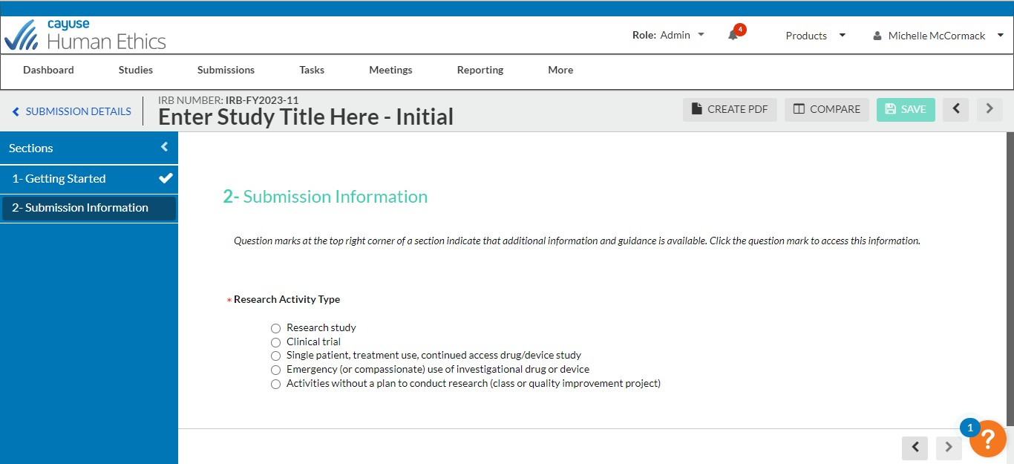
- Now you will see a second menu item in the blue box (2. Submission information). Click this item to go to and complete the next section. The form contains logic, so other questions may appear depending upon your answer to a question. When you are finished, click “save. ” Note that when you complete a section, a checkmark appears in the blue box next to that menu item. If it is not checked after you save, then you have missed something. Every item must have a check by it before you can submit the form. Note that all required fields are marked with an *.

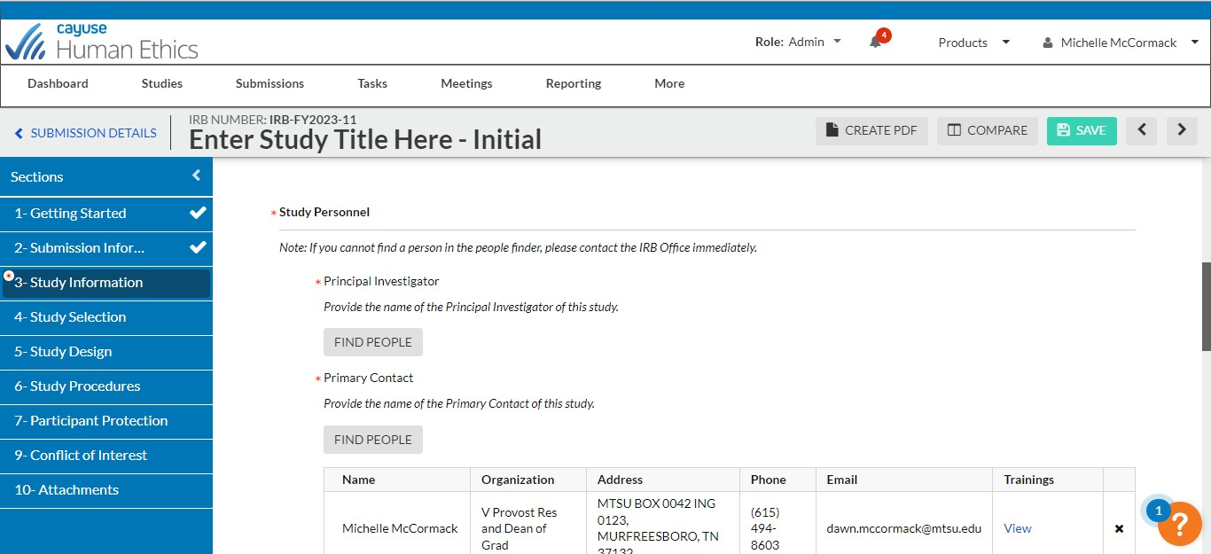
- For the personnel section, you will need to search for the appropriate person in the system. If you cannot find the person, please fill out the form noted at the beginning of this document.

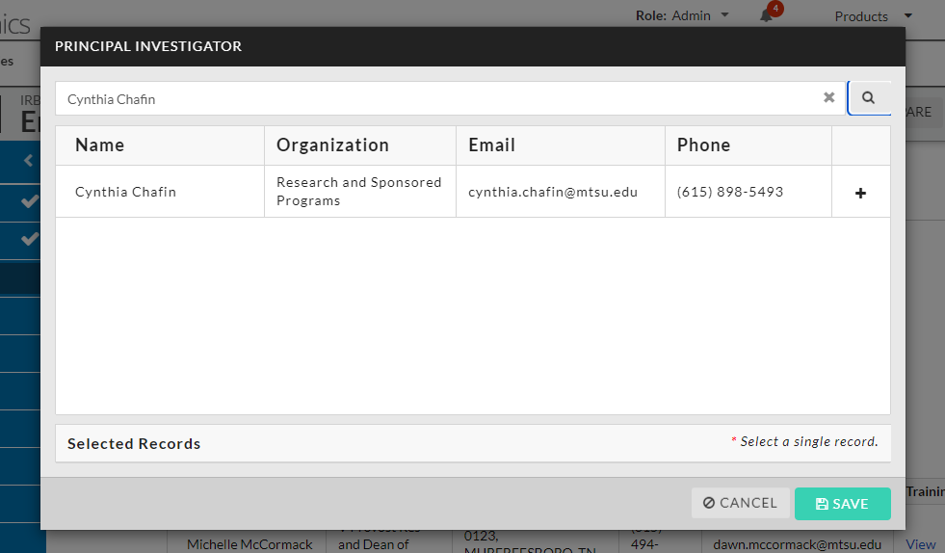

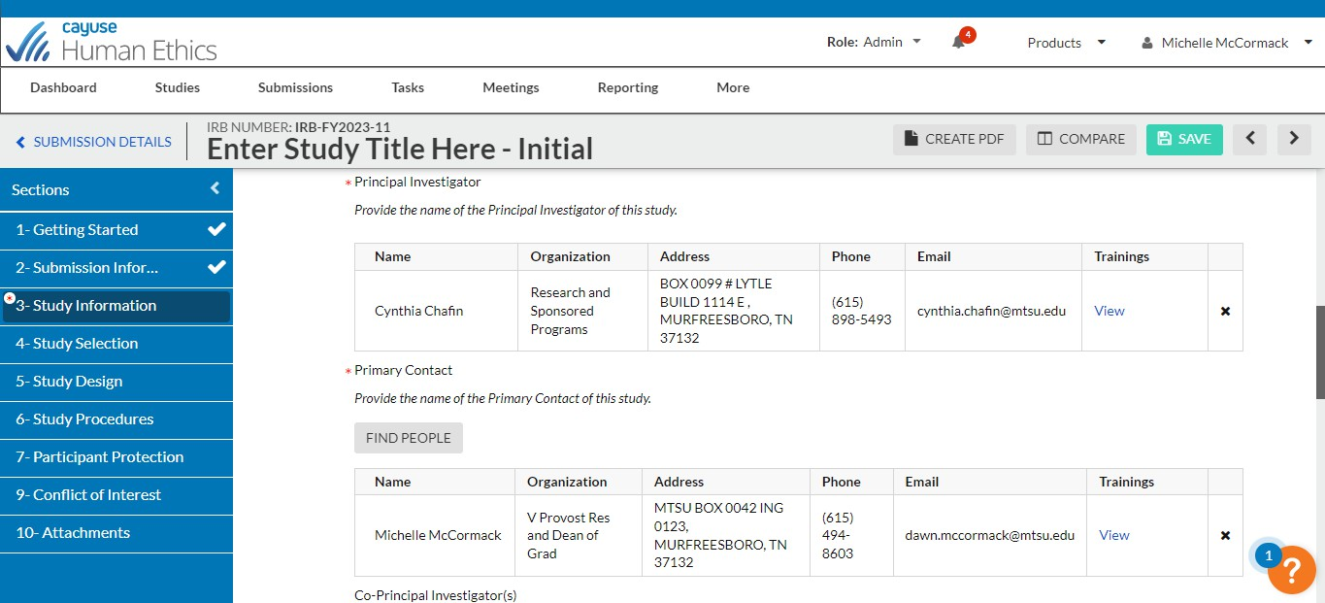
- When you click “Find People”, you should see a search box. Place the name of the person in the box and either click enter or press the search icon. To select the person, click the “+” button after their information. Then make sure that you press “save. ”

- The information for the PI should now appear in the form. If it does not, then you forgot to click the plus or save, and you will need to repeat the step above. Note that the contact person will be you (the person filling out the form). You can change this in this section. Continue to fill out this section as needed. When finished, press save, and follow the same process as before.

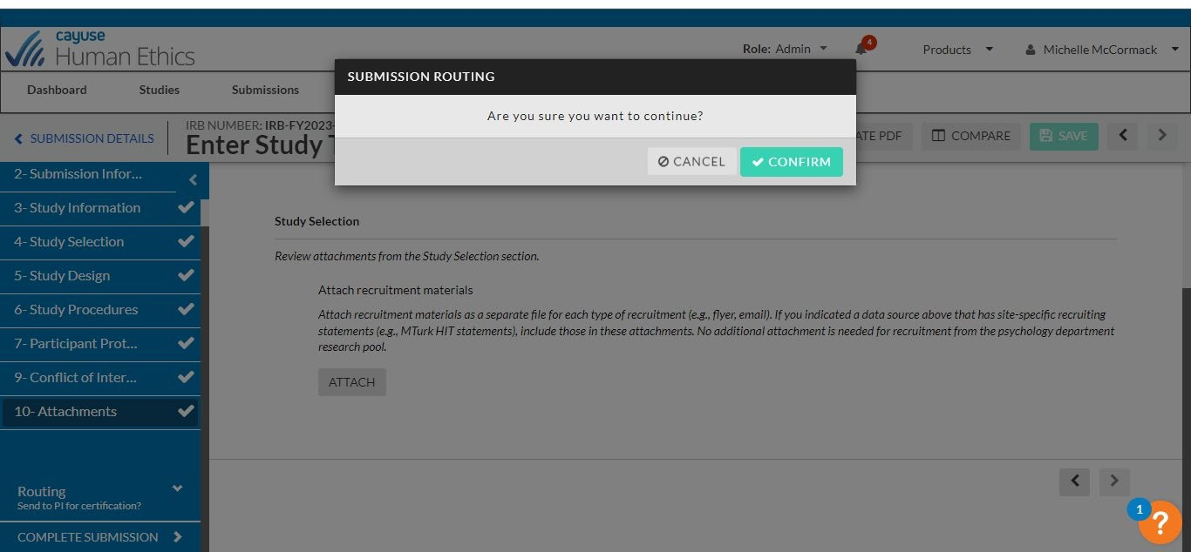

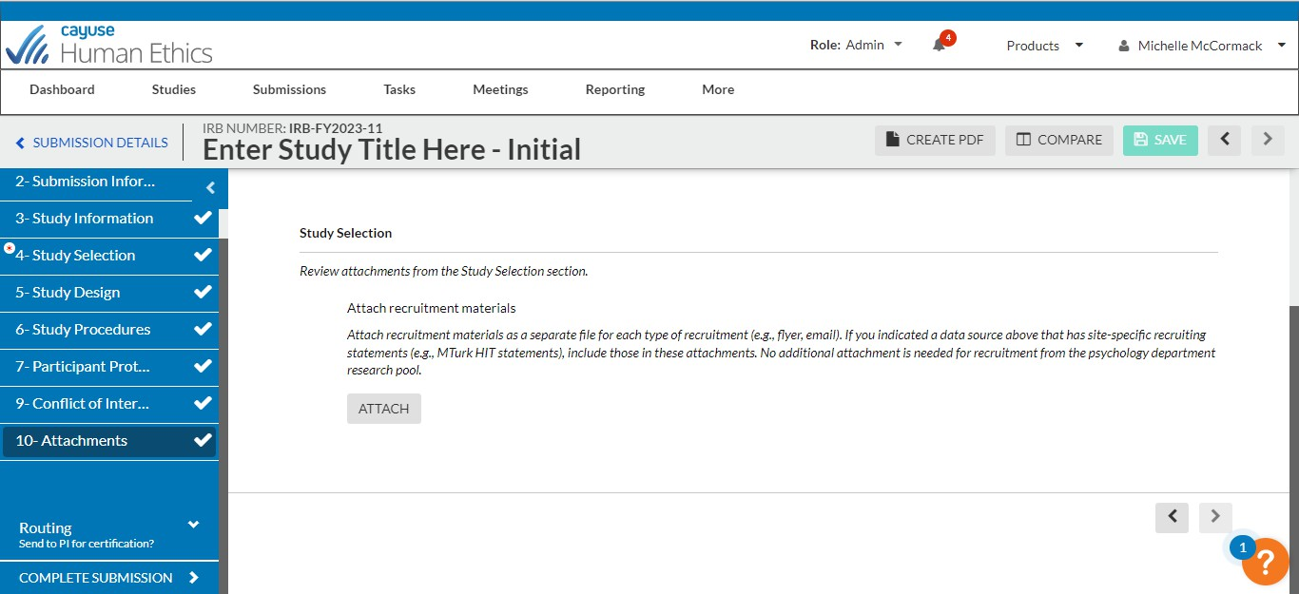
- Once you have completed all of the sections in the form, and all menu items have check marks, then press complete submission. And then confirm.

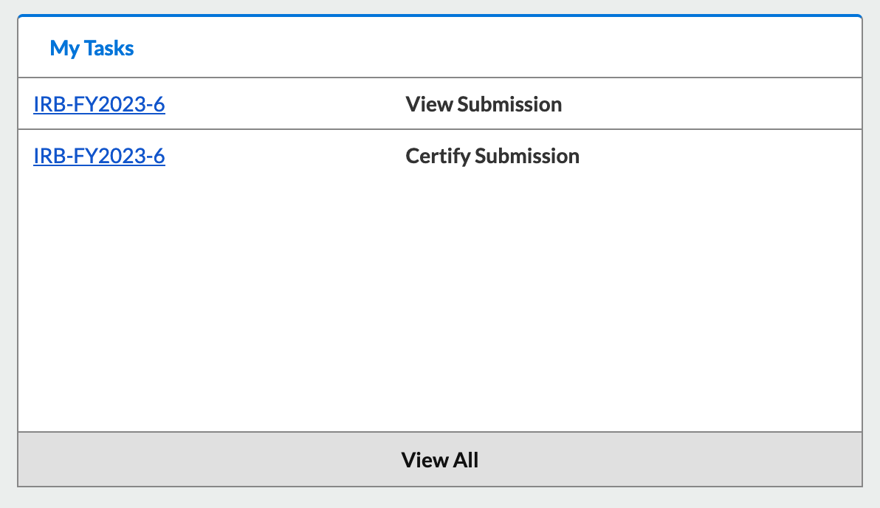
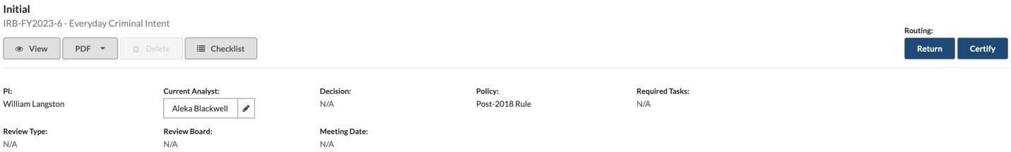
- Once the protocol is submitted, all study personnel must certify the submission. When study personnel log into Cayuse they will see studies requiring certification in the “My Tasks” section of their dashboard.

- Clicking the row for “Certify Submission” will allow study personnel to click the “Certify” button. The protocol is not submitted to the IRB until all study personnel have clicked “Certify. ”

Congratulations! You have submitted your IRB form! The form will automatically route to approvers, the IRB office, and the committee. You will receive emails from do-not-reply@cayuse. com when
/information requests/comments/decisions are made.

