HOW TO SEARCH FOR AND EXPORT

OPEN PURCHASE ORDERS IN MT$OURCE

Open MT$ource

Select Orders My Orders Purchase Orders
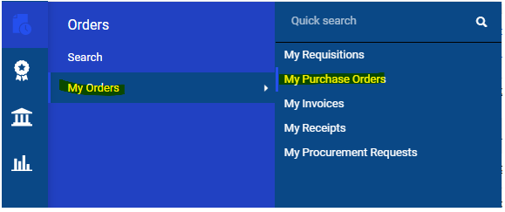

A list of YOUR Purchase Orders will display on the screen

Check Purchase Orders you created for two different periods:
- Fiscal Year-to-Date
- Previous Fiscal Year

Change Created Date
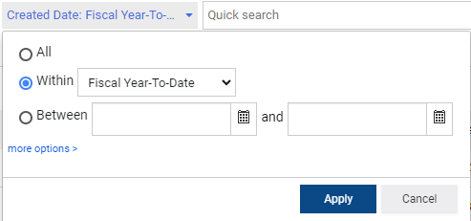
“Fiscal Year-to-Date”
OR
“Previous Fiscal Year”

Add a Filter

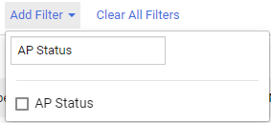
- Click on “Add Filter” drop-down arrow

Type “AP Status” in Search Box
Check box “AP Status”

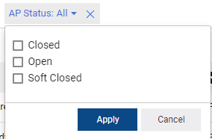
Check box for “Open”

Click on “Apply”

Here is an example of filters set correctly for Fiscal Year to Date
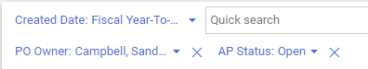

Here is an example of filters set correctly for Previous Year to Date
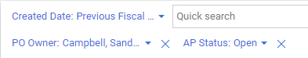

YOUR Open Purchase Orders
(purchase orders that are not closed in MT$ource)
will display on screen.

Export your Data to an Excel Spreadsheet
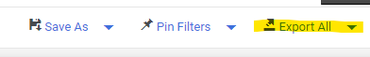
At the top right of the screen, click on “Export All”
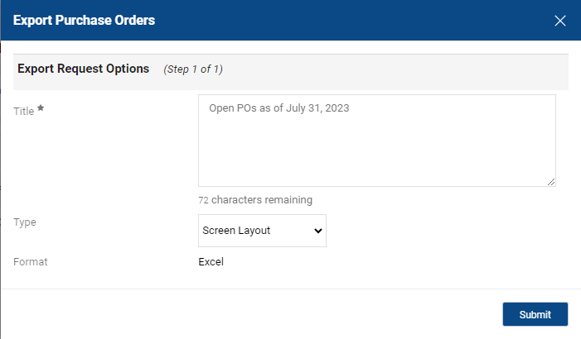
Enter a Name for your Exported file
in the “Title*” text box

Click on Submit

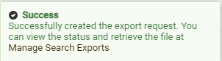

You will get on on-screen message:

Click on the words “Manage Search Exports” in the popup window
(You can also get to your file through the “Export All” drop down menu)

From the Manage Exports window, click on the Title of your file name.
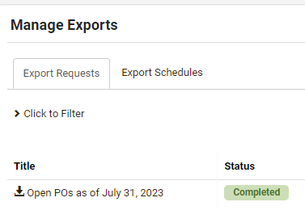

You will either prompted to Save in a location on your computer
(you can change the name of the file)

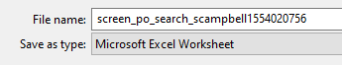

From this name

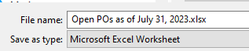

To this name

OR

You may see your report at the bottom of the screen and open it from there.

Save (or Open and Save) your Excel File

Review your list and take the necessary actions to finalize your purchases:

- Did you get the product or service?
Create a cost or quantity receipt.

- Does the vendor need to send their invoice?
Contact the vendor to follow up.
PO # needs to be on the invoice and should be sent to invoice@mtsu.edu.

- Is there money left on the purchase order after all invoices have been paid?
Create a Comment on the Purchase Order in MT$ource to:
Sandra Campbell OR the Buyer listed on the Purchase Order
requesting the funds be unencumbered (returned to your index) and
that the purchase is complete, paid for, and can be closed.

NOTE: The Buyer assigned is on the Summary tab of the Purchase Order; if no Buyer listed, always make your Comment to Sandra Campbell.

