Forensic Science

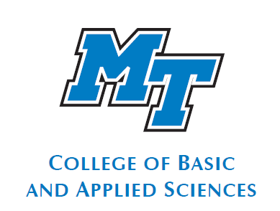
Student Handbook

Forensic Science Program
http://www.mtsu.edu/ programs/forensic-science/

Dear Student:

Welcome to Middle Tennessee State University and the Forensic Science program. We are delighted to have you as a major in this exciting and dynamic field. Students majoring in Forensic Science may apply the concepts they learn in careers as laboratory scientists, or as preparation for additional graduate or professional schools. The curriculum is challenging, and was developed through consultations with practicing forensic scientists, laboratory directors, and recommendations of professional organizations.

The program requires one to have an aptitude for the sciences and be a serious student. The forensic scientist must be able to apply concepts and skills he or she has learned in the program to real world situations. As with most science disciplines, the degree is just the beginning of a life journey, as one will continually learn and apply new concepts and skills. Forensics is not as portrayed on the currently popular TV programs. The forensic scientist objectively analyzes physical evidence collected at a crime scene and provides a written opinion, as well as expert court testimony, based on the analysis results. Most forensic scientists do not typically take evidence at the crime scene and data analysis may take weeks, not minutes. An excellent resource and summary of what forensic scientists do and available career opportunities can be found at the American Academy of Forensic Science web site: https://www.aafs.org/ .

The purpose of this handbook is to provide Forensic Science majors with a resource that can help guide them through their degree program. This handbook is not intended as a replacement for the academic advisor and does not contain all the information that is necessary for successful academic planning. The Blue Raider Planner and Handbook has additional general information and can be found at: http://www.mtsu.edu/stuaff/PDF/handbook.pdf .
We encourage all students to meet with their advisor to discuss academic and career goals as well as to plan course sequencing. We will do all we can to help you succeed.

Sincerely,

Frank Bailey, Ph.D.
Professor
Director, Forensic Science Program
Dept. of Biology, Box 60
Office: SCI 2026
(615) 898-5483
frank.bailey@mtsu.edu


Forensic Science
At Middle Tennessee State University

Forensic Science is the application of techniques and principles of the natural and physical sciences to the analysis of evidence collected during criminal investigations.
The Forensic Science program shares faculty from the departments of the Biology, Chemistry, and Criminal Justice and offers a strong interdisciplinary curriculum within these well-established departments.
The mission of the MTSU Forensic Science Program is:
- To provide a strong academic foundation that will prepare graduates for advanced study in forensic science or professional schools; or employment in public crime laboratories, specialized private laboratories, and law enforcement agencies.
- To provide students with an appropriate curriculum that will ensure understanding of basic scientific principles and methodologies, as well as development of analytical skills.
- To promote student understanding of the role of the forensic scientist in the criminal justice system and introduce them to the process whereby oral and written findings are presented to the court.
- To promote student interaction with current forensic practitioners through seminars and internships.
EMPLOYEES and INTERNS AT CRIME LABORATORIES MUST PASS AN EXTENSIVE BACKGROUND CHECK. The criteria below are typical.

Be advised that applicants with the following will not be accepted for internships or employment: (a) prior convictions for a felony or for misdemeanors of a high and aggravated nature (b) illegal use of any drug, other than experimental use of cannabis (c) deliberate misrepresentation of illegal drug history in connection with the application (d) deliberate association with individuals who participate in criminal activity (e) conduct or activity which reflects a disregard for state or federal laws or which conflicts with the standards of behavior or ethical principles of the TBI.

Please visit the Web site at https://mtsu.edu/programs/forensic-science/.

The Forensic Science Major

In addition to the general education requirements, the Forensic Science major requires

CORE COURSES
Rubric/Number Course Title Credits

FRSC 1010 Intro to the Forensic Science Major 2
BIOL 1110/1111 General Biology I/Lab 4
BIOL 1120/1121 General Biology II/Lab 4
BIOL 2230/2231 Microbiology/Lab 4
BIOL 3250/3251 Genetics/Lab 4
BIOL 4110/4111 General Phys/Lab 4
FSBI 4300/4301 Immunology/Lab 4
OR
BIOL 4570/4571 Toxicology 3
FSBI 4550 Biotechnology 3
CHEM 1110/1111 General Chemistry I 4
CHEM 1120/1121 General Chemistry II 4
CHEM 2230/2231 Quantitative Analysis 5
CHEM 3010/3011 Organic Chemistry I 4
CHEM 3020/3021 Organic Chemistry II 4
FSCH 3530/3531 Princ. of Biochemistry 4
FSCH 4230/4231 Instrumental Analysis in Forensic Sci. 4
FSCJ 4330 Criminal Investigations 3
FSCJ 4340 Crime Scene Investigation 3
ANTH 3660 Forensic Sciences 3
FRSC 4010 Senior Seminar 2
FRSC 4020 Internship 4

SUPPORTING COURSES

PHYS 2010/2011 Physics I and Problems Lab 4
PHYS 2020/2021 Physics II and Problems Lab 4
MATH 1910 Calculus I 4
BIOL 4350/4351 Biometry 4

The program requires completion of 120 semester credit hours distributed as follows:

Curriculum Component Hours Required
General Education 30 (without 8 hrs. Natural Science;
3 hrs. Math)
Major Field Core 73
Electives 1
Other 16 (including 3 hr. Math)
TOTAL 120

Traditional Major Course Offerings

Below is a list of required courses and the semester(s) when typically offered:
Fall / Spring / Summer  BIOL 1110/11-General Biology  BIOL 1120/21-General Biology  BIOL 2230/31-Microbiology  BIOL 3250/51-Genetics  BIOL 4110/11-General Physiology  BIOL 4300/01-Immunology  CHEM 1110/11-General Chemistry  CHEM 1120/21-General Chemistry  CHEM 3010/11-Organic Chemistry I  CHEM 3020/21-Organic Chemistry II  CHEM/FSCH 3530/31-Principles of Biochemistry  CJA/FSCJ 4330-Criminal Investigations  CJA/FSCJ 4340-Crime Scene Investigation  FRSC 4020-Forensic Internship | Fall  FSBI 4550-Biotechnology  CHEM 2230/31-Quantitative Analysis  FRSC 4010-Forensics Senior Seminar | Spring  ANTH 3660-Forensic Sciences  BIOL 4570/71-Toxicology  FRSC 1010-Intro FRSC major  FSCH 4230/31-Instrumental  Analysis in Forensic Science

SUPPORTING COURSES

Fall / Spring / Summer  MATH 1910-Calculus I  PHYS 2010/11-Non-Calculus-Based Physics I  PHYS 2020/21- Non-Calculus-Based Physics II | Fall / Spring  BOL 4350-51-Biometry

Please see Tammy Howell (Tammy.Howell@mtsu.edu )in the Biology Department Office (SCI 2044), phone 898-2291 if you need assistance in registering for these courses.

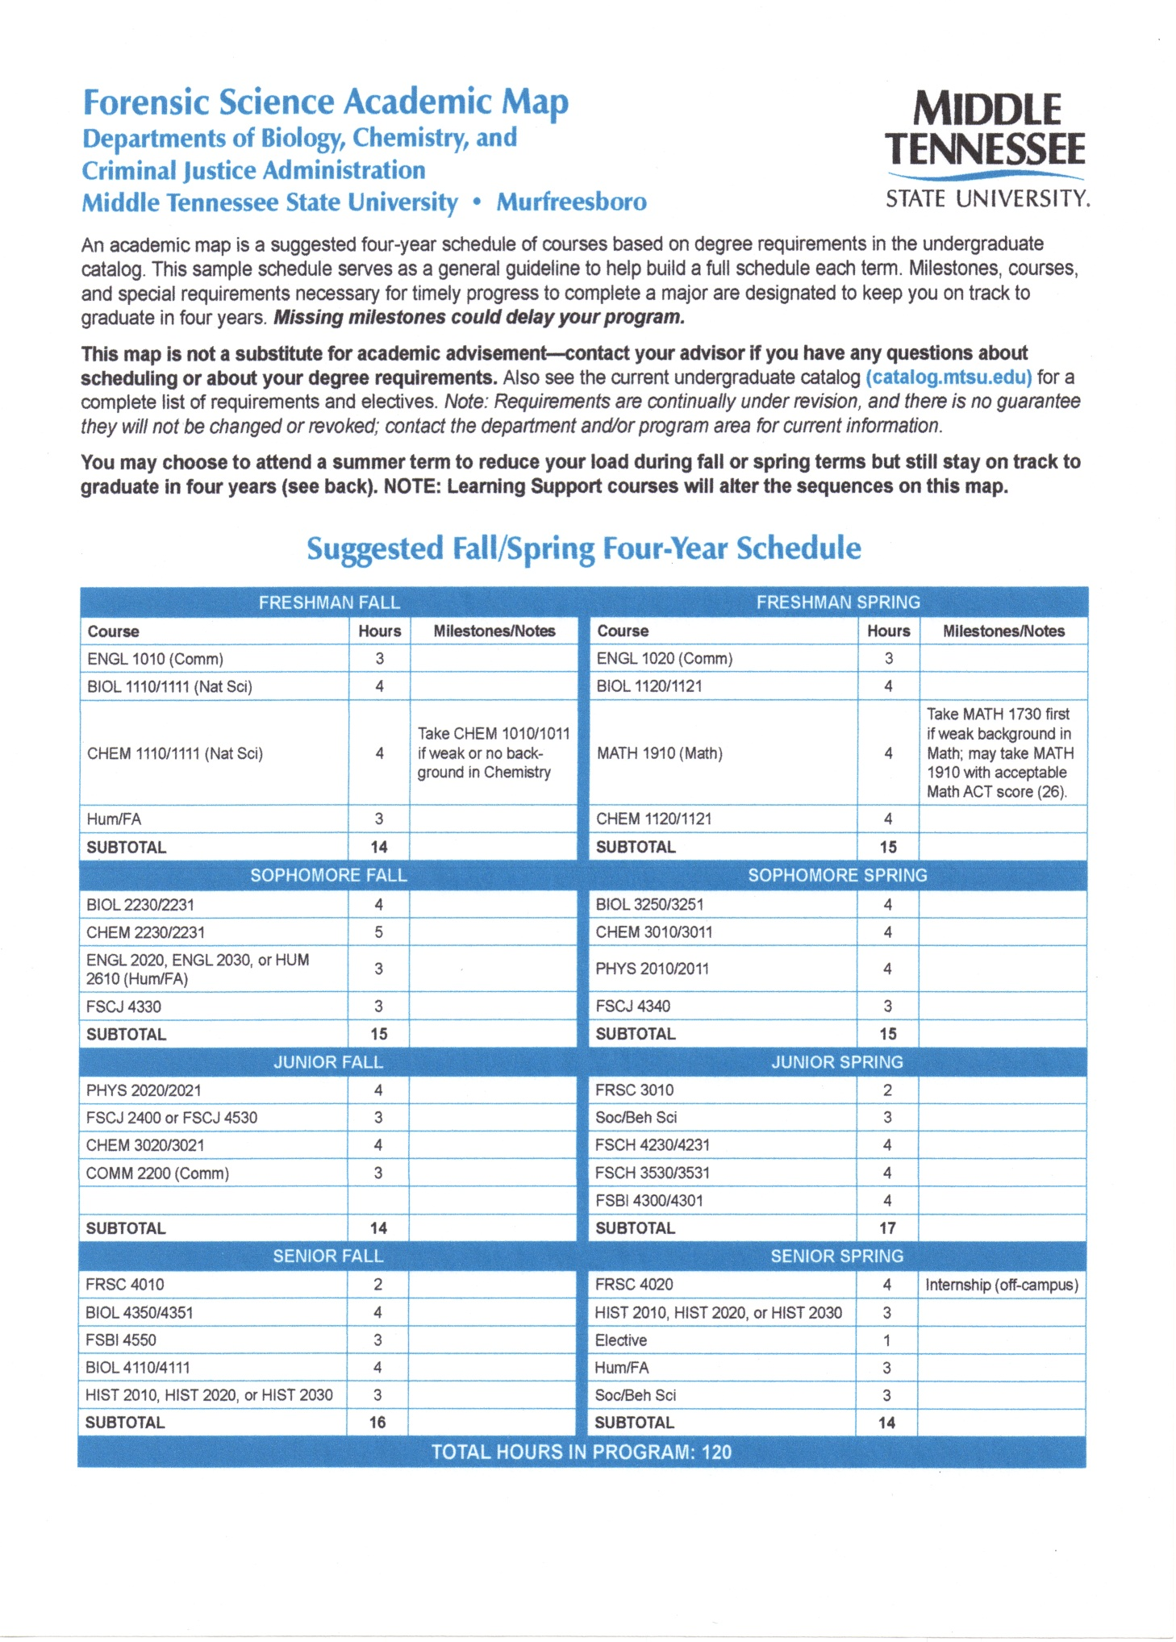

Advising Available and Tips

While the Program Director, Frank Bailey, will play a major role in advising and assisting students, College Advisors have been assigned as academic advisors for Forensic Science majors. Though the forensic program is interdisciplinary and under the Dean of the College of Basic and Applied Sciences, this advisor will have information on the forensic major and is available to assist students in course selection and registration. Contact information is below.

Doug Adams Renee Robbins Beth Bonner
Last Names A-G Last Names H-O Last Names P-Z
DSB 120-I DSB 120-L DSB 120-M
615-898-2316 615-898-2229 615-898-2184
Douglas.Adams@mtsu.edu Renee.Robbins@mtsu.edu Beth.Bonner@mtsu.edu

Who is my faculty mentor?
You will be assigned a faculty mentor in addition to your academic advisor. The role of the faculty mentor is mainly to help with career planning and choices and not to answer academic policy questions or to help with selection of particular classes. Currently, Dr. Frank Bailey, Director the Forensic Science program, will be your primary faculty mentor. There may be times or situations where you will be directed to one of the other faculty members for specific questions. Dr. Bailey’s office is in the Science building, room 2026. His email address is frank.bailey@mtsu.edu, phone number is 615-898-5483, and campus box 60. Since he is frequently visiting interns or locations of internships, emails are preferred. The Department of Biology secretaries, Tammy Howell, 615-898-2291, or Becky Elrod, 615-494-7672 can assist in contacting or taking messages for Dr. Bailey.

Required Internship: What should I do and when?
An internship of 160 on-site hours is required in the Forensic Science major. Dr. Bailey (frank.bailey@mtsu.edu ) can provide a list of potential internship locations that could be contacted. Please be advised that the program does not find internships for students. The students are expected to take the initiative to find potential internships, contact the organizations, and apply. Students should start the process of looking for potential internship locations early in their MTSU career and plan to actually do the internship during their Junior or Senior after having acquired appropriate laboratory skills.

WORKERS AT CRIME LABORATORIES MUST PASS AN EXTENSIVE BACKGROUND CHECK. Tennessee Bureau of Investigation (TBI) criteria as highlighted below are typical.

Be advised that applicants with the following will not be accepted for internships or employment: (a) prior convictions for a felony or for misdemeanors of a high and aggravated nature (b) illegal use of any drug, other than experimental use of cannabis (c) deliberate misrepresentation of illegal drug history in connection with the application (d) deliberate association with individuals who participate in criminal activity (e) conduct or activity which reflects a disregard for state or federal laws or which conflicts with the standards of behavior or ethical principles of the TB

COURTROOM TESTIMONY EVALUATION
(FRSC 4010 - Senior Seminar Event)

Analyst:
Date of Testimony: 11/28/2017
Please circle the option which most closely matches your assessment of the student in each category below. Comments are optional and as time allows.
ASSESSMENT OF COURTROOM TESTIMONY

General Demeanor and Appearance Excellent Satisfactory Unsatisfactory

Comments:

Communication Skills Excellent Satisfactory Unsatisfactory

Comments:

Appropriate Eye Contact Excellent Satisfactory Unsatisfactory

Comments:

Answer Questions Effectively Excellent Satisfactory Unsatisfactory

Comments:

Overall Performance Excellent Satisfactory Unsatisfactory

Comments:

Additional Recommendations

