Enneagram Worksheet

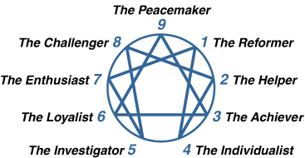

- My Type: __________________________________

- My Wing: __________________________________

- My type moves to _____________________ in growth.

- My type moves to _____________________ in stress.

Information about my type:

Website: https://www.enneagraminstitute.com/type-descriptions
Test Website: https://www.eclecticenergies.com/enneagram/dotest

