Instructions for Proposal Submission
Disclaimer: Registering on this website does NOT register you for attendance at the Tennessee STEM Education Research Conference 2021. This is only registering for proposal submission.

BEGINNING OF INSTRUCTIONS
- Go to https://mtsuorsp.awardsplatform.com/
- To submit your proposal, you must register on the website by entering your information in the middle fields as shown below. Your email and password will be used to log back into the site. 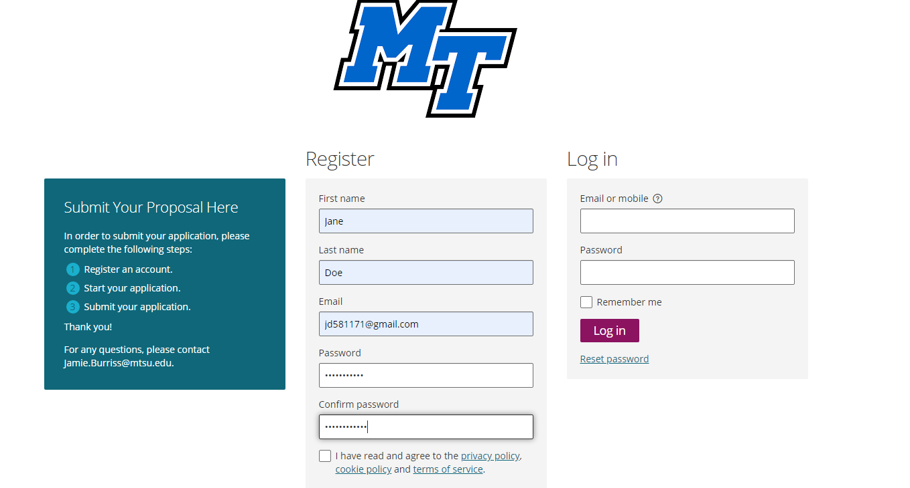
- After you have filled out all of the required fields, you will be taken to a portion of the site that looks like this:
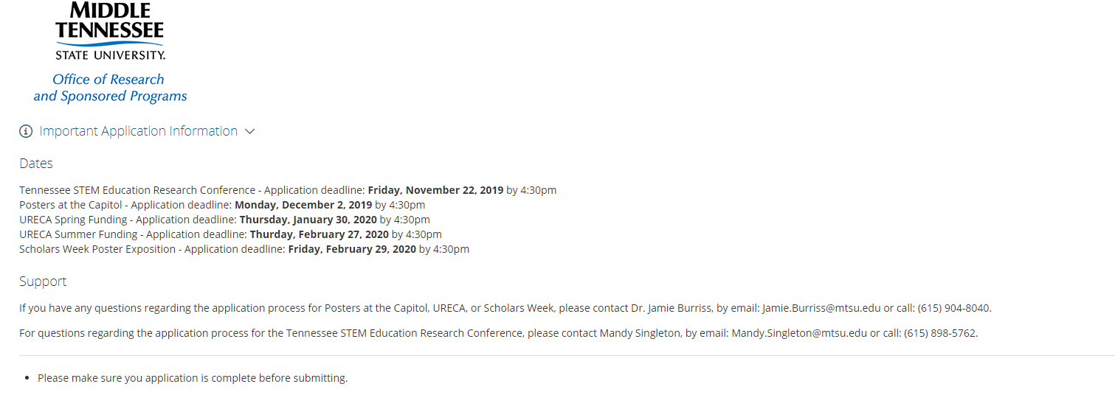
- The first thing that you will notice is that at the top of the screen, there is a list of dates for different events.
- Underneath you will see a notification that looks like this:
You MUST go into your email and click on the verification email to continue registering.

- The email that will be sent to you will look like this:

You will need to click on the link that is in the email and it will take you back to the website. Your account is now verified.

- Once you have arrived back to the website, you will now have access to start your official proposal submission application.
Here you will use the drop down tab under “Event” and select the Tennessee STEM Education Research Conference 2021. Enter the Title of your Proposal

- After you have chosen the Tennessee STEM Education Research Conference 2021 as the event, you will now be able to fill out your name. Following this, you will click “Save + next”
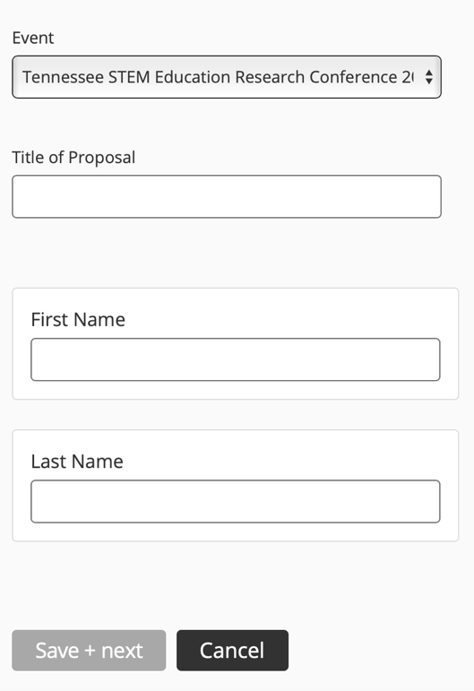

As you fill out the application, each time you click “Save + next,” your work to that point is saved to your account. You may begin your application and come back later to complete it without starting over again. Simply log back into your account using the email and password you created at the beginning.

- After providing all required information and attaching your proposal as a PDF, complete the process by clicking the “Submit Application” button on the “Attachments” tab.
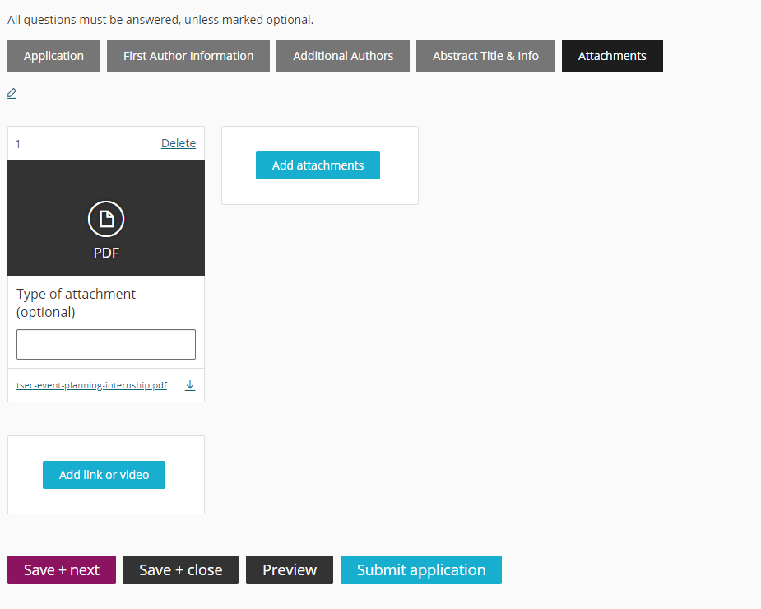

You have now succussfully completed the submission process for the Tennessee STEM Education Research Conference 2021 and will be notified when judging is finalized. If you have any questions or problems, please contact Mandy Singleton at the Tennessee STEM Education Center at MTSU by email mandy.singleton@mtsu.edu or phone (615) 898-5762.

Abstract Instructions

Abstracts should be limited to two single spaced pages, not including references, or between 250-500 words. Include in the abstract a brief overview of the background literature, the significance of the research, the research question(s), data analysis procedures, and summary of findings.The First Call for Abstracts deadline is Monday, November 23, 2021 at 12 PM noon CST. If there are still presentation slots available, a second call will follow.

Abstract Example:

The primary goal of professional development programs is to support teachers in increasing student achievement. In many cases, this requires a significant change in how mathematics is taught (Sowder, 2007). In turn, this demands not only a change in teachers’ beliefs (Pajares, 1992) but also a new vision for what mathematics teaching entails (Ball & Cohen, 1999). Unfortunately, professional development often fails to support teachers in making these changes as it does not provide opportunities for teachers to view reform-oriented teaching practices with students similar to their own (Santagata, 2011).
With this limitation of professional development in mind, we designed our professional development project to include demonstration lessons. In demonstration lessons, project participants (who were middle grades mathematics teachers) visited a school site where a fellow participant taught. Within this participant’s classroom, project staff members taught mathematics lessons to the participant’s students while visiting project participants observed the lessons. Project staff members included mathematics education faculty and graduate students from the university. Through this experience, project participants not only had the opportunity to observe reform-oriented teaching practices but also observed this work with students who were very similar to their own.

Project participants attended three demonstration lessons during a single academic year. Recognizing the unique opportunity this provided, we sought to document the impact of these demonstration lessons by gaining insights into the participants’ views. Specifically, the following research questions were posed.

1. How does viewing reform-oriented demonstration lessons impact teacher practice as reported by teachers?
2. What are teachers’ perceptions of the benefits of demonstration lessons in established classes?
Researchers have indicated that teachers need opportunities to observe reform-oriented instruction (Borasi & Fonzi, 2002; Santagata, 2011). Including observations of reform-oriented instruction in professional development programs seems to be a logical means for providing these needed opportunities. The significance of this study rested in its examination of demonstration lessons as a setting for observing reform-oriented instruction and the potential demonstration lessons held as a viable option for supporting teacher learning in professional development.

Five participants were selected for interviews. Interviews consisted of a set of open-ended questions that primarily focused on the transfer of information from demonstration lessons to the individual classrooms of the teachers. Transcripts of the interviews were analyzed utilizing an open-coding process. Results indicated that observing demonstration lessons provided participants with a vision of reform-oriented instruction that could be transferred into their own classrooms. As a result of these observations, participants reported that they returned to their classrooms with a goal of improving their questioning techniques and supporting their students in thinking deeply about mathematics. Meeting this goal was supported by their use of the demonstration lessons.

References

Ball, D. L., & Cohen, D. K. (1999). Developing practice, developing practitioners: Toward a practice-based theory of professional education. In L. Darling-Hammond & G. Sykes (Eds.), Teaching as the learning profession: Handbook of policy and practice (pp. 3–32). San Francisco: Jossey-Bass.

Borasi, R., & Fonzi, J. (2002). Professional development that supports school mathematics reform. Foundations series of monographs for professionals in science, mathematics, and technology education. Arlington, VA: National Science Foundation.

Pajares, M. F. (1992). Teachers’ beliefs and educational research: Cleaning up a messy construct. Review of Educational Research, 62, 307-332.

Santagata, R. (2011). From teacher noticing to a framework for analyzing and improving classroom lessons. In M. G. Sherin, V. R. Jacobs, & R. A. Philipp (Eds.), Mathematics teacher noticing: Seeing through teachers’ eyes (pp. 152–168). New York: Routledge.

Sowder, J. T. (2007). The mathematical education and development of teachers. In F. K. Lester, Jr. (Ed.), Second handbook of research on mathematics teaching and learning (pp. 157-224). Charlotte, NC: Information Age Publishing.

